|  |  |
| --- | --- |
| **MINISTRY OF  EDUCATION AND TRAINING** | **MINISTRY OF  NATIONAL DEFENCE** |

**MILITARY TECHNICAL ACADEMY**



**FULL NAME: PHAM QUANG TUNG**

**TRAN THI TOI**

**COURSE: 55**

**TRAINING TYPE: MILITARY ENGINEER**

**GRADUATION THESIS**

**MAJOR: INFORMATION TECHNOLOGY**

**CODE: 7480201**

**SUB-MAJOR: INFORMATION TECHNOLOGY**

**DEEP LEARNING FOR UAV-BASED**

**OBJECT DETECTION**

**YEAR 2024**

Hà Nội, 11/2019

Hà Nội, 11/2019

Hà Nội - 2018

|  |  |
| --- | --- |
| **MINISTRY OF  EDUCATION AND TRAINING** | **MINISTRY OF  NATIONAL DEFENCE** |

**MILITARY TECHNICAL ACADEMY**



**FULL NAME: PHAM QUANG TUNG**

**TRAN THI TOI**

**COURSE: 55**

**TRAINING TYPE: MILITARY ENGINEER**

**GRADUATION THESIS**

**MAJOR: INFORMATION TECHNOLOGY**

**CODE: 7480201**

**SUB-MAJOR: INFORMATION TECHNOLOGY**

**DEEP LEARNING FOR UAV-BASED**

**OBJECT DETECTION**

***Supervisor: Senior Lieutenant Colonel, Assoc. Prof. PhD. Tran Cao Truong***

**YEAR 2024**

Hà Nội, 11/2019

Hà Nội, 11/2019

Hà Nội - 2018

|  |  |
| --- | --- |
| HỌC VIỆN KỸ THUẬT QUÂN SỰ | **CỘNG HÒA XÃ HỘI CHỦ NGHĨA VIỆT NAM** |
| **VIỆN CNTT & TT**  **BỘ MÔN HỆ THỐNG THÔNG TIN** | **Độc lập – Tự do – Hạnh phúc** |

**NHIỆM VỤ ĐỒ ÁN TỐT NGHIỆP**

Họ và tên: Phạm Q uang Tùng, Lớp: Công nghệ thông tin 1, Khóa: 55

Họ và tên: Trần Thị Tới, Lớp: Công nghệ thông tin 2, Khóa: 55

Ngành: Công nghệ thông tin, Chuyên ngành: Công nghệ thông tin

1. Tên đề tài: Nghiên cứu và ứng dụng học sâu cho nhận dạng đối tượng trong ảnh thu nhận được từ UAV.

2. Các số liệu ban đầu: Tự tìm hiểu.

3. Nội dung bản thuyết minh:

Chương 1: Tổng quan về bài toán nhận dạng đối tượng trên ảnh thu được từ UAV.

Chương 2: Các phương pháp nhận dạng đối tượng trên ảnh thu được từ UAV.

Chương 3: Nghiên cứu, ứng dụng học sâu nhận dạng đối tượng có hướng trên ảnh thu được từ UAV.

Chương 4: Nghiên cứu, ứng dụng học sâu sử dụng ảnh chụp từ nhiều phương thức trong nhận dạng đối tượng có hướng trên ảnh thu được từ UAV.

4. Số lượng, nội dung các bản vẽ (ghi rõ loại, kích thước và cách thực hiện các bản vẽ) và các sản phẩm cụ thể (nếu có):

Không có bản vẽ.

5. Cán bộ hướng dẫn:

Họ và tên: Trần Cao Trưởng

Cấp bậc: Thượng tá

Chức vụ: Chủ nhiệm bộ môn

Đơn vị: Bộ môn Khoa học máy tính - Viện Công nghệ Thông tin và truyền thông - Học viện Kỹ thuật quân sự.

Hướng dẫn toàn bộ đồ án.

|  |  |
| --- | --- |
| Ngày giao: 27/6/2024 | Ngày hoàn thành: 23/9/2024 |
| **Chủ nhiệm bộ môn**  **3//, PGS. TS. Nguyễn Văn Giang** | *Hà Nội, ngày tháng năm 2024*  **Cán bộ hướng dẫn**  **3//, PGS. TS. Trần Cao Trưởng** |

**Học viên thực hiện**

Đã hoàn thành và nộp đồ án ngày 24 tháng 9 năm 2024

|  |  |
| --- | --- |
| **Phạm Quang Tùng** | **Trần Thị Tới** |

# Abstract

The problem of object detection in UAV imagery has numerous real-world applications and continues to prove effective alongside the development of UAV manufacturing technologies. Many studies have achieved promising results in object detection tasks. Moreover, combining multiple types of images from different sensors has also seen improvements and produced good results. However, there have not been many methods proposed for object detection in UAV imagery that utilize multi-modal images. Additionally, due to the unique characteristics of UAV imagery, oriented object detection becomes a challenging issue and differentiates itself from conventional object detection tasks using horizontal bounding boxes.

In this thesis, we review several existing deep learning methods for object detection in UAV imagery. At the same time, we also propose a new method for oriented object detection in UAV imagery using multi-modal images. The proposed method is tested on real-world datasets captured by UAVs, demonstrating its effectiveness compared to existing methods.

# Abbreviations

|  |  |
| --- | --- |
| AP | Average precision |
| CBAM | Convolutional block attention module |
| CCR | Cross-Modal Conflict Rectification |
| CNNs | Convolutional Neural Networks |
| FPN | Feature Pyramid Network |
| IR | Infrared |
| OBB | Oriented bounding box |
| OD | Object detection |
| RGB | Red – Green – Blue |
| RNNs | Recurrent Neural Networks |
| RPN | Region proposal network |
| SCF | Selected Cross-Modal Fusion |
| SDD | Single Shot MultiBox Detector |
| UAV | Unmanned Aerial Vehicle |
| YOLO | You only look one |

# List of Figures

Figure 1.1. The difference between deep learning and traditional machine learning. 4

Figure 1.2. Example of object detection 7

Figure 1.3. Partial statistical analysis results of light and small UAVs 10

Figure 1.4. Data captured by different sensors 12

Figure 1.5. Example of Object rotation problem in UAV object detection 17

Figure 1.6. Example of RGB images and Infrared images captured by UAV 19

Figure 1.7. Electromagnetic spectrum showing the visible and infrared wavelength intervals Excerpt from page 2 [16]. 20

Figure 2.1. The development of object detection from 2001 to 2023 23

Figure 2.2. Two-stage object detection framework 23

Figure 2.3. One-stage object detection framework 24

Figure 2.4. High-level overview of the detection pipeline for object detectors 25

Figure 2.5 Image pyramid for the multiscale detections using a sliding window 26

Figure 2.6. The comparison between Yolo and SSD algorithm 30

Figure 2.7. The development of typical methods for UAV-based object detection 35

Figure 2.8. The overall structure of the RSOD model 36

Figure 2.9. The main concern of FPN 39

Figure 2.10. An overview of the speed-up techniques in object detection 43

Figure 2.11. Precision-Recall curve 52

Figure 3.1. Examples of annotated images in DOTA. 55

Figure 3.2. Comparisons between HBB and OBB representations for objects. 58

Figure 3.3. Features misalignment 59

Figure 3.4. Spatial misalignment 60

Figure 3.5. Periodicity of Angle 61

Figure 3.6. A taxonomy of oriented object detection methods. Divided into two methods: Anchor-based methods and Anchor-free methods 62

Figure 3.7. The structure of RoI Transformer 63

Figure 3.8. The architecture of the S2A-Net.. 64

Figure 3.9. The basic architecture of keypoint-based and center-based anchor-free detectors. 65

Figure 3.10. The framework of Oriented RepPoints.. 67

Figure 3.11. The correlation between the predicted classification confidence and localization score of the oriented reppoints with and without APAA scheme. 75

Figure 3.12. The default inference flowchart of YOLOv5 76

Figure 3.13. Default network structure of YOLOv5 77

Figure 3.14. Structure comparision of SPPF and SPP 77

Figure 3.15. Some common feature fusion paths 78

Figure 3.16. The dotted line in the figure is default feature fusion path of YOLOv5 78

Figure 3.17. YOLOv5 Head & Bounding Box Regression 78

Figure 3.18. Five versions of YOLOv5 79

Figure 3.19. YOLOv5l: Detailed Architecture 80

Figure 3.20. Several definitions of bounding boxes 81

Figure 3.21. The boundary problem of 3 categories of regression based methods. The red solid arrow indicates the actual regression process, and the red dotted arrow indicates the ideal regression process 83

Figure 3.22. Two kinds of labels for angular classification 83

Figure 3.23. Examples detection results of Oriented RepPoints with Swin-T-FPN backbone on DOTA test set 92

Figure 3.24. Examples detection results of YOLOv5_OBB on DOTA test set 93

Figure 3.25. Comparison detection results of Oriented RepPoints with 3 different backbones (R-50-FPN, R-101-FPN, Swin-T-FPN) vs. YOLOv5_OBB 93

Figure 3.26. Loss Components and Learning Rate over Epochs of Oriented RepPoints with Swin-T-FPN backbone 94

Figure 3.27. Comparison of Total loss and Learning rate across different backbones 94

Figure 3.28. Train loss, val loss and metrics in training of YOLOv5_OBB 95

Figure 3.29. Examples of five categories in the DroneVehicle 98

Figure 3.30. The distribution of data under different lighting conditions (left) and at different heights and angles (right) in the DroneVehicle dataset and its sample images. 99

Figure 4.1. Uncertainty in the RGB modality and infrared modality 106

Figure 4.2. Illustrations of the information with semantic conflicts in multispectral object detection for different inputs. 108

Figure 4.3. Three ways of fusing visible and infrared images in multimodal object detection task 110

Figure 4.9. The overall architecture of the proposed multispectral object detection framework 113

Figure 4.10. Framework of Cross-Modality Fusion Backbone - ResNet 50 114

Figure 4.11. Structures of our CCR and SCF modules 115

Figure 4.12. Convolutional Block Attention Module 119

Figure 4.13. Channel Attention Module 120

Figure 4.14. Spatial Attention Module 121

Figure 4.15. Illustration of the correlation matrix 122

Figure 4.16. Speed vs accuracy on the Drone Vehicle 128

Figure 4.18. Confusion Matrixes of Baseline model and CALNet 132

Figure 4.19. Visualization of the features in Stage 3 133

Figure 4.20. Visualization results of CALNet on the DroneVehicle 134

# List of Tables

Table 3.1. Evaluation on various σ in the dynamic top k assignment of APAA scheme with ResNet-50-FPN 88

Table 3.2. Comparison with different conversion functions 89

Table 3.3. Performance evaluation on spatial constraints. BD, BR, RA and HC denote the categories of Baseball Diamond, Bridge, Roundabout and Helicopter, respectively 89

Table 3.4. Performance evaluation on different settings of quality measure Q in APAA scheme 90

Table 3.5. Comparison with state-of-the-art methods on DOTA dataset. 91

Table 3.6. Comparison for Oriented RepPoints with different backbone and with or with-out data augmentation (HSV & Rotation) 93

Table 3.7. Summary of annotation counts for classes in the Drone Vehicle dataset 98

Table 3.8. Detection results (mAP, in %) on DroneVehicle dataset. 103

Table 4.1. Setup for parameters of single-modal methods 124

Table 4.2. Training Parameters for training UA-CMDet 125

Table 4.3. Training Parameters for training C2Former 125

Table 4.4. Training Parameters for training E2E-MFD 125

Table 4.5. Training Parameters for training CALNet 126

Table 4.6. Comparison of single and multi-modal methods on Drone Vehicle test set 127

Table 4.7. Ablation experiments of three image fusion methods on Drone Vehicle 128

Table 4.8. Ablation experiments of CCR and SCF module on the DroneVehicle dataset 129

# Contents

INTRODUCTION 1

Chapter 1 OVERVIEW 4

1.1. Deep Learning and Object Detection 4

1.1.1. Deep Learning 4

1.1.2. Object Detection 6

1.2. UAVs and Object Detection in Images Captured by UAVs 8

1.2.1. UAVs for Object Detection 8

1.2.2. Applications of Object Recognition in UAV Images 12

1.2.3. Challenges of Object Recognition in UAV Images 15

1.3. Infrared and RGB Images 18

1.3.1. Visible light and visible imaging 18

1.3.2. Infrared light and infrared imaging 19

1.4. Conclusion 21

Chapter 2 UAV-BASED OBJECT DETECTION METHODS 22

2.1. Object Detection Development Process 22

2.2. Traditional methods for object detection. 24

2.2.1. Traditional pipeline 25

2.2.2. Traditional detectors 27

2.3. Deep learning methods for object detection 28

2.3.1. One-stage object detection methods 28

2.3.2. Two-stage object detection methods 31

2.4. Related works 34

2.4.1. Deep learning for object detection in RGB images 34

2.4.2. Deep learning for object detection in Infrared images 44

2.4.3. Deep learning for object detection in RGBI images 46

2.4.4. Deep learning for object detection in RGBI images captured from UAVs 48

2.2.5. Metrics for UAV-based object Detection 50

Chapter 3 DEEP LEARNING FOR UAV-BASED ORIENTED OBJECT DETECTION 53

3.1. Introduction to Oriented Object Detection 54

3.1.1. Definition and Importance of Oriented Object Detection 54

3.1.2. Comparison between Oriented Bounding Boxes (OBB) and Horizontal Bounding Boxes (HBB) 55

3.1.3. Challenges Specific to UAV Imagery with OBB 58

3.2. Key Techniques and Algorithms for Oriented Object Detection 61

3.2.1. Anchor-based Detectors for Oriented Object Detection 62

3.2.2. Anchor-free Detectors for Oriented Object Detection 65

3.3. Oriented RepPoints 65

3.3.1. Overview 66

3.3.2. Adaptive Points Learning with Orientation 67

3.3.3. Adaptive Points Assessment and Assignment 72

3.4. YOLOv5 + Circular Smooth Labels 76

3.4.1. YOLOv5 76

3.4.2. Circular Smooth Labels 80

3.4.3. Combination of YOLOv5 and Circular smooth labels 86

3.5. Experiments 87

3.5.1. Dataset 87

3.5.2. Implementation Details 87

3.5.3. Ablation Study 88

3.5.4. Results comparison 91

3.5.5. Discussion 95

3.6. Additional Experiments on DroneVehicle Dataset 96

3.6.1. Dataset 97

3.6.2. Implementation 102

3.6.3. Results comparison 102

3.6.4. Discussion 104

Chapter 4 MULTI-MODAL METHODS FOR UAV-BASED ORIENTED OBJECT DETECTION 105

4.1. Introduction 105

4.2. Image fusion 108

4.2.1. Macro-level fusion methodology 109

4.2.2. Micro-level fusion methodology 111

4.3. Multi-modal Object Detection via Cross-Modal Conflict-Aware Learning 112

4.3.1. Overall Architecture 112

4.3.2. Cross-Modal Conflict Rectification Module 114

4.3.3. Selected Cross-Modal Fusion Module 117

4.3.4. Explanation 119

4.4. Experiments 122

4.4.1. Comparison methods 123

4.4.2. Experiments setting 124

4.5. Results 126

4.5.1. Comparison between single-modal and multi-modal methods 126

4.5.2. Ablation Studies 128

4.5.3. Visualization Results 131

4.6. Disscusion 134

CONCLUSION 136

REFERENCES 137

# INTRODUCTION

**1. Motivations**

In recent years, Unmanned Aerial Vehicles (UAVs), commonly known as drones, have been widely used in various fields, including surveillance, rescue operations, agriculture, and security. This has driven the growing demand for automatic, accurate, and efficient object detection methods. While many existing methods have proven effective for this task, they are often limited to specific conditions and relatively stable environments. A unique challenge in UAV imagery is the need for oriented object detection, due to the inherent diversity in object viewing angles, sizes, and shapes. Additionally, the variety of sensors mounted on UAVs presents an opportunity to combine multiple types of imagery, which can improve the effectiveness of object detection in UAV imagery. Although some approaches have successfully detected objects using multi-modal images in traditional imagery, few models have shown strong results in the context of UAV imagery and oriented object detection. This study, therefore, seeks to address these challenges.

**2. Significance of the Study**

**- Scientific significance:** This research contributes to the advancement of UAV-based object detection by integrating advanced deep learning methods, particularly in oriented object detection and multi-modal fusion techniques. Deep learning models can learn and extract features from various data sources, thereby improving the accuracy of object recognition and classification. Researching and improving these models not only fosters the development of artificial intelligence but also opens new avenues for UAV applications.

**- Practical Significance:** This study holds high practical value in applying advanced technologies to real-life and production activities. UAV-based object detection solutions can provide significant support in agricultural monitoring, urban management, disaster rescue, and national security. Specifically, the multi-modal fusion method helps make the most of data from various sensors, leading to more accurate predictions and decisions, reducing errors, and enhancing operational efficiency.

**3. Research Objective**

The objective of this research is to develop a deep learning model capable of detecting oriented objects from UAV data, while effectively integrating multi-modal fusion techniques to improve the system's accuracy and usability.

**4. Research Subjects and Scope**

The subjects of this study are deep learning models applied to the task of oriented object detection from UAV imagery and multi-modal fusion techniques. The research scope includes collecting and preprocessing UAV data, building and optimizing deep learning models, and testing and evaluating model performance on real-world datasets.

**5. Contributions of Team Members**

| **Chapter** | **Contributor** | **Role** |
| --- | --- | --- |
| Chapter 1: Overview | Both Members | Jointly contributed to summarizing the key concepts of UAV-based object detection. |
| Chapter 2: UAV-Based Object Detection Methods | Both Members | Both members researched and presented various UAV-based object detection methods. |
| Chapter 3: Deep Learning for UAV-Based Oriented Object Detection | Tran Thi Toi | Focused on deep learning models for oriented object detection in UAV imagery. |
| Chapter 4: Multi-Modal Methods for UAV-Based Oriented Object Detection | Pham Quang Tung | Focused on multi-modal fusion techniques using infrared and RGB images for oriented object detection. |
| Conclusion | Both Members | Jointly contributed to summarizing findings and proposing future improvements. |

**6. Outline**

Chapter 1 introduces the overview of the thesis and contains knowledge of UAV-based object detection.

Chapter 2 presents some methods of UAV-based object detection.

Chapter 3 studies and experiments with deep learning methods for oriented object detection in UAV imagery (Tran Thi Toi).

Chapter 4 studies and experiments with deep learning methods for oriented object detection using infrared and RGB images in UAV imagery (Pham Quang Tung).

The Conclusion is a summary of our work, limitations, and possible ideas that may improve the model's performance in the future.

# Chapter 1 OVERVIEW

In this chapter, we will present the most basic knowledge about some related works on UAV-based Object Detection:

- Deep Learning and Object Detection.

- UAVs and Object Detection in Images Captured by UAVs

- Infrared and RGB Images

## 1.1. Deep Learning and Object Detection

### 1.1.1. Deep Learning

Deep Learning is a subset of machine learning that involves training artificial neural networks with multiple layers, known as deep neural networks, to learn and model complex patterns in large datasets. Unlike traditional machine learning methods that rely heavily on manual feature extraction, deep learning automatically learns hierarchical feature representations from raw data, making them highly adaptable to various tasks and domains enabling it to achieve remarkable performance in a wide range of tasks, including image classification, speech recognition, and natural language processing. Figure 1.1 illustrates the difference between deep learning and traditional machine learning.

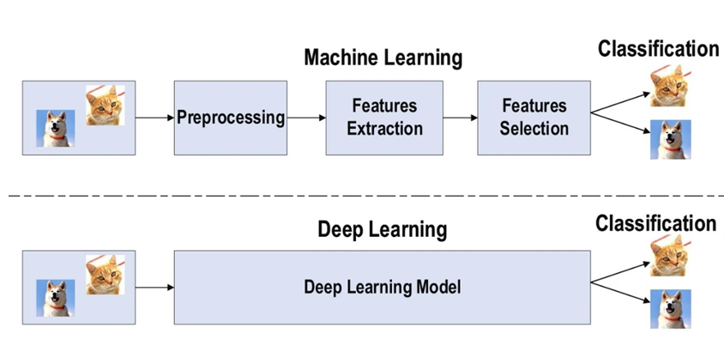

Figure 1.1. The difference between deep learning and traditional machine learning.

The history of deep learning traces back several decades, with roots in the development of artificial neural networks in the 1940s and 1950s. However, it wasn’t until the early 2000s that deep learning experienced a resurgence, fueled by advancements in computational power, the availability of large-scale datasets, and breakthroughs in algorithmic innovation. Key mile stones include the introduction of deep belief networks by Geoffrey Hinton and colleagues in the mid-2000s, which laid the groundwork for training deep neural networks layer by layer using unsupervised learning techniques. This approach, along with the development of efficient optimization algorithms like stochastic gradient descent, paved the way for the modern era of deep learning.

One of the most influential architectural innovations within deep learning is the CNN (Convolutional Neural Network), which has revolutionized the field of computer vision. CNNs are specifically designed to process grid-like data, such as images, by employing layers of convolutional filters that extract spatial features hierarchically. Through operations like convolution, pooling, and non-linear activation, CNNs can automatically learn to recognize patterns, edges, and textures, enabling tasks like image classification, object detection, and image segmentation with unprecedented accuracy and efficiency. The advent of CNNs, exemplified by seminal works like AlexNet and ResNet, has propelled advancements in fields ranging from autonomous vehicles to medical imaging diagnostics.

In parallel, Recurrent Neural Networks (RNNs) have emerged as powerful tools for processing sequential data, such as time series, speech, and text. Unlike feedforward neural networks, RNNs possess recurrent connections that Figure 1. The difference between deep learning and traditional machine learning allow them to maintain an internal state or memory, enabling them to capture temporal dependencies and context across sequential inputs. Early RNN architectures faced challenges like the vanishing gradient problem, which hindered their ability to learn long-range dependencies. However, innovations like Long Short-Term Memory (LSTM) and Gated Recurrent Unit (GRU) architectures have addressed these issues, making RNNs highly effective in tasks such as language modeling, machine translation, and sentiment analysis.

The combined capabilities of CNNs and RNNs have catalyzed trans formative advancements across a myriad of domains, including healthcare, f inance, natural language processing, and robotics. By harnessing the power of deep learning, researchers and practitioners are pushing the boundaries of what’s possible, creating intelligent systems that can perceive, understand, and interact with the world in increasingly sophisticated ways.

### 1.1.2. Object Detection

Object detection is a computer technology related to computer vision and image processing that focuses on detecting instances of semantic objects of a certain class (such as humans, buildings, or cars) in digital images and videos. The goal of object detection is to develop computational models and techniques that answer one of the most fundamental questions needed by computer vision applications: What objects are present, and where are they located? The two most significant metrics for object detection are accuracy (including classification accuracy and localization accuracy) and speed. Figure 1.2. illustrates an example of an object detection task where objects such as buildings, vehicles, humans, bags, etc., can be detected and classified.

Well-researched domains of object detection include multi-categories detection, edge detection, salient object detection, pose detection, scene text detection, face detection, and pedestrian detection, etc.

Object detection serves as a basis for many other computer vision tasks, such as instance segmentation, image captioning, object tracking, etc. In recent years, the rapid development of deep learning techniques has greatly promoted the progress of object detection, leading to remarkable breakthroughs and propelling it to a research hot spot with unprecedented attention. Object detection has now been widely used in many real-world applications, such as autonomous driving, robot vision, video surveillance, etc.

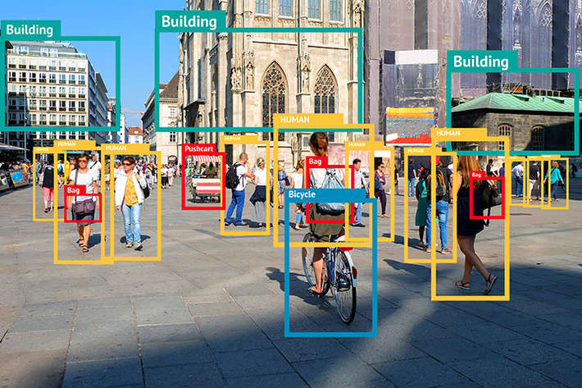

Figure 1.2. Example of object detection

Among many factors and efforts that lead to the fast evolution of object detection techniques, notable contributions should be attributed to the development of deep convolution neural networks and GPUs computing power.At present, deep learning model has been widely adopted in the whole field of computer vision, including general object detection and domain-specific object detection. Most of the state-of-the-art object detectors utilize deep learning networks as their backbone and detection network to extract features from input images (or videos), classification and localization respectively.

As different detection tasks have totally different objectives and constraints, their difficulties may vary from each other. In addition to some common challenges in other computer vision tasks, such as objects under different viewpoints, illuminations, and intraclass variations, the challenges in object detection include but are not limited to the following aspects: object rotation and scale changes (e.g., small objects), accurate object localization, dense and occluded object detection, speedup of detection, etc. Excerpt from page 1 [5].

## 1.2. UAVs and Object Detection in Images Captured by UAVs

### 1.2.1. UAVs for Object Detection

#### 1.2.1.1. Classification of UAVs

Different criteria can be used to categorize UAVs, such as lift system, payload weight, size, maximum takeoff weight, operational range, operational altitude (above ground level), endurance, operational conditions, or autonomy level. Excerpt from page 2 [12].

Based on the lift system, they can be divided into several types, such as lighter-than-air UAVs, fixed-wing UAVs, rotary-wing UAVs, flapping-wing UAVs, etc.

Fixed-wing UAVs and rotary-wing UAVs are the most common ones. Fixed-wing UAVs have the advantages of fast speed, long range, and large payload, but they require large landing sites and auxiliary equipment.

Rotary-wing UAVs have the ability to hover and take off vertically. They are suitable for low-altitude and complex terrain flight but have shorter range and endurance. Rotary-wing UAVs are the widely used type of UAVs in military and civilian applications, and the commontypes include helicopter-type and multi-rotor-type.

Helicopter-type UAVs have large payloads and high flexibility, but the disadvantages are that the mechanical structure is more complex than multi-rotor, the operation difficulty is high, and the maintenance cost is high.

Multi-rotor UAVs, capable of vertical takeoff, landing, and hovering, are particularly suited for missions requiring low-altitude operations and stationary flight. At present, multi-rotor UAVs have become the main type of object detection research and are widely used in environmental protection, precision agriculture, and disaster rescue.

#### 1.2.1.2. Developments of UAVs

These UAVs develop fast because they are relatively cheap and have the ability to take pictures simply. UAVs can carry high-resolution cameras or other sensors, obtaining clearer and richer object information. Compared with orbital and other aerial sensing acquisition methods, UAV platforms can perform object detection in high-altitude or hazardous areas, avoiding the risk of casualties and cost expenditure. Therefore, UAV-based image acquisition systems are very popular in commercial and scientific exploration. However, visual inspection of objects by UAVs is still biased, inaccurate, and time-consuming.

Currently, the real challenge regarding remote sensing methods is to automate the process of obtaining fast and accurate information from data, where detecting objects from UAV images is one of the key tasks. UAV images for object detection are classified based on flight altitude and application areas at different altitudes: (1) eye-level view: this category, at altitudes between 0 and 5 m, is optimal for ground-level observations. (2) Low and medium height: 5-120 m. It represents the gap between most commercial and industrial applications. (3) Aerial imaging: higher than 120 m, this category is synonymous with high-altitude data capture and often requires special permissions.

#### 1.2.1.3. Characteristics of UAVs

Figure 1.3 shows the classification of UAVs in present use through statistical analysis. From the perspective of power supply, battery power is used more often than fuel power; for the aerodynamic shape, multi-rotor is more common than fixed-wing; for the weight of the aircraft, the majority is under 30 kilograms, which is considered small light UAV; and the flight time for most UAVs is less than 1 hour. The quantitative analysis results show that small light UAVs have become the main type used for study and application, and have more market weight. In addition, the “Small light UAV remote sensing development report” published in 2016 shows that China has more than 3,000 professional small light UAVs for remote sensing applications. This type of UAV exhibits the following five main characteristics. Excerpt from page 3 [12].

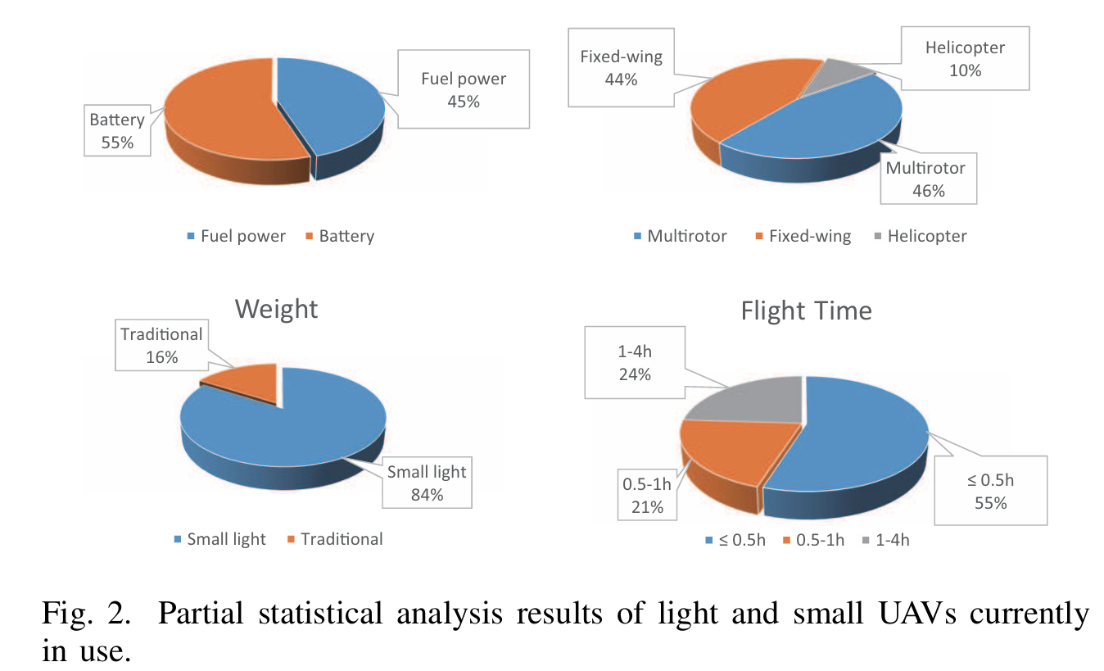

Figure 1.3. Partial statistical analysis results of light and small UAVs currently in use

1) Long flight time. As new energy technology, energy management technology, and lightweight composite material research technology have developed, UAV flight time has been continuously extended.

2) Low comprehensive cost and high technical content. On the one hand, the use of low-cost and lightweight materials reduces the production cost of UAV and remote sensors. On the other hand, the increase of mass users promotes the mass production of components and structural parts, further reducing the production cost of UAV and remote sensors.

3) Small, light-weight, diversified remote sensing cameras. All remote sensing loads on small light UAVs are developed to below 30 kilograms, and optical and infrared loads are even reduced to less than a half kilogram. In addition, multi angle photography, tilt photography, sensor integration, hy perspectral imaging interference, and other technologies have been used in UAV remote sensing. Commercial high end cameras have been widely used for professional aerial missions, and popular cameras are used for mass entertainment and general applications.

4) Real-time data transmission. Advances in wireless com munication and information compression technology have powerfully impelled image resolution with a higher data rate and longer transmission distance. Almost no-delay data link transmission makes real-time observation possible.

#### 1.2.1.4. UAV Sensors for Object Detection

UAV sensors are various devices that can measure the motion state, position infor mation, and environmental parameters of UAVs. They are important components for achieving autonomous flight and mission execution. The use of UAVs depends on various factors, such as payload capacity, size, cost, safety, environment, redundancy level, and autonomy level. Excerpt from page 3 [8].

According to different measurement principles and functions, we will only introduce four sensor technologies that are important for UAV object detection:

**Visual sensors:** A visual sensor is a device that uses photoelectric sensors to obtain images of objects. From the image, state information such as location and speed of the object can be calculated. The more important thing for visual sensors is the processing algorithm. Recently, the development of deep learning algorithms has brought more extensive applications to visual sensors.

**Ultrasonic sensor:** Ultrasonic waves are sound waves that exceed the upper limit of humanhearing frequency. Due to their good directivity and strong penetration, they are widely used for distance and speed measurement. The ultrasonic sensor emits a signal that is reflected by the object and then received by another ultrasonic sensor. An ultrasonic sensor is generally cheap, but its drawbacks include a low data update rate and a limited measurement range.

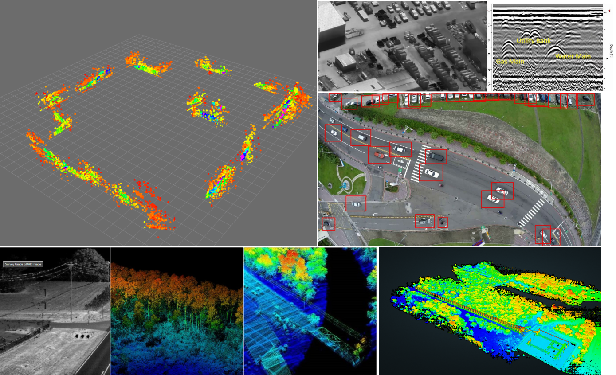

Figure 1.4. Data captured by different sensors

**Laser sensor:** The principle of the laser sensor is basically the same as the ultrasonic sensor, except for the different emitted signal. A laser source is emitted by the laser ranging sensor at the speed of light, which makes the signal frequency much higher than the ultrasonic sensor. Its disadvantages are high price, small measurement range, and the ability to scan.

**Ground-penetrating radar:** Ground-penetrating radar (GPR) is a popular nondestruc tive testing technique for object detection and imaging in geological surveys. Fast and accurate object detection on the surface can reduce computation time and hardware re quirements.

**Thermal imager:** A thermal imager is a device that can convert invisible infrared radiation into visible images. It can detect the temperature distribution and thermal anomalies of objects in dark or harsh environments.

### 1.2.2. Applications of Object Recognition in UAV Images

The versatility of object detection algorithms has led to their widespread adoption across a broad range of applications, particularly in conjunction with UAV technology. The ability to automatically detect and analyze objects from aerial images has opened up new possibilities in various fields, transforming how we monitor, manage, and interact with our environment. Excerpt from page 3 [12].

**1) Environmental Monitoring:** One of the most significant applications of UAV-based object detection is in environmental monitoring. UAVs equipped with object detection capabilities can efficiently survey large areas to identify and track changes in the environment. This includes monitoring deforestation, tracking wildlife populations, assessing the health of crops, and detecting illegal activities such as poaching or logging. By providing real-time data, UAVs help environmental agencies and conservationists make informed decisions and take timely action to protect ecosystems.

**2) Precision Agriculture:** In agriculture, UAVs play a critical role in precision farming, where they are used to monitor crop health, assess soil conditions, and optimize irrigation and fertilization practices. Object detection algorithms can identify specific crop types, detect signs of disease or pest infestation, and even count plants. This information enables farmers to manage their fields more effectively, reduce waste, and increase crop yields.

**3) Disaster Management:** In the wake of natural disasters such as earthquakes, floods, or hurricanes, UAVs equipped with object detection systems can quickly assess the extent of damage, identify survivors, and locate critical infrastructure. Object detection helps in mapping affected areas, detecting debris, and prioritizing rescue and relief efforts. This rapid assessment capability is crucial for saving lives and coordinating emergency response operations.

**4) Urban Planning and Management:** UAV-based object detection is increasingly being used in urban planning and management. By analyzing aerial images, city planners can monitor construction sites, assess the impact of urban development on the environment, and manage traffic flow. Object detection can also be used to track the growth of informal settlements, ensuring that urban expansion is managed in a sustainable and organized manner.

**5) Security and Surveillance:** In security and surveillance, UAVs equipped with object detection systems are used to monitor large areas for potential threats. This includes detecting unauthorized vehicles, tracking individuals, and identifying suspicious activities in real-time. In military applications, UAVs can be deployed for reconnaissance missions, where they detect and track enemy assets or monitor borders for illegal crossings.

**6) Traffic Monitoring and Management:** Traffic monitoring is another key application of UAV-based object detection. UAVs can be deployed over highways and urban areas to monitor traffic flow, detect accidents, and identify traffic violations. This data can be used to optimize traffic light timings, reroute traffic to avoid congestion, and improve overall traffic management. Additionally, in emergency situations, UAVs can quickly provide an overview of traffic conditions, enabling faster and more effective responses.

**7) Search and Rescue Operations:** UAVs equipped with object detection algorithms are invaluable in search and rescue missions, particularly in challenging environments such as mountains, forests, or oceans. These UAVs can cover vast areas quickly, detecting missing persons or vehicles and transmitting their location to rescue teams. Object detection can be enhanced with thermal imaging to detect heat signatures, making it possible to locate individuals even in low-visibility conditions.

**8) Wildlife Conservation:** In the field of wildlife conservation, UAVs are used to monitor animal populations, track migration patterns, and protect endangered species. Object detection algorithms can identify individual animals or herds, estimate population sizes, and detect poachers. This technology is crucial for conservationists working in remote or difficult-to-access areas, providing them with the data needed to protect vulnerable species and their habitats.

**9) Infrastructure Inspection:** UAVs with object detection capabilities are increasingly used for inspecting critical infrastructure, such as bridges, pipelines, and power lines. Object detection can identify structural defects, corrosion, or other signs of wear and tear, enabling maintenance teams to address issues before they lead to failures. This application is particularly valuable in industries where regular, thorough inspections are necessary for safety and operational efficiency.

**10) Real Estate and Property Management:** In the real estate sector, UAVs are used to survey properties, providing detailed aerial views that can be analyzed using object detection algorithms. This allows for the accurate assessment of property boundaries, the identification of amenities, and the detection of unauthorized structures. For property management, UAVs can monitor large estates or commercial properties, ensuring that maintenance issues are promptly identified and addressed.

The applications of UAV-based object detection are vast and continually expanding as technology advances. As deep learning algorithms become more sophisticated and UAV platforms more accessible, the potential for innovation in these areas will continue to grow, offering new solutions to some of the most pressing challenges in our society.

### 1.2.3. Challenges of Object Recognition in UAV Images

The object detection task in UAV remote sensing images faces many challenges, such as object rotation, complex background, an increase in small object issues, low detection efficiency caused by scale changes, and sparse and uneven distribution of object categories. Detailed explanations of the different challenges are as follows:

**Image degradation problem:** The load that a mini-UAV platform carries is strictly limited in terms of weight, volume, and power. Rapid movement changes in the external environment (such as light, cloud, fog, rain, etc.) cause aerial images to be fuzzy and noisy, which inevitably leads to image degradation. In addition, high-speed f light or camera rotation also increases the complexity of object detection. Thus, it is necessary to carry out image pre-processing, such as noise reduction, camera distortion correction, etc., to ensure the effectiveness of the object detection model. Excerpt from page 4 [12].

**Uneven object intensity problem:** The image acquisition equipment of a UAV typically uses a large aperture, fixed focal, and wide-angle lens. In addition, flexible camera movement results in an uneven density of captured objects. Some of them are densely arranged and overlap many times, so that it is easy to repeat detection. Some are sparse and unevenly distributed, so that it is prone to missed detection. In addition, most objects occupy a small number of pixels, which makes it difficult to separate them from their surroundings.

**Small objects increasing problem:** The scale range of objects in UAV images is large. Buildings, pedestrians, mountains, and animals often appear in the same image. Small objects have a very small proportion in the image, which makes detection difficult. The multiscale feature fusion method can effectively solve the problem of small objects increasing by detecting objects of different sizes through different levels of features. Excerpt from page 5 [12].

**Background complexity problem:** The dense object areas in UAV images contain many identical items, which increases the probability of false detection. In addition, a large amount of noise information in the background of UAV images can also weaken or obscure the object, making it difficult to detect continuously and completely. In order to im prove detection accuracy and robustness in the complex background, attention mechanisms and graph neural networks can be used to enhance the relationships between objects.

**Category imbalance problem:** The objects in the images captured by UAVs may have category imbalance problems, such as having a large number of objects in one category and a small number of objects in the other category, resulting in the detector leaning towards predicting categories with a large number. Generative adversarial networks or autoencoders can be used to enhance data diversity and quality, which will alleviate issues regarding data imbalance and noise.

**Object rotation problem:** In UAV images, objects can appear in any position and direction. Traditional object detection algorithms usually assume that the object is horizontal, but, in UAV images, the object may be rotated at any angle. In addition, rotating objects may change their shape and appearance in the image, which makes the object detection algorithm based on shape and appearance not work accurately. Use a rotation box or polygon box to represent the object that can adapt to any angle of the object. Excerpt from page 7 [12].

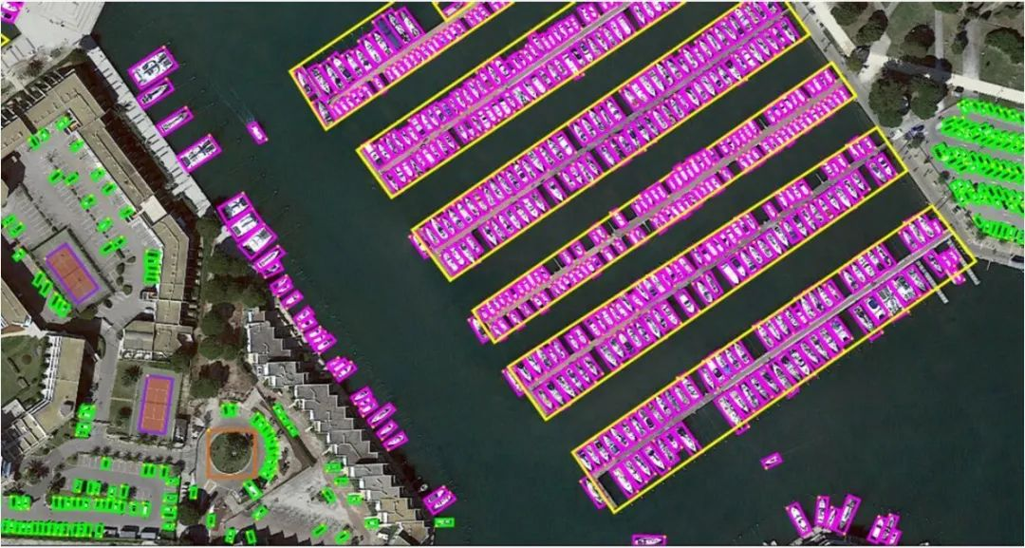

Figure 1.5. Example of Object rotation problem in UAV object detection

**Adverse illumination and diverse weather conditions:** Due to the strict limitations on weight, size, and power of mini-UAV platforms, rapid changes in the external environment (such as light, clouds, fog, rain, etc.) can cause aerial images to become blurry and noisy. This leads to image degradation, reducing the performance of object detection models. Additionally, high-speed flight or camera rotation further complicates object detection tasks. To ensure the effectiveness of the detection models, image preprocessing is necessary, including noise reduction and camera distortion correction, to enhance the clarity and accuracy of object detection in UAV images.

**Real-time problem:** Object detection or tracking in a video obtained by a drone needs to quickly and accurately locate moving ground objects, so real-time processing performance is highly essential.

## 1.3. Infrared and RGB Images

### 1.3.1. Visible light and visible imaging

Visible light is a subset of the electromagnetic spectrum, which in cludes all forms of electromagnetic radiation, ranging from gamma rays to radio waves. Visible light occupies a specific band within this spectrum, with wavelengths ranging from approximately 400 to 700 nanometers. These wavelengths correspond to the colors we perceive in the world around us: violet, blue, green, yellow, orange, and red. Each color is associated with a particular wavelength, with shorter wavelengths appearing violet and longer wavelengths appearing red. The interaction of visible light with objects is governed by principles of reflection, absorption, and transmission. When light strikes an object, it can be reflected off the surface, absorbed by the material, or transmitted through it. The wavelengths of light that are reflected or transmitted determine the color of the object as perceived by an observer. For example, a red apple appears red because it absorbs most wavelengths of visible light and reflects primarily red wavelengths.

Visible imaging harnesses the properties of visible light to capture and convey visual information. Cameras and imaging devices utilize lenses or optical systems to focus incoming light onto photosensitive surfaces, such as film or digital sensors. Excerpt from page 3 [16]. These surfaces record the intensity and color of light at each point in the scene, effectively translating the three-dimensional world into a two-dimensional image. Visible imaging finds applications across various fields, from photography and cinematography to scientific research and surveillance. Its versatility and accessibility make it an indispensable tool for documenting, exploring, and understanding the world around us, offer ing insights into realms both familiar and unseen. Through visible imaging, we can preserve memories, document discoveries, and share experiences, enriching our understanding of the human experience and the wonders of the universe. Figure 1.6. a) present some examples of images captured by UAV.

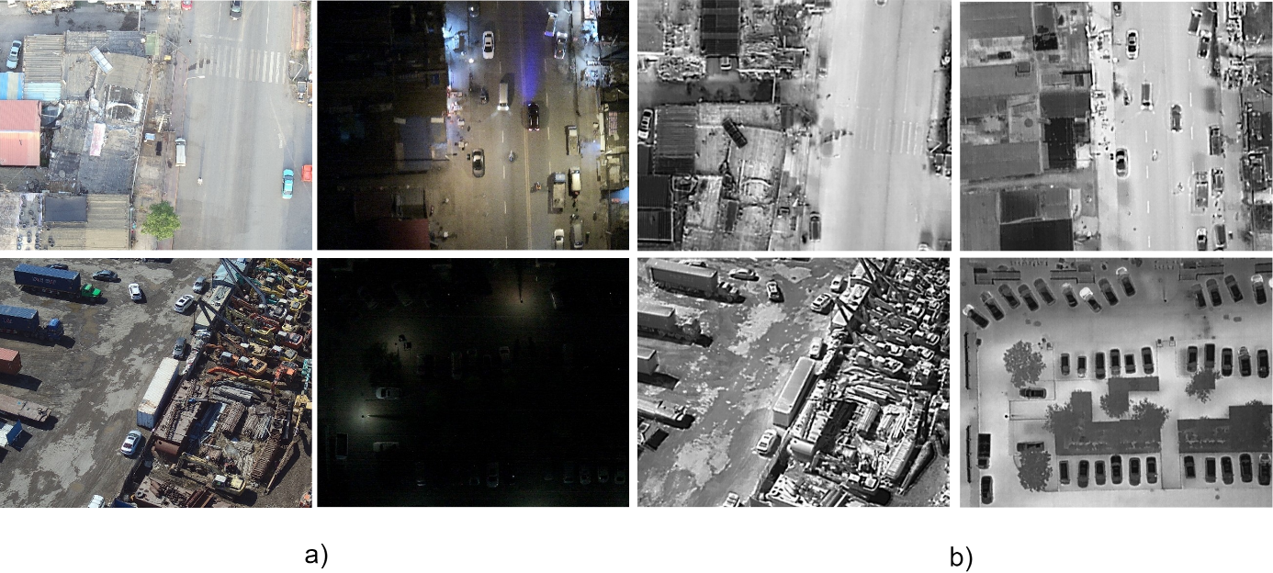

Figure 1.6. Example of RGB images (a) and Infrared images (b) captured by UAV

### 1.3.2. Infrared light and infrared imaging

Infrared light exists just beyond the visible spectrum, with wavelengths longer than those of visible light, typically ranging from around 700 nanometers to 1 millimeter. Excerpt from page 2 [16]. While invisible to the human eye, infrared radiation is present in various forms in our environment, emitted by objects and mate rials as a result of their temperature. This thermal radiation is fundamental to concepts like heat transfer and thermal imaging. Infrared light is divided into three categories: near-infrared, mid-infrared, and far-infrared, each with distinct applications and properties. Near-infrared is often used in communication, sensing, and spectroscopy, while mid-infrared and far-infrared find applications in thermal imaging, remote sensing, and astronomy.

Infrared imaging, also known as thermal imaging or infrared thermography, is a technology that captures and visualizes infrared radiation emitted by objects and surfaces. Infrared cameras utilize specialized sensors that detect infrared radiation and convert it into electronic signals, which are then processed to generate images. These images represent variations in temperature across the scene, with warmer areas appearing brighter and cooler areas appearing darker. Infrared imaging enables the visualization of thermal patterns that are invisible to the naked eye, allowing users to detect anomalies, identify sources of heat or cold, and assess the condition of materials and structures.

Advancements in infrared imaging technology have led to the development of increasingly compact, sensitive, and high-resolution infrared cameras. These cameras offer improved performance and versatility across a wide range of applications, from industrial maintenance and scientific research to military reconnaissance and environmental monitoring. As infrared imaging continues to evolve, it promises to unlock new capabilities and insights, en abling us to explore and understand the world in ways that were previously inaccessible.

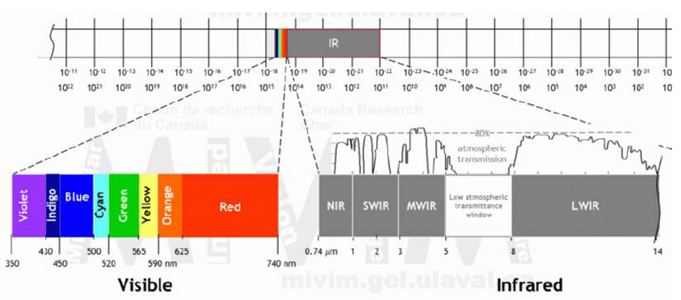

Figure 1.7. Electromagnetic spectrum showing the visible and infrared wavelength intervals.

In recent years, there has been growing interest in integrating visible and infrared imaging modalities to improve the capabilities of computer vision systems, particularly in tasks such as object detection, recognition, and tracking. Combining visible and infrared images can provide richer contextual information and enhance the robustness of vision systems, especially in challenging environments with varying lighting conditions and weather con ditions. However, effectively integrating information from both modalities poses technical challenges, including differences in resolution, noise charac teristics, and sensor calibration. Figure 6. b) is an example of some infrared images captured by a UAV, showing that they are not affected by low ambient light conditions.

Deep learning techniques have shown promise in addressing these challenges by automatically learning features from multi-modal data and effectively fusing information for improved performance. CNNs and other deep learning architectures have been successfully applied to tasks such as multi modal image fusion, cross-modal retrieval, and object detection in visible and infrared images. By leveraging the complementary strengths of visible and infrared imaging modalities, researchers aim to develop more robust and versatile computer vision systems capable of operating effectively in diverse real-world scenarios.

## 1.4. Conclusion

This chapter has provided an overview of the field of deep learning and the object detection problem, while also highlighting the characteristics of UAVs and the applications and challenges of object detection in UAV imagery. It serves as a foundational introduction to the subsequent chapters, which delve into the research on methods to solve the problem and address its challenges.

# Chapter 2 UAV-BASED OBJECT DETECTION METHODS

Chapter 2 will present the methods of object recognition. It provides an in-depth exploration of the technology and methods used for the object recognition problem. The chapter outlines the evolution of speaker recognition methods, from traditional machine learning approaches to modern deep learning techniques. It discusses the key components, including certain main elements such as feature representation and classification techniques. Furthermore, this section also covers studies related to the object recognition problem and UAV image recognition both domestically and globally, discussing how these methods address various issues in the UAV image object recognition problem. This chapter is considered a comprehensive guide to the diverse approaches employed in object detection.

## 2.1. Object Detection Development Process

The development of object detection algorithms can be divided into two stages: traditional object detection algorithms and deep-learning-based object detection algorithms. Deep-learning-based object detection algorithms are further divided into two main technical routes: one-stage and two-stage algorithms. Figure 2.1 shows the development of object detection from 2001 to 2023.

Traditional object detection algorithms are mainly based on sliding window and artificial feature extraction methods, which generally consist of three steps: region proposal, feature extraction, and classification regression. The region proposal is to obtain the regions of interest where the object may be located. In the feature extraction process, artificial feature extraction methods are utilized to transform images in candidate regions into feature vectors. Finally, the classifier classifies objects according to the extracted features. These algorithms have the disadvantages of high computational complexity, weak feature representation ability, and difficulty in optimization. Representative algorithms include the Viola–Jones detector, the HOG pedestrian detector, etc. Excerpt from page 5 [8].

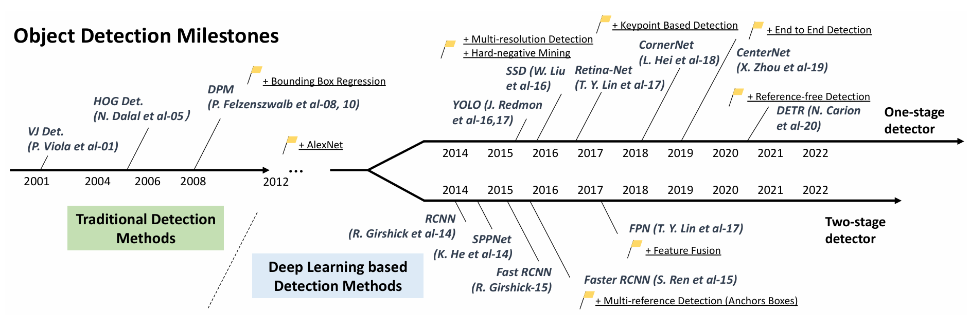

Figure 2.1. The development of object detection from 2001 to 2023

In 2012, with the rise of neural networks (convolutional neural network, CNN), object detection developed fast. Deep neural networks are mainly used in deep-learning-based object detection algorithms to automatically extract high-level features from input images and classify objects. These algorithms have the advantages of fast speed, high accuracy, and strong robustness. In addition, the two-stage detector only processes the content of region proposals in the second stage, which results in the loss of position information of the object in the entire image.

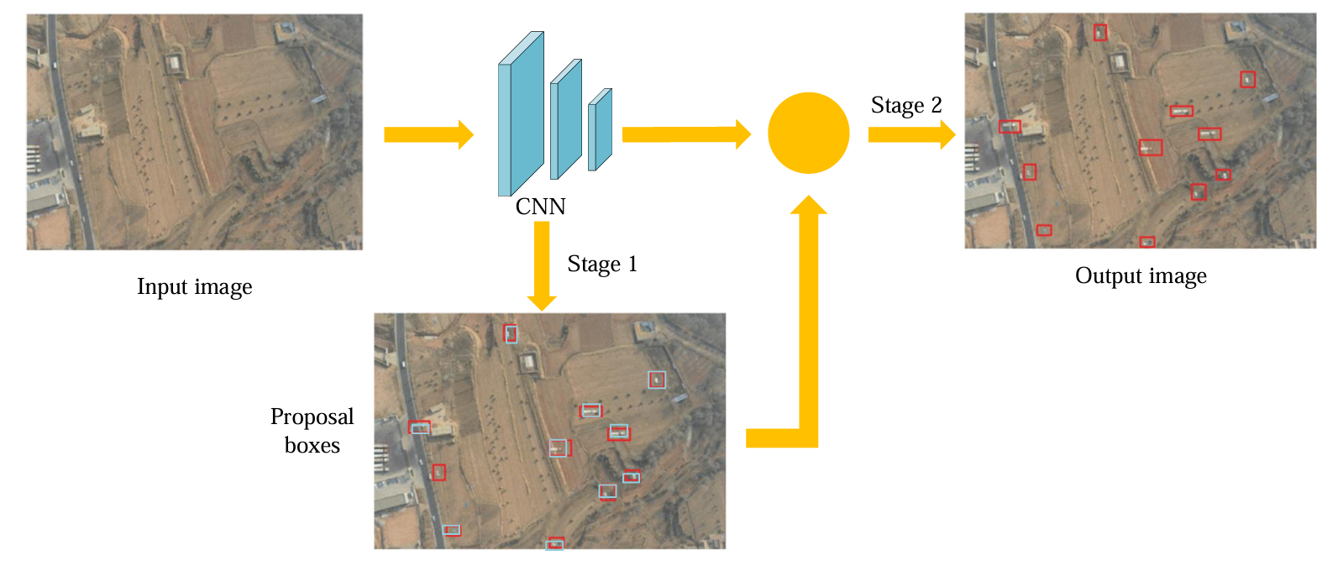

Figure 2.2. Two-stage object detection framework

As shown in Figure 2.2, the two-stage object detection framework solves the problems of boundary object detection, inaccurate localization, and multiscale object. These algorithms generate proposal regions in the first stage and perform classification and regression on the contents in the regions of interest in the second stage. These algorithms usually have high accuracy but low speed. Representative algorithms include R-CNN (Region-based CNN), SPP-Net, Fast R-CNN, Faster R-CNN, etc. Excerpt from page 5 [8].

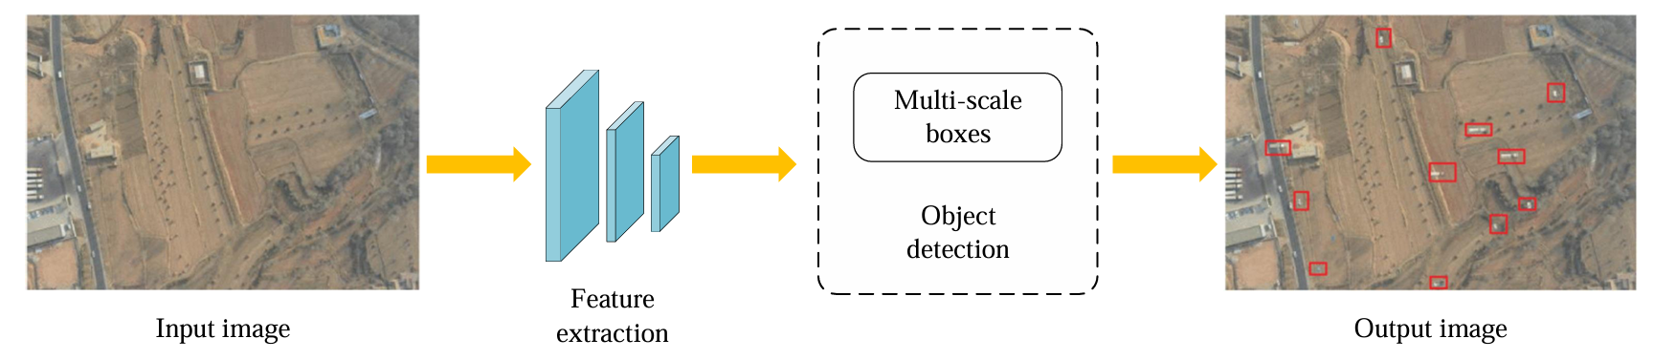

Figure 2.3. One-stage object detection framework

Due to the fact that two-stage detectors need two stages to perform detection, the first stage generates many proposal regions, resulting in large computation and low speed, which is not suitable for real-time scenarios. One-stage detectors solve these problems, and their framework is shown in Figure 2.3. One-stage object detection algorithms directly generate location and category from the image, removing the process of proposal region, thus having faster speed. However, one-stage object detection algorithms are susceptible to incorrect detection in localizing and detecting small objects due to the high number of densely generated region proposals. In addition, the classification and regression branches of one-stage methods are usually simple and difficult to capture the detailed features of the target, leading to unstable detection performance. Representative algorithms include SSD, Yolo series, etc.

## 2.2. Traditional methods for object detection.

In traditional methods, we can consider object detectors as a combination of two key building blocks: a feature extraction algorithm that encodes image regions as descriptors, and a classifier that decides upon the class label of subregions in the image based on the feature representation. In other words the first task is finding an informative representation for describing image regions, i.e. feature vectors or descriptors. After feature extraction, apply a machine learning algorithm to classify image regions for determining the presence of certain objects. As is typical in machine learning problems there are two fundamental questions underlying this problem.

### 2.2.1. Traditional pipeline

The high-level detection pipeline as described in this subsection is summarized in Figure 2.4. Excerpt from page 8 [4].

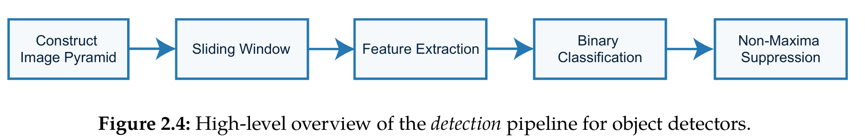

Figure 2.4. High-level overview of the detection pipeline for object detectors

For detecting objects at all positions in an image a commonly adopted detection and localization approach is the sliding-window technique. Moving across the image the sliding-window scans the image by feeding the descriptors of each subwindow to the classifier. The specified sliding-window step size at which the detector scans across the image is an important parameter influencing both speed and detection rate. Subwindows classified as positive are saved as object detections characterized by the position in the image and classifier score. Since the total number of possible subwindows is vast, the sliding-window is generally applied with a certain stride or step size, e.g. 4 or 8 pixels. Consider the scenario where we want to perform object detection in an image of 800×600, a trained template of 64 × 64 and a step size of 4 pixels. This already results in 24.656 subwindows that need to be processed by the classifier for a single image over one scale.

**Sliding-windows** are designed for object detection at all locations in an image, however in practice objects generally do not appear at the same size and aspect ratio as the trained template. Since the sliding template is trained at a fixed size it can only detect objects of this particular size. To overcome this problem the traditional detection pipeline includes **construction of the image pyramid** by rescaling the input image several times. Aside from actual feature extraction and classification, the construction of the image pyramid is a computationally expensive task and can take more than a second on a modern desktop computer. After constructing the image pyramid, multiscale object detections at all locations and scales can be achieved by applying the sliding-window to each level of the pyramid. This process is illustrated in Figure 2.5. Not surprisingly the the number of subwindows proposed to the classifier rapidly grows with the multiscale analysis over all levels in the image pyramid.

**Feature extraction**. To recognize different objects, we need to extract visual features which can provide a semantic and robust representation. SIFT, HOG and Haar-like features are the representative ones. This is due to the fact that these features can produce representations associated with complex cells in human brain. However, due to the diversity of appearances, illumination conditions and backgrounds, it’s difficult to manually design a robust feature descriptor to perfectly describe all kinds of objects.

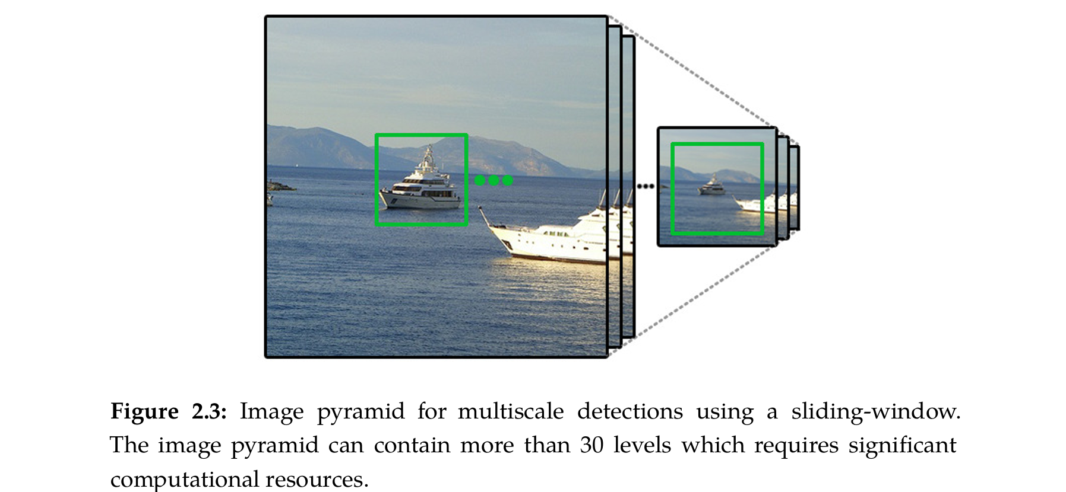

Figure 2.5 Image pyramid for the multiscale detections using a sliding window. The image pyramid can contain more than 30 levels which requires significant computational resources

**Classification** of all subwindows encountered by the sliding-window over all scales in the pyramid typically results in a list of object proposals comprising of a bounding box and detection score. Since detections are made over a large number of adjacent scales and locations each object is typically detected multiple times at slightly different size and position. The last step in the detection process is to group nearby detections so that every object is only detected once, i.e. **non-maxima suppression (NMS)**. Simple NMS algorithms are straightforward and group together overlapping detections and only maintain the detection with the highest detection score.

### 2.2.2. Traditional detectors

If we consider to day’s object detection technique as a revolution driven by deep learning, then back in the 1990s, we would see the ingenious design and long-term perspective of early computer vision. Most of the early object detection algorithms were built based on handcrafted features. Due to the lack of effective image representation at that time, people have to design sophisticated feature representations and a variety of speed-up skills.

**Viola Jones Detectors:** In 2001, P. Viola and M. Jones achieved real-time detection of human faces for the first time without any constraints (e.g., skin color segmentation). Running on a 700MHz Pentium III CPU, the detector was tens or even hundreds of times faster than other algorithms in its time under comparable detection accuracy. The VJ detector follows a most straightforward way of detection, i.e., sliding windows: to go through all possible locations and scales in an image to see if any window contains a human face. Although it seems to be a very simple process, the calculation behind it was far beyond the computer’s power of its time. The VJ detector has dramatically improved its detection speed by incorporating three important techniques: “integral image”, “feature selection”, and “detection cascades”. Excerpt from page 6 [8].

**HOG Detector:** In 2005, N. Dalal and B. Triggs proposed Histogram of Oriented Gradients (HOG) feature descriptor. HOG can be considered as an important improvement of the scale-invariant feature transform and shape contexts of its time. To balance the feature invariance (including translation, scale, illumination, etc) and the nonlin earity, the HOG descriptor is designed to be computed on a dense grid of uniformly spaced cells and use overlapping local contrast normalization (on “blocks”). Although HOG can be used to detect a variety of object classes, it was motivated primarily by the problem of pedestrian detection. To detect objects of different sizes, the HOG detector rescales the input image for multiple times while keeping the size of a detection window unchanged. The HOG detector has been an important foundation of many object detectors and a large variety of computer vision applications for many years.

**Deformable Part-based Model (DPM):** DPM, as the winners of VOC-07,-08, and-09 detection challenges, was the epitome of the traditional object detection methods. DPM was originally proposed by P. Felzenszwalb in 2008 as an extension of the HOG detector. It follows the detection philosophy of “divide and conquer”, where the training can be simply considered as the learning of a proper way of decomposing an object, and the inference can be considered as an ensemble of detections on different object parts. For example, the problem of detecting a “car” can be decomposed to the detection of its window, body, and wheels. This part of the work, a.k.a. “star-model”, was introduced by P. Felzenszwalb et al. Later on, R. Girshick has further extended the star model to the “mixture models” to deal with the objects in the real world under more significant variations and has made a series of other improvements. Although today’s object detectors have far surpassed DPM in detection accuracy, many of them are still deeply influenced by its valuable insights, e.g., mixture models, hard negative mining, bounding box regression, context priming, etc. In 2010, P. Felzenszwalb and R. Girshick were awarded the “lifetime achievement” by PASCAL VOC. Excerpt from page 6 [8].

## 2.3. Deep learning methods for object detection

### 2.3.1. One-stage object detection methods

Most of the two-stage detectors follow a coarse-to-fine processing paradigm. The coarses trives to improve recall ability, while the fine refines the localization on the basis of the coarse detection, and places more emphasis on the discriminate ability. They can easily attain a high precision without any bells and whistles, but rarely employed in engineering due to the poor speed and enormous complexity. On the contrary, one stage detectors can retrieve all objects in one-step inference. They are well-liked by mobile devices with real-time and easy deployed features, but their performance suffers noticeably when detecting dense and small objects.

**You Only Look Once (YOLO):** YOLO was proposed by R. Joseph et al. in 2015. It was the first one-stage detector in the deep learning era. YOLO is extremely fast: a fast version of YOLO runs at 155fps with VOC07 mAP=52.7%, while its enhanced version runs at 45 fps with VOC07 mAP=63.4%. YOLO follows a totally different paradigm from two-stage de tectors: to apply a single neural network to the full image. This network divides the image into regions and predicts bounding boxes and probabilities for each region simultaneously. In spite of its great improvement of detection speed, YOLO suffers from a drop of localization accuracy compared with two stage detectors, especially for some small objects. YOLO’s subsequent versions and the latter proposed SSD has paid more attention to this problem. Recently, YOLOv8, a follow-up work from YOLOv5 team, has been proposed. It outperforms most existing object detectors in terms of speed and accuracy (range from 5 FPS to 160 FPS) by introducing optimized structures like dynamic label assignment and model structure reparameterization.

**Single Shot MultiBox Detector (SSD):** SSD was proposed by W. Liu et al. in 2015. The main contribution of SSD is the introduction of the multi-reference and multi resolution detection techniques (to be introduced in Section II-C1), which significantly improves the detection accuracy of a one-stage detector, especially for some small objects. SSD has advantages in terms of both detection speed and accuracy (COCO mAP@.5=46.5%, a fast version runs at 59 fps). The main difference between SSD and previous detectors is that SSD detects objects of different scales on different layers of the network, while the previous ones only run detection on their top layers. Figure 2.6 shows the comparison of Yolo and SSD algorithm structures. Excerpt from page 7 [12].

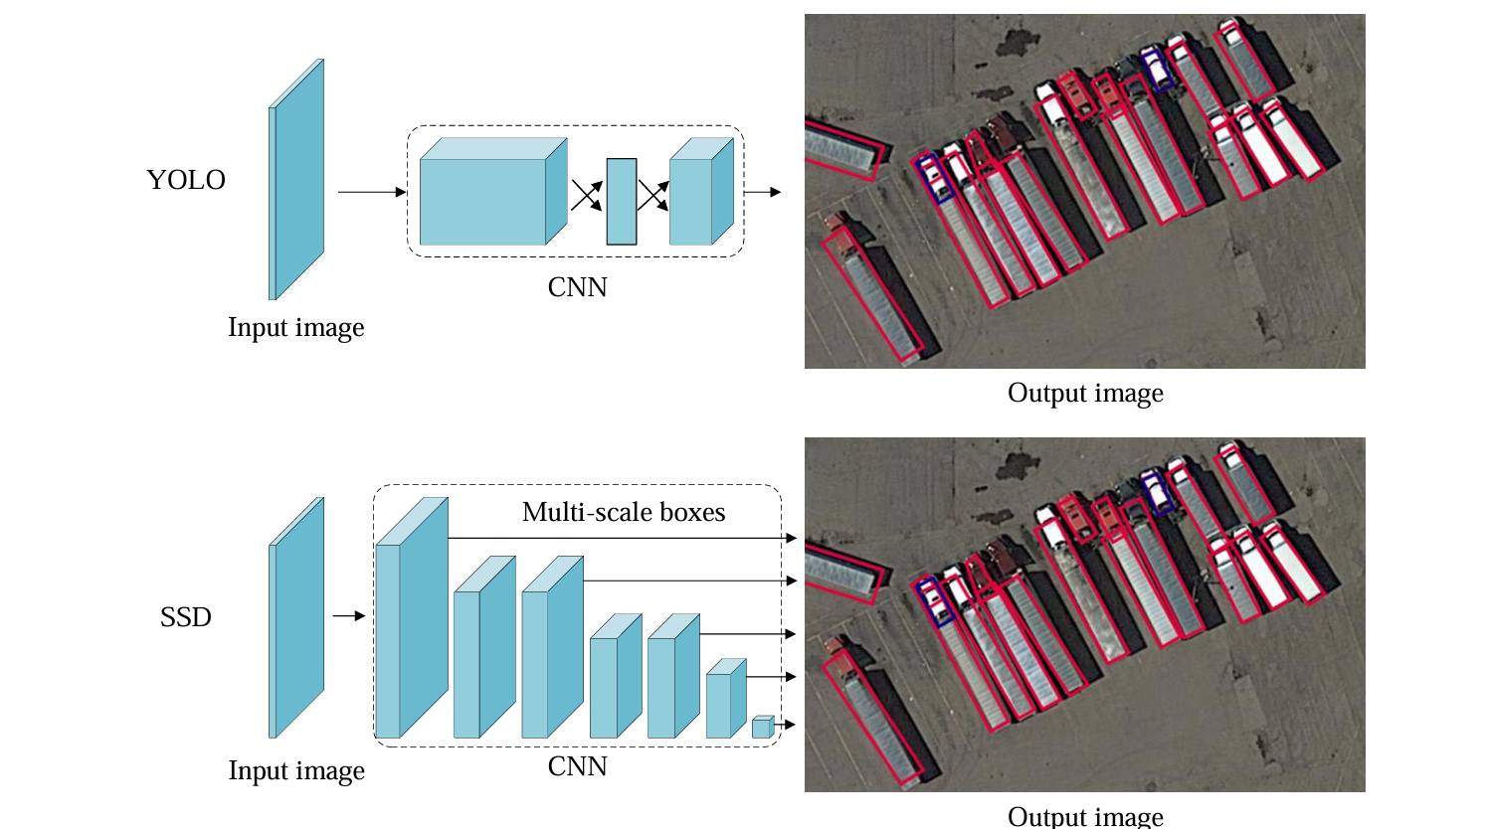

Figure 2.6. The comparison between Yolo and SSD algorithm

**RetinaNet:** Despite its high speed and simplicity, the one stage detectors have trailed the accuracy of two-stage detectors for years. T.-Y. Lin et al. have explored the reasons behind and proposed RetinaNet in 2017. They found that the extreme foreground-background class imbalance encountered during the training of dense detectors is the central cause. To this end, a new loss function named “focal loss” has been introduced in RetinaNet by reshaping the standard cross entropy loss so that detector will put more focus on hard, misclassified examples during training. Focal Loss enables the one-stage detectors to achieve comparable accuracy of two stage detectors while maintaining a very high detection speed (COCO mAP@.5=59.1%).

**CornerNet:** Previous methods primarily used anchor boxes to provide classification and regression references. Objects frequently exhibit variation in terms of number, location, scale, ratio, etc. They have to follow the path of setting up a large number of reference boxes to better match ground truths in order to achieve high performance. However, the network would suffer from further category imbalance, lots of hand-designed hyper-parameters, and a long convergence time. To address these problems, H. Law et al discard the previous detection paradigm, and view the task as a keypoint (corners of a box) prediction problem. After obtaining the key points, it will decouple and re-group the corner points using extra embedding information to form the bounding boxes. CornerNet outperforms most one-stage detectors at that time (COCO mAP@.5=57.8%).

Due to their fast running speed and high detection accuracy, one-stage detectors Yolo and SSD are widely applied. For example, Hossain et al. transferred Yolo and SSD to the embedded device GPU Jetson TX2 to achieve UAV ground object detection and tracking. Lu et al. integrated Yolov5 with shallow feature information, effectively improving the efficiency of UAV marine fishery law enforcement. Marta proposed a method using dense point clouds to estimate obstacle heights and used the Yolo algorithm to detect atypical aviation obstacles. This method achieved the identification and classification of atypical aviation obstacles. Li et al. integrated SSD with a convolutional block attention mechanism (SSD-CBAM) for earthquake disaster building detection. Excerpt from page 8 [12].

In addition to directly applying the original one-stage detectors to multi-object detection under the UAV perspective, many scholars have improved them from various aspects such as network structure optimization, multi-task learning, introducing region-specific contextual information, and integrating multiple networks. The following will mainly introduce the object rotation problem, complex background problem, small object problem, and class imbalance problem in UAV one-stage detection.

### 2.3.2. Two-stage object detection methods

Two-stage UAV object detection is a method that performs classification to determine categories after proposing the regions of interest (ROI). The two-stage method has higher accuracy than the one-stage method because the region of interest is located and classified by the two-stage detector from the first stage. However, the two-stage method takes more time to infer than the one stage method due to extra regions and stage processing. Excerpt from page 7 [5].

**RCNN:** The idea behind RCNN is simple: It starts with the extraction of a set of object proposals (object candidate boxes) by selective search. Then each proposal is rescaled to a fixed size image and fed into a CNN model pretrained on ImageNet (say, AlexNet) to extract features. Finally, linear SVM classifiers are used to predict the presence of an object within each region and to recognize object categories. RCNN yields a significant performance boost on VOC07, with alarge improvement of mean Average Precision (mAP) from 33.7% (DPM-v5) to 58.5%. Although RCNN has made great progress, its drawbacks are obvious: the redundant feature computations on a large number of overlapped proposals (over 2000 boxes from one image) lead to an extremely slow detectionspeed (14s per image with GPU). Later in the same year, SPPNet was proposed and has solved this problem.

**SPPNet:** In 2014, K.Heet al. proposed Spatial Pyramid Pooling Networks (SPPNet). Previous CNN models require a fixed-size input, e.g., a 224x224 image for AlexNet. The main contribution of SPP Net is the introduction of a Spatial Pyramid Pooling (SPP) layer, which enables a CNN to generate a fixed-length representation regardless of the size of the image/region of interest without rescaling it. When using SPPNet for object detection, the featuremaps can be computed from the entire image only once, and then fixed length representations of arbitrary regions can be generated for training the detectors, which avoids repeatedly computing the convolutional features. SPPNet is more than 20 times faster than R-CNN without sacrificing any detection accuracy (VOC07 mAP=59.2%). Although SPPNet has effectively improved the detection speed, it still has some drawbacks: first, the training is still multi-stage, second, SPPNet only fine-tunes its fullyconnected layers while simply ignoring all previous layers. Later in the nextyear, FastRCNN was proposed and solved these problems.

**FastRCNN:** In 2015, R. Girshick proposed the FastRCNN detector, which is a further improvement of R-CNN and SPPNet. FastRCNN enables us to simultaneously train a detector and a bounding box regressor under the same network configurations. On the VOC07 dataset, Fast-RCNN increased the mAP from 58.5% (R-CNN) to 70.0%, while with a detection speed over 200 times faster than R-CNN. Although Fast-RCNN successfully integrates the advantages of R-CNN and SPPNet, its detection speed is still limited by the proposal detection (see Section II-C1 for more details). Then, a question naturally arises: “Can we generate object proposals with a CNN model?” Later, Faster R-CNN answered this question.

**Faster RCNN:** In 2015, S. Ren et al. proposed the Faster RCNN detector shortly after the FastRCNN. Faster RCNN is the first near-real-time deep learning detector (COCO mAP@.5 = 42.7%, VOC07 mAP = 73.2%, 17 fps with ZF-Net). The main contribution of Faster RCNN is the introduction of the Region Proposal Network (RPN) that enables nearly cost-free region proposals. From R-CNN to Faster RCNN, most individual blocks of an object detection system, e.g., proposal detection, feature extraction, bounding box regression, etc., have been gradually integrated into a unified, end-to-end learning framework. Although Faster RCNN breaks through the speed bottleneck of FastRCNN, there is still computation redundancy at the subsequent detection stage. Later on, a variety of improvements have been proposed, including R-FCN and Light-Head RCNN.

**Feature Pyramid Networks (FPN):** In 2017, T.-Y. Lin et al. proposed FPN. Before FPN, most deep learning-based detectors ran detection only on the feature maps of the network's top layer. Although the features in deeper layers of a CNN are beneficial for category recognition, they are not conducive to localizing objects. To address this, a top-down architecture with lateral connections was developed in FPN for building high-level semantics at all scales. Since a CNN naturally forms a feature pyramid through its forward propagation, FPN shows great advances in detecting objects across a wide variety of scales. Using FPN in a basic Faster R-CNN system, it achieved state-of-the-art single-model detection results on the COCO dataset without bells and whistles (COCO mAP@.5 = 59.1%). FPN has now become a basic building block of many of the latest detectors.

## 2.4. Related works

In sections 2.1 to 2.3, we have discussed the development of general object detection algorithms, covering both traditional methods and deep learning methods, including one-stage and two-stage approaches. In this related works section, we will focus on recent studies on object detection in UAV images. These methods will be categorized based on the type of problems they aim to address in UAV image object detection, as mentioned in the upcoming section. This section also serves as a foundation for our in-depth research into the methods in Chapter 3 and Chapter 4.

### 2.4.1. Deep learning for object detection in RGB images

Research in deep learning for UAV-based object detection has experienced notable advancements in recent years, propelled by the increasing demand for autonomous systems and aerial surveillance applications. Studies have concentrated on tackling challenges encountered in object detection within UAV remote sensing images, including complex backgrounds, variations in scale and orientation, and issues pertaining to small object sizes. Figure 2.7 illustrates The development of typical methods for UAV-based object detection.

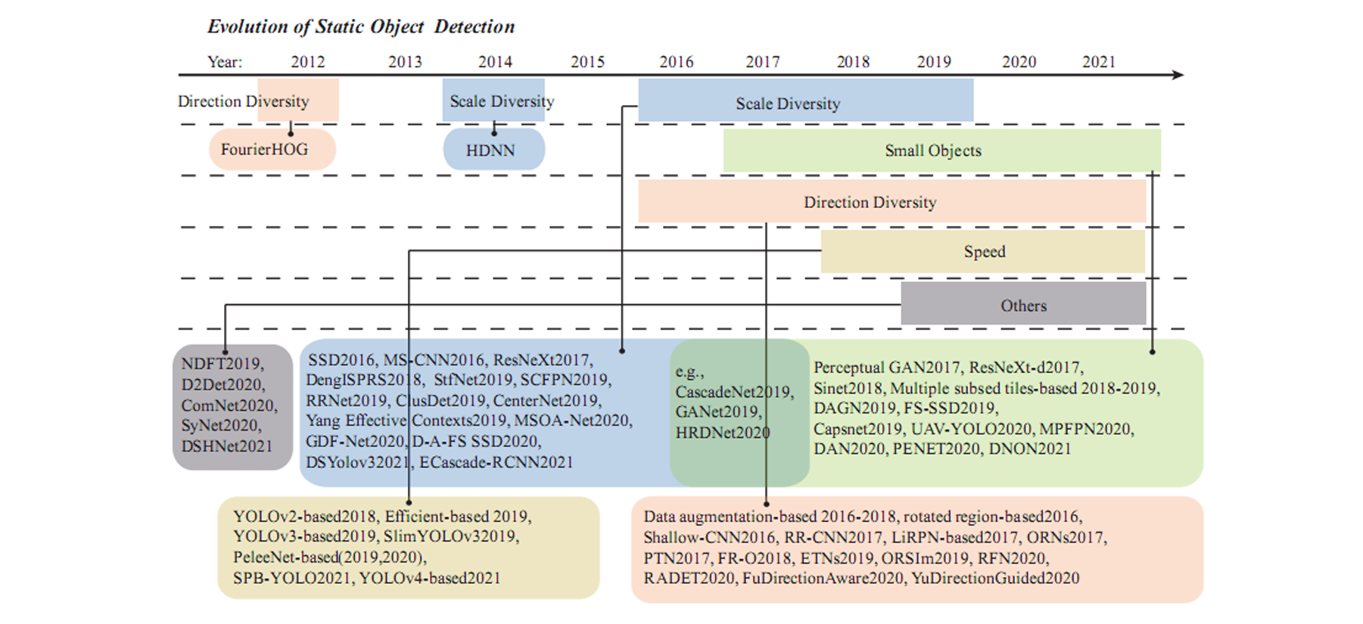

Figure 2.7. The development of typical methods for UAV-based object detection

#### 2.4.1.1. Aim at small object problems

Compared to larger and medium-sized objects, detecting small objects accurately poses greater challenges, attributed to several inherent difficulties. Firstly, small objects often exhibit low resolution and lack sufficient distinguishing features. Secondly, they encompass a wide range of scales, with multiple scales coexisting. Thirdly, there is a scarcity of examples available for small objects, exacerbating the training process. Finally, an imbalance exists in the distribution of categories among small objects.

To address these challenges, several approaches have been proposed. Incorporating additional contextual information is crucial to complement the detection of small objects, given the limited effectiveness of features extracted from them.

**Multi-scale representation learning:** Multi-scale representation learning enhances the effectiveness of information for small objects and partially mitigates the challenge posed by the wide range of object scales. Training strategies, such as the anchor mechanism, aid in matching more anchors to ground truths of small objects by adaptively setting anchor scales and ratios, thereby improving the scarcity of examples. Data augmentation proves effective in alleviating both the scarcity of examples and the category imbalance among small objects. Additionally, optimizing the choice of loss function contributes to balancing the categories of small objects.

For example, to solve small object problems, Sun et al. proposed a real-time small object detection algorithm for identifying small objects in the air called RSOD. This algorithm is specifically designed for monitoring traffic with UAVs. The algorithm is based on the Faster R-CNN framework, and introduces a multiscale fea ture fusion module and an adaptive anchor box generation module to improve the feature expression and localization ability of small objects. The structure of the RSOD model is shown in Figure 2.8. First, the image is input into the backbone network. Then, information fusion is performed on four feature layers with different depths. After that, the adaptive weighted feature fused four features. Finally, the object classes are predicted by the Yolo Head module.

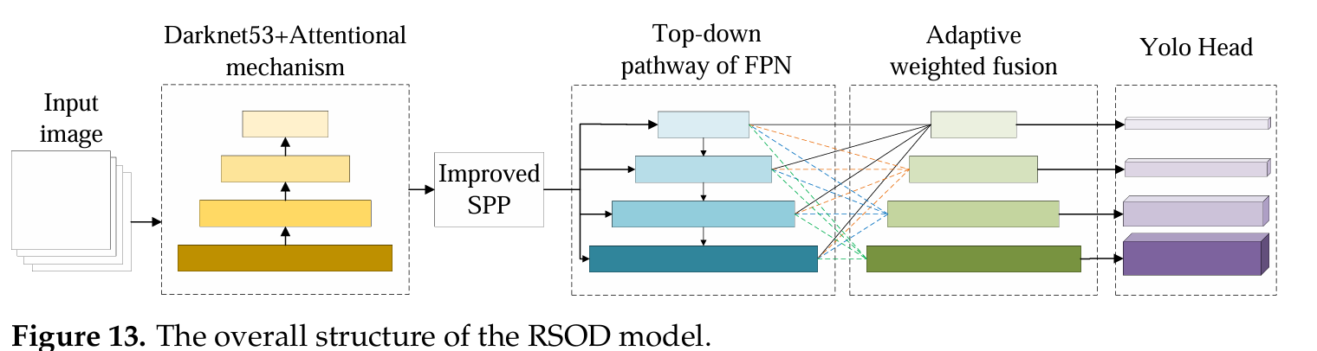

Figure 2.8. The overall structure of the RSOD model

**Super-resolution techniques:** Super-resolution techniques play a crucial role in enhancing small object detection in UAV-based images by in creasing image resolution and detail. These techniques utilize deep learning models, such as CNNs and GANs, to reconstruct high-resolution images from low-resolution inputs. By doing so, they reveal finer details that are essen tial for accurately identifying small objects that might otherwise be missed. Super-resolution not only improves the visibility of small features but also enhances the performance of subsequent object detection algorithms. For example, Liuetal. proposed a high-resolution detection network HRDNet, which used multi-resolution input and had multiple depth backbones.

**Feature extraction and representation methods:** These techniques focus on extracting informative features from input images and rep resenting them to facilitate accurate object detection. Multi-scale feature extraction methods, such as architectures like Feature Pyramid Networks (FPNs), capture features at multiple scales, enabling the detection of small objects across different levels of granularity. Additionally, anchor mechanisms, as utilized in models like Faster R-CNN and YOLO6, predict bound ing boxes at various scales and aspect ratios, facilitating precise localization of small objects amidst varying backgrounds. Moreover, attention mechanisms, including spatial or channel attention, highlight relevant regions of the image, enhancing the model’s ability to detect small objects amidst clut tered backgrounds. Super-resolution techniques also contribute to better feature representation by improving the resolution of input images, aiding in detecting objects with higher precision. By enhancing the effectiveness of feature extraction and representation, these methods enable more accurate and efficient small object detection in UAV imagery, benefiting applications such as surveillance, reconnaissance, and environmental monitoring.

**Data augmentation and domain adaptation methods:** Data augmentation techniques involve applying various transformations, such as random cropping, rotation, and scaling, to augment the training dataset. These transformations increase the diversity of the data and help the model generalize better to variations in object size, orientation, and appearance, ultimately improving its robustness. On the other hand, domain adaptation techniques focus on transferring knowledge from a source domain with ample labeled data to a target domain with limited or no labeled data. This is achieved by aligning the feature distributions between the source and target domains, enabling the model to adapt to the characteristics of UAV-captured imagery.

**Contextual information integration methods:** These methods focus on incorporating additional contextual cues, such as scene context and spatial relationships between objects, to improve the model’s understanding of the scene and enhance detection accuracy. It is widely acknowledged that visual objects often manifest within specific environments and may coexist with related objects. For instance, birds are commonly observed flying in the sky. Prior to the widespread adoption of deep learning, Oliva and Torralba demonstrated that the surrounding region of a small object can offer valu able contextual information aiding in target object detection. Graph-based models or R-CNN are commonly employed to capture these contextual de pendencies by modeling the interactions between objects or regions within the image. Leveraging contextual information, deep learning models improve the localization and recognition of small objects in cluttered backgrounds and varying conditions.

#### 2.4.1.2. Aim at multi-scale object problems

The scale diversity problem in object detection in UAV images refers to the challenge of accurately detecting objects of various sizes within aerial imagery captured by UAVs. This problem arises because objects of interest in UAV images can appear at different scales due to factors such as altitude, camera resolution, and the distance between the object and the camera. Consequently, a single detection algorithm may struggle to effectively detect objects across a wide range of scales within the same image or across multiple images.

**Traditional solutions:** Traditional solutions such as image pyramids involve generating multiple scaled versions of the input image to address variations in object size. While this method theoretically provides a solution by encompassing objects of different sizes, it often comes with computational overheads and may not fully capture the intricate scale distribution characteristic of UAV images. Moreover, constructing and processing image pyramids can be resource-intensive, making it less practical for real time applications and resource-constrained environments.

**Feature pyramid methods:** Feature pyramid methods offer an alternative strategy to tackle the scale diversity problem in UAV object detection. These methods create hierarchical representations of features at 24 different scales, enabling the model to extract relevant information across a range of object sizes. As shown in Figure 2.9, by incorporating multi-scale features into the detection process, feature pyramid architectures aim to enhance the model’s ability to discern objects of varying sizes within UAV imagery. (a) It is slow to use an image pyramid to build a feature pyramid. (b) Only single scale features is adopted for faster detection. (c) An alternative to the featurized image pyramid is to reuse the pyramid feature hierachy computed by a ConvNet. (d) FPN integrates both (b) and (c). Blue outlines indicate feature maps and thicker outlines denote semantically stronger features. However, while feature pyramids provide a more efficient and effective approach compared to image pyramids, they may still face limitations in capturing fine-grained scale details and contextual information necessary for accurate detection in complex aerial environments.

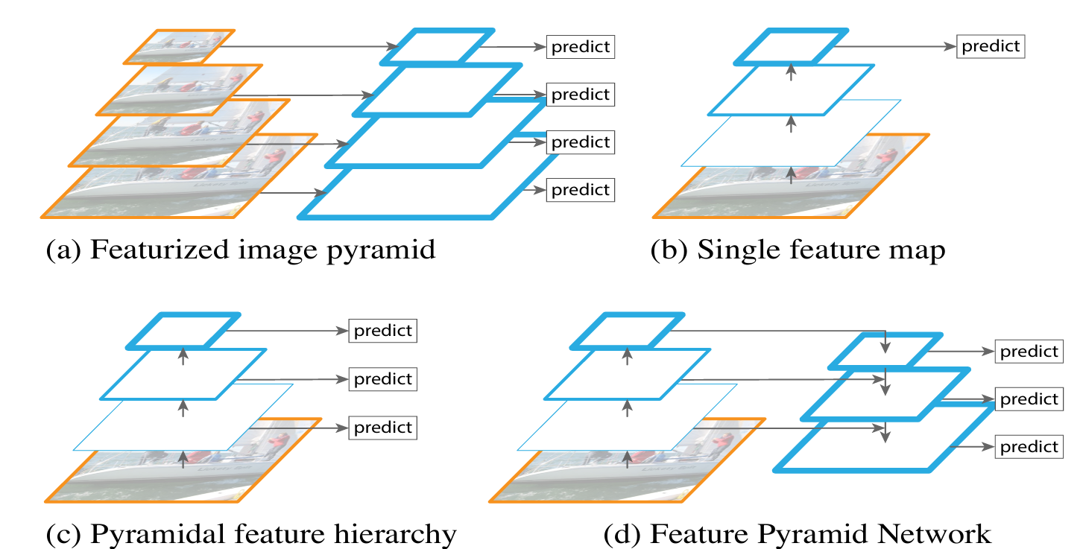

Figure 2.9. The main concern of FPN

**Scale-aware techniques:** In response to the limitations of traditional scale handling methods, scale-aware techniques have emerged as a promising direction in UAV object detection research. These methods dynamically adapt to the scale of objects present in the image, leveraging con textual information and scale-specific cues to improve detection accuracy. By integrating scale-aware mechanisms or specialized network architectures, these techniques aim to address the scale diversity problem more effectively while minimizing computational overheads. Cai introduced a guided attention network (GANet) aimed at integrating diverse scales of feature maps to enhance semantic feature representation significantly. In contrast to the approach involving the stacking of multiple sequential convolutions to extract features, Fu et al. proposed the bidirectional parallel multi-branch feature pyramid network (BPMFPN), which concurrently extracted features of various scales through a singular path in parallel. Although scale-aware methods represent a significant advancement in UAV object detection, on going research is essential to refine these techniques further and ensure their robustness in diverse aerial scenarios.

#### 2.4.1.3. Aim at rotated object problems

The rotation problem in object detection in UAV images refers to the challenge of accurately detecting and localizing objects that may appear at different orientations within the images. Addressing the rotation problem in object detection in UAV images requires the development of robust algo rithms that can effectively handle variations in object orientation. Several methods and techniques have been proposed to mitigate this challenge:

Rotation-invariant-based methods: These methods focus on designing CNNs that can learn features invariant to rotation, either by in corporating rotation-equivariant layers or by augmenting the training data with rotated versions of the images. By learning features that are insensitive to rotation, these methods enable the model to effectively detect objects regardless of their orientation in the image.

**Rotational data enhancement** is a pivotal strategy employed to combat the challenges posed by rotated objects in object detection tasks. By augmenting the training dataset with various rotations of objects, this technique enables the model to learn invariant representations that are robust to rotation. Through the introduction of random or systematic rotations during training, rotational data enhancement enriches the dataset with diverse orientations, facilitating better generalization of the model to unseen rotations during inference. This augmentation approach not only enhances the model’s ability to accurately detect objects across different orientations but also fosters improved resilience to rotation-related variations in real-world scenarios.

**Directional anchors** present a sophisticated solution to address rotated object problems in object detection by aligning anchor boxes with the prevalent orientation of objects in the dataset. Unlike conventional anchor boxes that are axis-aligned, directional anchors dynamically adjust their orientation based on the distribution of object orientations within the dataset. By aligning anchor boxes with the dominant object directions, these anchors enable more precise localization and classification of rotated objects. This adaptive approach not only enhances detection accuracy but also reduces ambiguity in cases where objects exhibit arbitrary rotations.

**Feature alignment techniques** serve as a fundamental component in mitigating rotated object problems by aligning features extracted from rotated objects to a canonical orientation. These methods aim to coun teract the negative impact of rotational variance on feature representations by transforming features into a standardized reference frame. By aligning features across different orientations, feature alignment techniques enable the model to focus on discriminative information regardless of rotational transformations. This alignment process enhances the model’s capability to learn invariant representations and improves its accuracy in detecting objects under varying rotational conditions.

**Anchor-free methods:** The previously mentioned approach re lies on anchor design, which can be problematic due to its heavy dependence on manual design, making adjustment of hyperparameters challenging. This limitation led to the emergence of anchor-free mechanisms. These methods can be broadly categorized into two types: those based on dense prediction and those based on key point estimation. Dense prediction methods involve constructing detection bounding boxes by predicting from the center point to the surrounding area. On the other hand, key point-based estimation starts by identifying the center point and then selecting diagonal key points to gen erate the prediction box. Following the notable success of the YOLO series in anchor-free mechanisms, there has been a growing interest in anchor-free object detection. With the inclusion of numerous aerial and remote sensing 26 images in object detection challenges, the adoption of anchor-free mechanisms for oriented object detection has gained popularity.

#### 2.4.1.4. Aim at real-time problems

Object detection or tracking in a video obtained by a drone needs to quickly and accurately locate moving ground objects, so real-time processing performance is highly essential. Deep learning methods for real-time object detection in images captured from UAVs need to balance accuracy and efficiency to meet the stringent computational constraints of real-time processing. As shown in Figure 2.10, some key methods for real-time object detection in UAV imagery include:

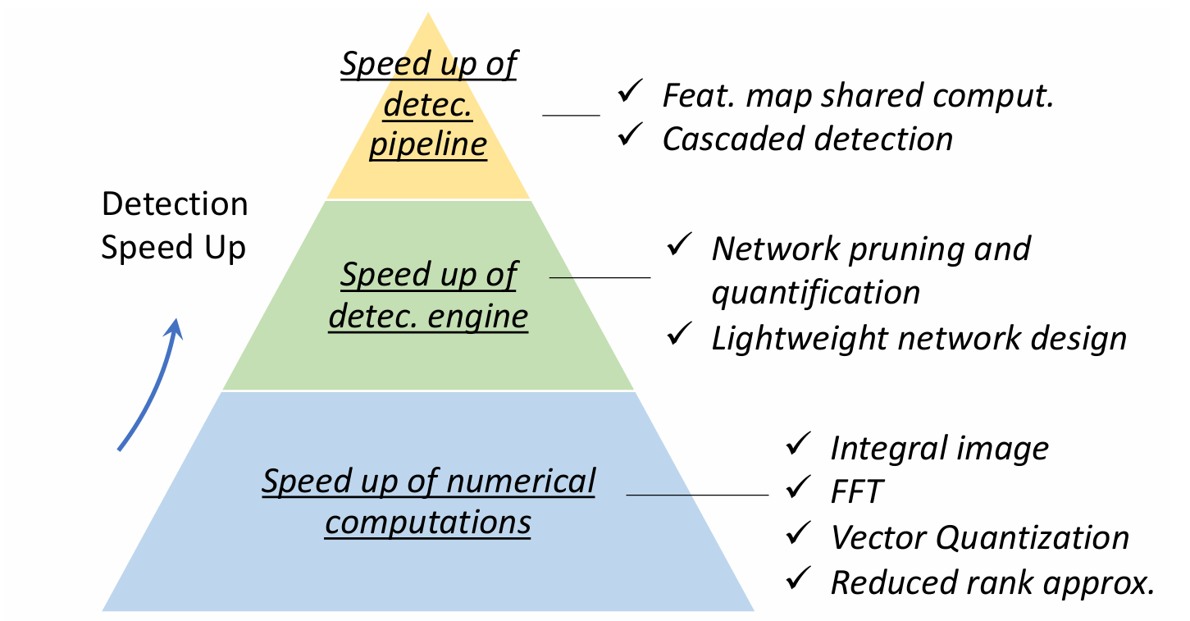

Figure 2.10. An overview of the speed-up techniques in object detection

**Feature Map Shared Computation:** Among the different computational stages of a detector, feature extraction usually dominates the amount of compu tation. The most commonly used idea to reduce the feature computational redundancy is to compute the feature map of the whole image only once, which have achieved tens or even hundreds of times of acceleration.

**Cascaded Detection:** Cascaded detection is a commonly used technique. It takes a coarse to fine detection philosophy: to filter out most of the simple background windows using simple calculations, then to process those more difficult windows with complex ones. In recent years, cascaded detection has been especially applied to those detection tasks of “small objects in large scenes”, e.g., face detection, pedestrian detection, etc.

**Network Pruning and Quantification:** “Network pruning” and “network quantification” are two commonly used methods to speed up a CNN model. The former refers to pruning the network structure or weights and the latter refers to reducing their code length. The research of “network pruning” can be traced back to as early as the 1980s. The recent network pruning methods usually take an iterative training and pruning process, i.e., to remove only a small group of unimportant weights after each stage of training, and to repeat those operations. The recent works on network quantification mainly focus on network binarization, which aims to compress a network by quantifying its activations or weights to binary variables (say, 0/1) so that the floating-point operation is converted to logical operations.

**Efficient architectures and lightweight designs:** Efficient architectures and lightweight designs are pivotal in deep learning methods for real-time object detection in images captured from UAVs, as they prioritize achieving high performance with minimal computational resources. Architectures like MobileNet and EfficientDet exemplify this approach, leveraging depthwise separable convolutions, efficient network structures, and streamlined design principles to strike a balance between accuracy and computational efficiency. By reducing the number of parameters, simplifying operations, and optimizing network architectures, these models can achieve real time performance without compromising detection accuracy. Furthermore, techniques such as factoriziing convolutions, group convolution, bottle-neck design downsampling, and parameter quantization are often employed to further optimize model size and computational complexity.

### 2.4.2. Deep learning for object detection in Infrared images

The identification of objects in infrared images has attracted substan tial attention in the realm of computer vision due to its wide-ranging implications for research and application. Its significance extends across multiple fields such as medical diagnosis, surveillance, drone navigation, infrared based alerts, night vision technology, and military operations. Despite the progress made in object detection models across various domains, the specific challenge of detecting objects in infrared imagery persists, largely because existing models are predominantly tailored for visible light images and may not fully account for the nuances of infrared data.

Arising from thermal radiation, infrared images exhibit distinct qualities, including their capacity for detecting objects across vast distances, en hanced concealment, and usability under both daylight and nighttime conditions. With the proliferation of distance imaging, there’s a growing demand for intelligent object detection in infrared imagery. Yet, developing effective models for such images faces challenges due to their longer wavelengths, increased noise levels, reduced spatial resolution, and greater sensitivity to environmental temperature changes compared to visible images. In recent years, various studies have explored methods like spatial filtering, frequency domain filtering, and sparse representation for object detection in infrared images. However, these traditional approaches are limited by their suitabil ity to specific scenarios, slow recognition speeds, and lack of adaptability, making them unsuitable for comprehensive feature extraction in real-time and multi-scene detection applications.

Deep learning for object detection in infrared images represents a fascinating intersection of cutting-edge technology and practical utility. In frared imaging, which captures the heat signatures emitted by objects rather than relying on visible light, offers distinct advantages in scenarios where traditional optical methods may be hindered by low light, adverse weather conditions, or camouflage. CNNs, a class of deep learning algorithms well suited for image analysis, have been pivotal in advancing the field of infrared object detection. These models possess the capacity to grasp intricate features from input data. They can learn high-level features from the raw pixels of training data, enhancing their ability to express complex contextual in formation. Certain networks have significantly enhanced their accuracy and generalizability, successfully addressing challenges in tasks such as image classification, image segmentation, and super resolution. Architectures like YOLO and SSD have been adapted and optimized for infrared imagery, enabling real-time detection of objects with impressive accuracy and speed. Excerpt from page 3 [15].

One of the key strengths of deep learning in this context lies in its ability to automatically learn and extract relevant features from the complex thermal patterns present in infrared images. Through the training process, these neural networks become proficient at recognizing the unique thermal signatures associated with different objects, such as humans, vehicles, ani mals, or other entities of interest. This capability is particularly valuable in applications such as surveillance, security, border control, and search and rescue operations, where timely and accurate detection of targets is critical. Moreover, transfer learning techniques have been instrumental in extending the capabilities of deep learning models for infrared object detection. By leveraging pre-trained models on large datasets, such as ImageNet, and fine tuning them on smaller infrared datasets, researchers and practitioners can expedite the training process and improve the performance of the models on specific tasks.

When compared to visible images, infrared images present challenges such as a lower signal-to-noise ratio, leading to easier submersion and in terference of objects. Additionally, the intricate backgrounds of infrared images often result in dark and uneven object areas, while the distance between objects and infrared sensors tends to be greater, causing objects to occupy smaller portions of the overall image. This highlights the robustness of CNN models when applied to visible images. However, despite the success of these models, employing convolutional neural networks for detecting faint and diminutive objects in infrared imagery has emerged as a challenging and prominent research area.

### 2.4.3. Deep learning for object detection in RGBI images

Currently, most object detection techniques rely on single-mode images pertinent to the detection task for training data. However, when these RGB-trained models are deployed in complex environments like nighttime, overcast, or rainy conditions, their detection efficacy often falls short, exhibit ing poor robustness. Consequently, to address the robustness issue stemming from RGB training data, some researchers have advocated for employing in frared images as training data. For instance, Zhao et al. utilized infrared image datasets to train models for pedestrian detection, and Dai et al. utilized the SIRST dataset to train models for infrared small target detection. Nonetheless, the utilization of infrared images as model training data tends to result in low algorithmic detection accuracy due to the lack of texture information in infrared imagery. Moreover, there are prevalent challenges concerning small target detection in practical scenarios such as remote sensing, necessitating improvements in the performance of relevant algorithms like DLAO and DRA. Excerpt from page 2 [7]. Notably, leveraging face detection technology proves to be an effective approach for enhancing the performance of algorithms aimed at detecting small targets.

Put simply, relying solely on single-modal images for training models poses challenges in complex real-world scenarios. To address this, many researchers propose utilizing multimodal image data for training detection models. Multimodal data offer complementary advantages, such as RGB-I images. Infrared images capture heat imaging from targets, unaffected by external lighting, while RGB images vividly depict texture characteristics but are sensitive to lighting. Consequently, research on multispectral object detection using multimodal input is gaining traction. Across various fields, there’s a growing trend in jointly utilizing RGB and infrared images for research purposes. However, despite the significant advantages of multimodal data, efficiently integrating complementary information from such data remains a central challenge for current algorithms.

Presently, cross-modal object detection algorithms integrating RGB and infrared images typically merge complementary information by either concatenating input features or employing attention mechanisms to generate robust target features. Regarding concatenation fusion, Li et al., building upon the two-stage Faster-RCNN object detection algorithm, directly concatenated RGB and infrared image features to produce fusion features, which were then fed into the RPN module. Wagner et al. devised two direct fusion models to assess their efficacy. The first, early fusion, combines RGB and infrared images directly at the pixel level, while the second, late fusion, merges RGB and infrared image features in the final fully connected layer. Their analysis indicates that late fusion is more effective. Excerpt from page 4 [15]. Concerning attention-based approaches, Zhang et al. constructed separate feature hierarchies for each modality and encoded the correlation between modali ties into the attention module for subsequent fusion operations by extracting global features. Another method proposed by Zhang et al. introduces a cross-spectral fusion network, incorporating a channel attention module (CAM) and a spatial attention module (SAM) to enhance meaningful feature learning while suppressing interference at both channel and spatial levels. Excerpt from page 2 [4]. Fu et al. suggested an adaptive spatial pixel-level feature fusion network, utilizing SAM and position attention module (PAM) to obtain fusion weights for different spatial positions and pixels in the two feature maps, thereby recalibrating original features of RGB and infrared images to generate a multi-scale fusion feature layer. Excerpt from page 3 [7]. Additionally, Cao et al. intro duced a novel multi-spectral channel feature fusion module for merging RGB and infrared image features, employing the squeeze-and-excitation (SE) module to derive fusion weights and recalibrating the original features accordingly. However, these methods fail to fully exploit the complementary information across modalities and underutilize the advantages of multimodal complementarity.

### 2.4.4. Deep learning for object detection in RGBI images captured from UAVs

With the widespread adoption of sensors and advancements in imaging technology, imaging sensors are now commonly integrated into small UAVs, marking a significant breakthrough in both military and civilian applications. These small unmanned aerial vehicles are utilized for a diverse range of tasks including battlefield surveillance, condition assessment, target tracking, aerial photography, environmental research, meteorological moni toring, and even forest fire prevention and monitoring. Presently, the imag ing sensors on small UAVs are capable of capturing multi-spectral, visible, and infrared images. However, due to constraints such as lighting and en vironmental conditions, single-source sensor imagery may be susceptible to errors, leading to inaccuracies in target assessment. As imaging sensor technology matures, the emergence of multi-source imaging sensors has be come notable. These sensors can integrate complex and variable data using fusion techniques to generate more reliable and comprehensive information. Image data fusion, a significant category of multi-source sensor data fusion, combines redundant and complementary information from source images to enhance the accuracy, richness, and effectiveness of the fused image result. Excerpt from page 7 [16].

Currently, image fusion technology is widely employed in various fields such as remote sensing monitoring, target tracking, military reconnaissance, and medical diagnostics. Multi-source sensors operate on different imaging principles. Infrared sensors rely on thermal radiation principles, resulting in images with prominent infrared targets, albeit with unclear details and blurred edges. On the other hand, visible light sensors utilize light reflection principles to capture clear images with distinct details; however, their performance is limited under low visibility conditions. Research indicates that combining infrared and visible light images can enhance the visibility of infrared targets, improve recognition, and enhance image sharpness. Excerpt from page 8 [16].

The integration of infrared and visible images is implemented in the embedded infrared target detection or tracking system of small UAVs, facilitating the identification of infrared targets by these UAVs. Leveraging the thermal radiation principle of infrared images and the light reflection principle of visible light images, the two images can be seamlessly registered and Figure 8. Illustration of IoU fused in real-time. This fusion preserves the color, clear details, and edges of the visible image, while also retaining the brightness information from the infrared image. Consequently, the infrared target objects are accentuated relative to the background brightness, enhancing target recognition. However, available datasets for drone object detection predominantly consist of either RGB or IR imagery. The few datasets containing both IR and RGB images either lack registered frames or are not captured via drones. Moreover, existing datasets are predominantly collected in urban environments, potentially limiting their applicability in broader contexts. Furthermore, many recent studies focusing on merging RGB and IR channels propose deep networks tailored to specific applications like pedestrian detection, leak checking, or autonomous driving, which may not be directly transferrable to drone-captured data.

### 2.2.5. Metrics for UAV-based object Detection

Object detection metrics are essential tools for quantitatively evaluating the performance of algorithms designed to detect and localize objects within images or videos. These metrics provide valuable insights into how effectively a model can identify objects of interest and accurately determine their locations relative to ground truth annotations. Several key metrics are commonly used in object detection evaluations, each serving a specific purpose in assessing different aspects of model performance.

Intersection over Union (IoU): IoU is a fundamental metric used to quantify the spatial overlap between predicted bounding boxes and ground truth bounding boxes of objects. IoU is calculated as the ratio of the area of intersection between the two bounding boxes to the area of their union. Higher IoU values indicate better agreement between predicted and ground truth locations, providing a direct measure of object localization accuracy. IoU is commonly used as a threshold to determine whether a predicted detection is considered a true positive or a false positive. Excerpt from page 8 [5].

Precision and Recall: Precision and recall are used to assess the performance of object detection models, providing insights into their accuracy and completeness. In the context of object detection, precision refers to the proportion of correctly identified objects among all predicted objects. This is calculated as the number of true positive detections (where predicted bounding boxes correctly match ground-truth objects) divided by the total number of predicted detections (true positives plus false positives). Essentially, precision indicates how reliable the model’s positive predictions are in terms of correctly identifying objects within images (formula 2.1 and 2.2). Excerpt from page 8 [5].

$Precision = \frac{TP}{TP+FP}= \frac{TP}{all detections}$ (2.1)

$Recall = \frac{TP}{TP+FN}= \frac{TP}{all ground truths}$ (2.2)

On the other hand, recall measures the model’s ability to identify all relevant objects present in the dataset. It is calculated as the number of true positive detections divided by the total number of ground-truth objects (true positives plus false negatives, where false negatives represent missed detections). Recall quantifies the completeness of the model’s detections by assessing the proportion of actual objects that were successfully detected.

In practical terms, a high precision indicates that when the model predicts an object, it is likely to be correct, minimizing false positives. Conversely, a high recall suggests that the model is effective at detecting most of the actual objects, minimizing false negatives. However, optimizing one metric often comes at the expense of the other due to the inherent trade-off between precision and recall. Balancing these metrics is crucial depending on the specific application requirements; for example, certain applications might prioritize minimizing false positives (high precision) to avoid erroneous detections, while others may prioritize high recall to ensure that most objects are detected, even if it means accepting more false positives.

**Mean Average Precision (mAP):** mAP is a comprehensive metric that assesses the precision-recall performance of an object detection model across multiple IoU thresholds and object categories. Average Precision (AP) is calculated for each class by computing the area under the precision-recall curve (PR curve) (as shown in Figure 2.11) that plots precision against recall at varying confidence thresholds. mAP is then computed as the mean of AP values across all classes, providing an overall measure of detection quality that accounts for the trade-off between precision and recall at different operating points. Excerpt from page 8 [12].

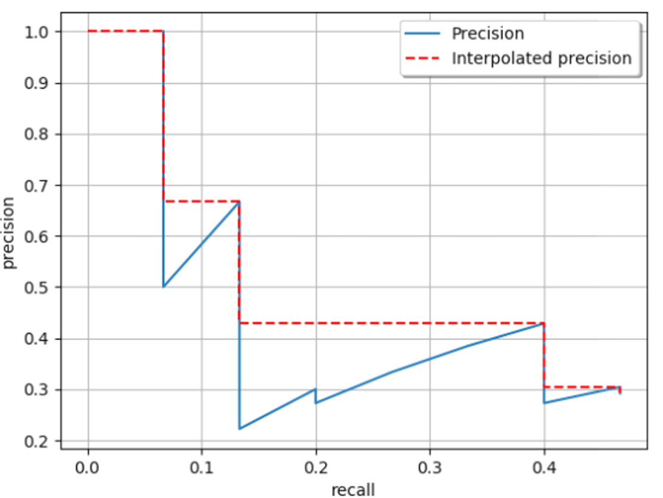

Figure 2.11. Precision-Recall curve

**Metrics for speed and efficiency**: In the context of UAV-based object detection, metrics for speed and efficiency are essential for evaluating the performance and feasibility of detection algorithms deployed on unmanned aerial vehicles. These metrics encompass several key aspects tailored to the unique operational requirements of UAVs. Speed metrics focus on the algorithm’s ability to process aerial imagery in real-time, measured by frames processed per second or inference time per frame. Efficiency metrics consider both computational resource utilization and detection accuracy, ensuring that the algorithm operates efficiently within the constraints of UAV hardware, such as limited processing power and onboard memory.

# Chapter 3 DEEP LEARNING FOR UAV-BASED ORIENTED OBJECT DETECTION

In recent years, UAV technology has become increasingly prominent in a variety of applications, from surveillance and environmental monitoring to disaster response and urban planning. One of the key tasks in utilizing UAV-captured imagery is object detection, which plays a critical role in identifying and localizing objects of interest within complex aerial scenes. Unlike traditional object detection methods that rely on horizontal bounding boxes (HBB), aerial images often present unique challenges due to the arbitrary orientations and non-axis-aligned nature of objects, such as buildings, vehicles, and ships. These objects may appear at various angles and perspectives, complicating the detection process when using conventional methods.

To address these challenges, oriented object detection has emerged as a more effective approach. By utilizing oriented bounding boxes (OBB) instead of horizontal bounding boxes, these methods are capable of capturing the true orientation of objects within the scene, providing more accurate localization and reducing errors in detection. Oriented object detection techniques involve adapting traditional algorithms and introducing new strategies that account for the unique geometry and spatial relationships present in aerial imagery.

This chapter delves into the key aspects of oriented object detection, exploring various techniques and methodologies that have been developed to handle these challenges. We will examine the different algorithms designed for oriented bounding boxes, discuss the advantages and limitations of each approach, and present experimental results from applying these techniques to UAV-captured datasets. Furthermore, we will explore potential improvements and optimizations that can enhance the accuracy and efficiency of oriented object detection in real-world UAV applications. By focusing on the nuances of oriented object detection, this chapter aims to provide a comprehensive understanding of the state-of-the-art methods and their practical implications in UAV-based image analysis.

## 3.1. Introduction to Oriented Object Detection

### 3.1.1. Definition and Importance of Oriented Object Detection

Oriented Object Detection is a specialized area within computer vision, designed to detect and localize objects that appear in arbitrary orientations. Unlike traditional object detection, which assumes that objects are axis-aligned and uses horizontal bounding boxes (HBB) for localization, oriented object detection employs oriented bounding boxes (OBB) that can rotate to match the orientation of objects in the scene. This capability allows for more accurate localization of objects, particularly in complex environments where objects may be tilted, rotated, or otherwise oriented in ways that are not parallel to the image axes. Oriented object detection is crucial for applications such as UAV-based surveillance, mapping, and environmental monitoring, where precise object localization is essential.

One of the key challenges in implementing oriented object detection lies in how objects are represented within the image. The most common representation of an object in traditional object detection is the horizontal bounding box (HBB), which is typically defined by four parameters: (𝑥c, 𝑦c, 𝑤, ℎ) where (𝑥c, 𝑦c) represents the center coordinates of the box, and 𝑤, ℎ are the width and height of the box. This simple rectangular representation works well for objects that are axis-aligned, meaning their edges are parallel to the image axes. However, it falls short when dealing with objects that are oriented at arbitrary angles, as is often the case in UAV imagery. For example, vehicles, ships, or buildings viewed from above are rarely aligned with the image axes, resulting in HBBs that enclose large amounts of background or overlap with neighboring objects.

To address these limitations, oriented bounding boxes (OBB) are used, which are defined by a set of vertices that can rotate to match the object's orientation. Specifically, an OBB is typically represented by four vertices (x1, y1, x2, y2, x3, y3, x4, y4), where each (xi, yi) corresponds to the coordinates of one of the box's corners. These vertices are arranged in a clockwise or counterclockwise order to form a rotated rectangle that closely aligns with the object's orientation. This flexible representation allows for more accurate localization of objects in UAV imagery, reducing the inclusion of background and enabling better separation between objects that are close together or overlap when viewed from certain angles. Figure 3.1 show An example image taken from DOTA with OBB annotations.

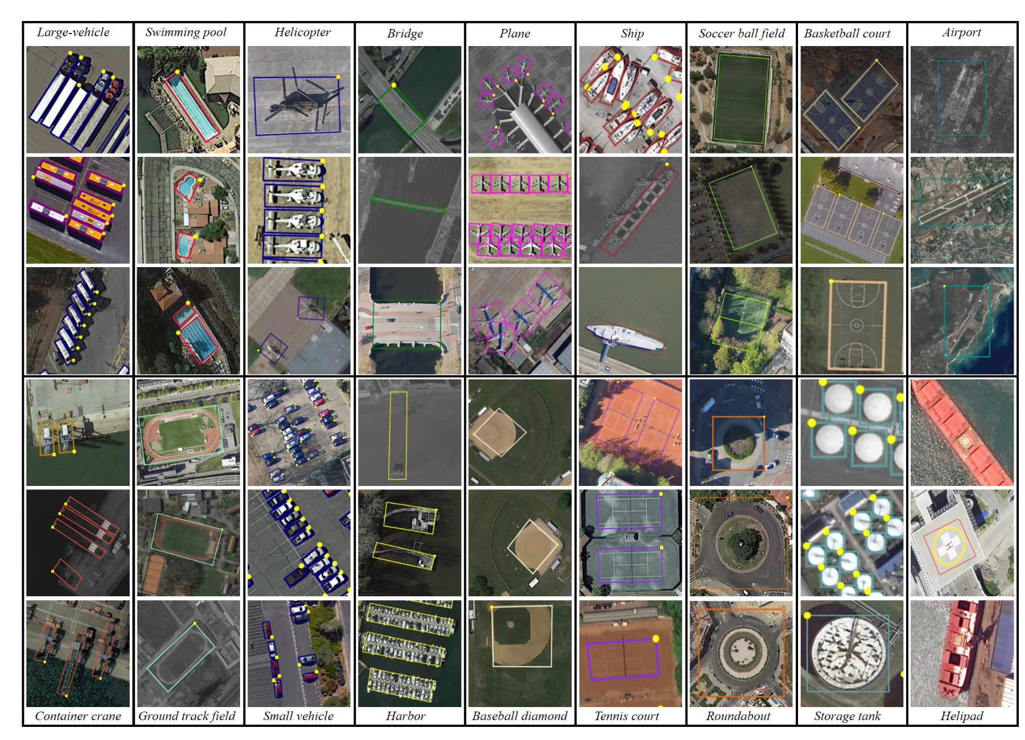

Figure 3.1. Examples of annotated images in DOTA. We show three examples per category.

### 3.1.2. Comparison between Oriented Bounding Boxes (OBB) and Horizontal Bounding Boxes (HBB)

The fundamental difference between HBB and OBB lies in their ability to represent objects with arbitrary orientations. Horizontal Bounding Boxes (HBB) are axis-aligned rectangles that are simple to define and compute but are limited in their ability to capture objects that are rotated. An HBB is typically defined by four parameters: the center coordinates (xc, yc), width 𝑤, and height ℎ. This representation assumes that the object is aligned with the horizontal and vertical axes of the image, which works well for many tasks but becomes problematic when objects are not aligned with these axes.

For example, in aerial images captured by UAVs, objects such as buildings, ships, or vehicles are often viewed at oblique angles or from perspectives where they are rotated. In these cases, an HBB may cover a large amount of background or overlap with adjacent objects, leading to inaccurate detections and reduced performance in downstream tasks. Additionally, the features extracted from HBBs are not rotation invariant, meaning that the same object viewed from different angles may be represented differently, complicating the detection process.

On the other hand, Oriented Bounding Boxes (OBB) offer a more flexible representation by allowing the bounding box to rotate to match the object's orientation. An OBB is represented by the coordinates of its four corners (x1, y1, x2, y2, x3, y3, x4, y4), which are arranged in a specific order (usually clockwise or counterclockwise). This allows the OBB to tightly enclose the object, regardless of its rotation relative to the image axes. For example, a rotated vehicle in an aerial image can be accurately enclosed by an OBB, minimizing the amount of background included in the bounding box and improving localization precision. However, the flexibility of OBBs also introduces additional complexity in the annotation process, as annotators must carefully place the box's vertices to match the object's orientation. Figure 3.2 show difference between HBB and OBB representations for objects. (a) OBB representation. (b) HBB representation. The HBB representation cannot distinguish rotated dense objects.

**Oriented Object Annotation**

In the context of oriented object detection, annotation plays a critical role in creating the training data required to teach models how to detect objects with arbitrary orientations. Annotating OBBs is inherently more complex than annotating HBBs, as it involves not only defining the position and size of the bounding box but also accurately determining its orientation.

The most straightforward way to annotate an OBB is to first draw an HBB around the object and then manually adjust the angle of the box to align with the object's orientation. However, this process can be time-consuming and requires multiple adjustments to ensure that the box fits the object closely. Additionally, since HBBs do not inherently contain information about the object's orientation, annotators must rely on visual cues and trial-and-error to achieve an accurate representation.

An alternative approach to OBB annotation involves directly clicking on the physical points that define the corners of the bounding box. For many categories of objects, such as vehicles or buildings, these points are relatively easy to identify, as they correspond to visible corners or edges of the object. By allowing annotators to click on these points, the annotation process can be made more efficient and precise. For objects with more irregular shapes, such as airplanes, the annotation process may involve identifying key points on the object, such as the head, wingtips, and tail, and then converting these points into an OBB. This method provides greater accuracy in representing the object's orientation and shape, particularly for objects that do not conform to a simple rectangular structure.

One challenge that arises when using OBBs to represent objects is the potential for multiple valid representations of the same object. For example, the same object can be represented by different permutations of the box's vertices, depending on which vertex is chosen as the starting point. To address this, annotators must follow consistent rules when selecting the first vertex, such as always starting with the "head" of the object for categories where there is a clear distinction between the front and back (e.g., vehicles, airplanes). For objects where the orientation is ambiguous or there are no clear visual cues, the top-left corner of the OBB is often chosen as the starting point to maintain consistency across annotations.

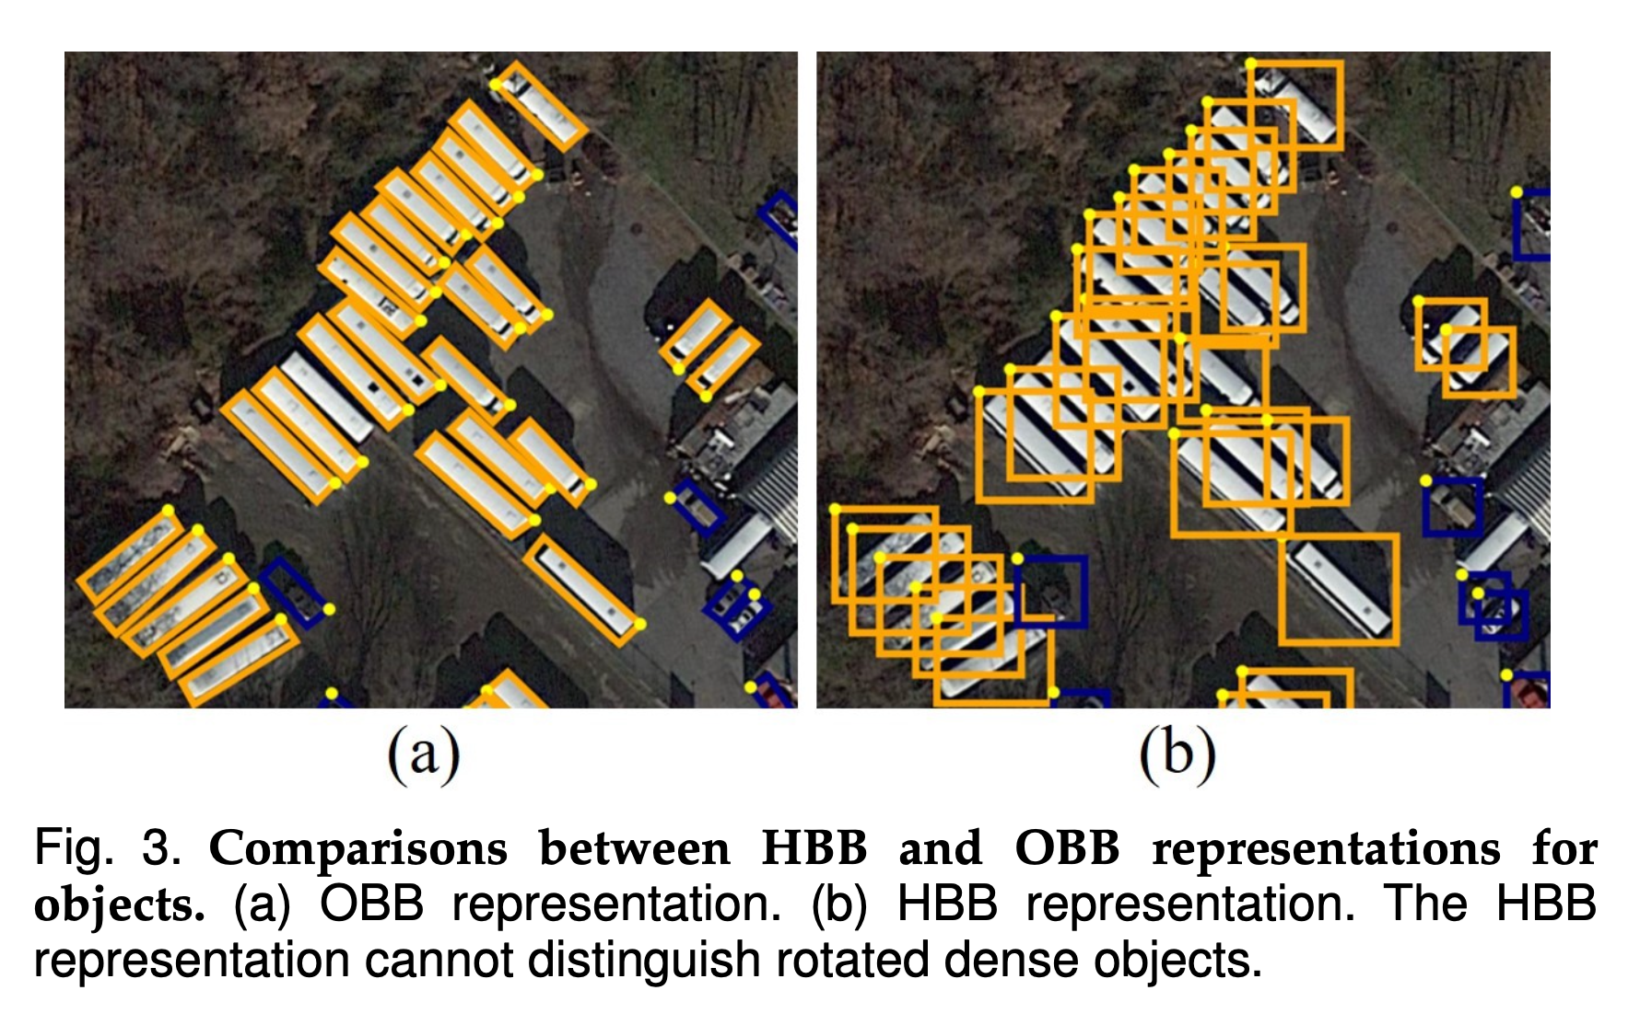

Figure 3.2. Comparisons between HBB and OBB representations for objects. (a) OBB representation. (b) HBB representation. The HBB representation cannot distinguish rotated dense objects.

### 3.1.3. Challenges Specific to UAV Imagery with OBB

The application of oriented object detection in UAV imagery presents several unique challenges. These challenges are primarily related to feature misalignment, spatial misalignment, and the periodicity of angle (PoA), each of which significantly affects the accuracy and reliability of OBB-based detection. Below, we analyze these key challenges in the context of UAV imagery.

***1) Feature Misalignment***

In most UAV-based object detection tasks, the objects of interest are often captured from various angles due to the UAV's mobility. This introduces the problem of feature misalignment, where the features extracted by the network fail to align properly with the orientation of the objects. This misalignment is particularly problematic when using traditional convolutional neural networks (CNNs), which typically rely on axis-aligned convolutions. Since these convolutions lack rotational information, they may struggle to effectively represent the rotated objects commonly found in UAV imagery. This lack of alignment between the extracted features and the actual object orientation can result in poor detection performance, particularly when dealing with complex scenes that include densely packed or small objects. Figure 3.3 show features misalignment

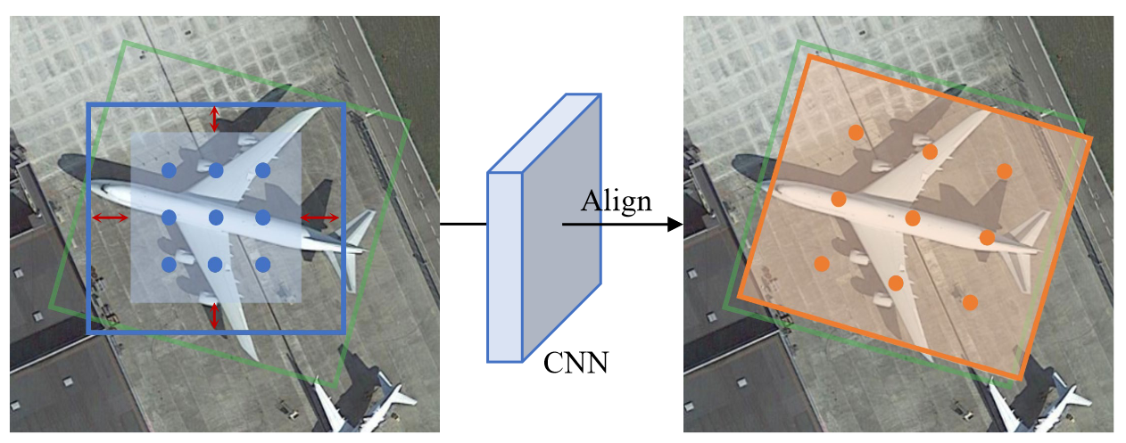

Figure 3.3. Features misalignment

1. ***Spatial Misalignment***

Spatial misalignment is another critical issue in UAV imagery, especially when anchor-based detection methods are employed. These methods generally use horizontal anchors as priors, which can limit the overlap between the anchor boxes and the arbitrarily oriented objects often seen in aerial images. This is particularly problematic when the objects have extreme aspect ratios, such as long, narrow vehicles or ships, which are frequently captured by UAVs. Due to this limited overlap, the standard label assignment strategies—which typically rely on intersection-over-union (IoU) thresholds—may fail to provide a sufficient number of positive samples for training. This imbalance can hinder the network's ability to learn effectively, leading to suboptimal detection performance. Figure 3.4 show spatial misalignment.

***3) Periodicity of Angle (PoA)***

The periodicity of angle (PoA) presents a unique challenge in OBB regression. When detecting oriented objects, the angle parameter must be accurately predicted to correctly align the bounding box with the object. However, the cyclic nature of angular values can create discontinuities at the boundaries of the angle range. For example, a small change in the angle can result in a large regression error if the angle approaches the boundary between 0° and 360°. This angular discontinuity can confuse the network during training, resulting in instability and increased error rates. In UAV imagery, where objects can appear at any angle due to the UAV's movement, this challenge is particularly pronounced and must be carefully managed to ensure reliable detection. Figure 3.5 show Periodicity of angle.

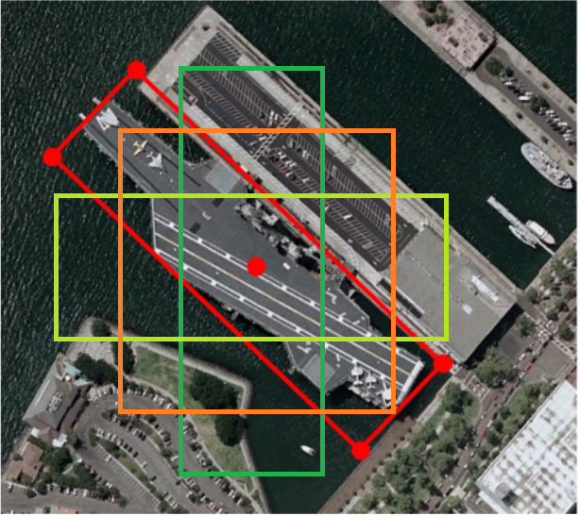

Figure 3.4. Spatial misalignment

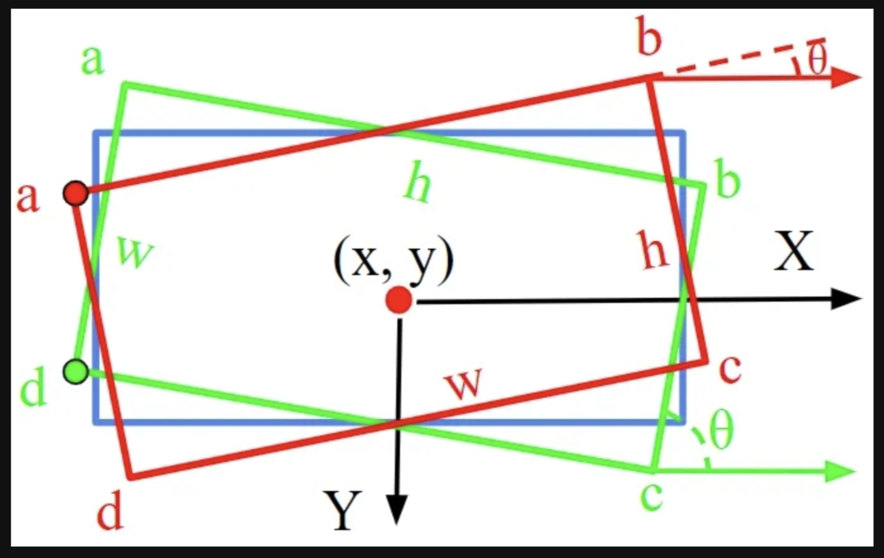

Figure 3.5. Periodicity of Angle

**Addressing the Challenges**

To address these challenges in UAV imagery, recent advancements have focused on designing more robust detection frameworks and improving the accuracy of OBB regression. For instance, some methods have introduced rotated proposal generation networks or refined detection heads to mitigate feature and spatial misalignment. Additionally, new loss functions and OBB representations have been developed to handle the PoA issue more effectively. These improvements have contributed to more accurate and stable detection results in UAV-based object detection tasks.

## 3.2. Key Techniques and Algorithms for Oriented Object Detection

The previous detection method detects densely arranged objects of arbitrary size and orientation when the anchor frames overlap, containing not only the current object but also other objects and complex backgrounds. This affects the detection accuracy and prediction results of the detector. Therefore, a bounding box that precisely encloses the object is very important for detection. The loss in the regression calculation has to be adjusted accordingly when the form of the bounding box changes. The birth of the anchor-free mechanism has brought another new direction for oriented object detection. Figure 3.6 shows a taxonomy of oriented object detection methods divided into two methods: Anchor-based methods and Anchor-free methods

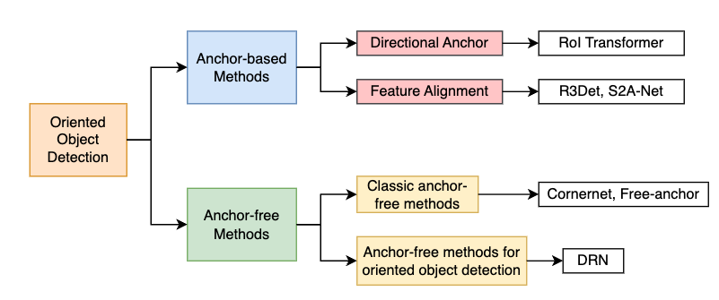

Figure 3.6. A taxonomy of oriented object detection methods. Divided into two methods: Anchor-based methods and Anchor-free methods

### 3.2.1. Anchor-based Detectors for Oriented Object Detection

Anchor-based methods rely on predefined anchor boxes to predict the position and size of objects within an image. In the context of oriented object detection, these anchors are designed to rotate, enabling the detection of objects with arbitrary shapes and orientations. Below are two key groups within anchor-based methods.

#### 3.2.1.1. Directional anchor

Even if we train the neural network with a large amount of data to improve its generalization ability, the bounding box obtained by the traditional method still has problems. In particular, the following two cases:

- When facing a dense arrangement of objects, the bounding boxes will overlap with each other.

- When the objects are oriented at any scale, a large box is used to completely enclose the objects, but in this case the box contains a lot of background in addition to the objects.

To ensure that rotation invariant features are obtained, the previous method chooses to generate a large number of rotated frames. The number of rotated anchors is too large, so high quality anchor must be computationally selected. Therefore, redundant computation leads to slow detection. RoI Transformer proposed to convert the output horizontal RoI (HRoI) into rotated ROI (RRoI). The RoI Transformer (RT) can be used flexibly for other network structures. Its structure is shown in Figure 3.7.

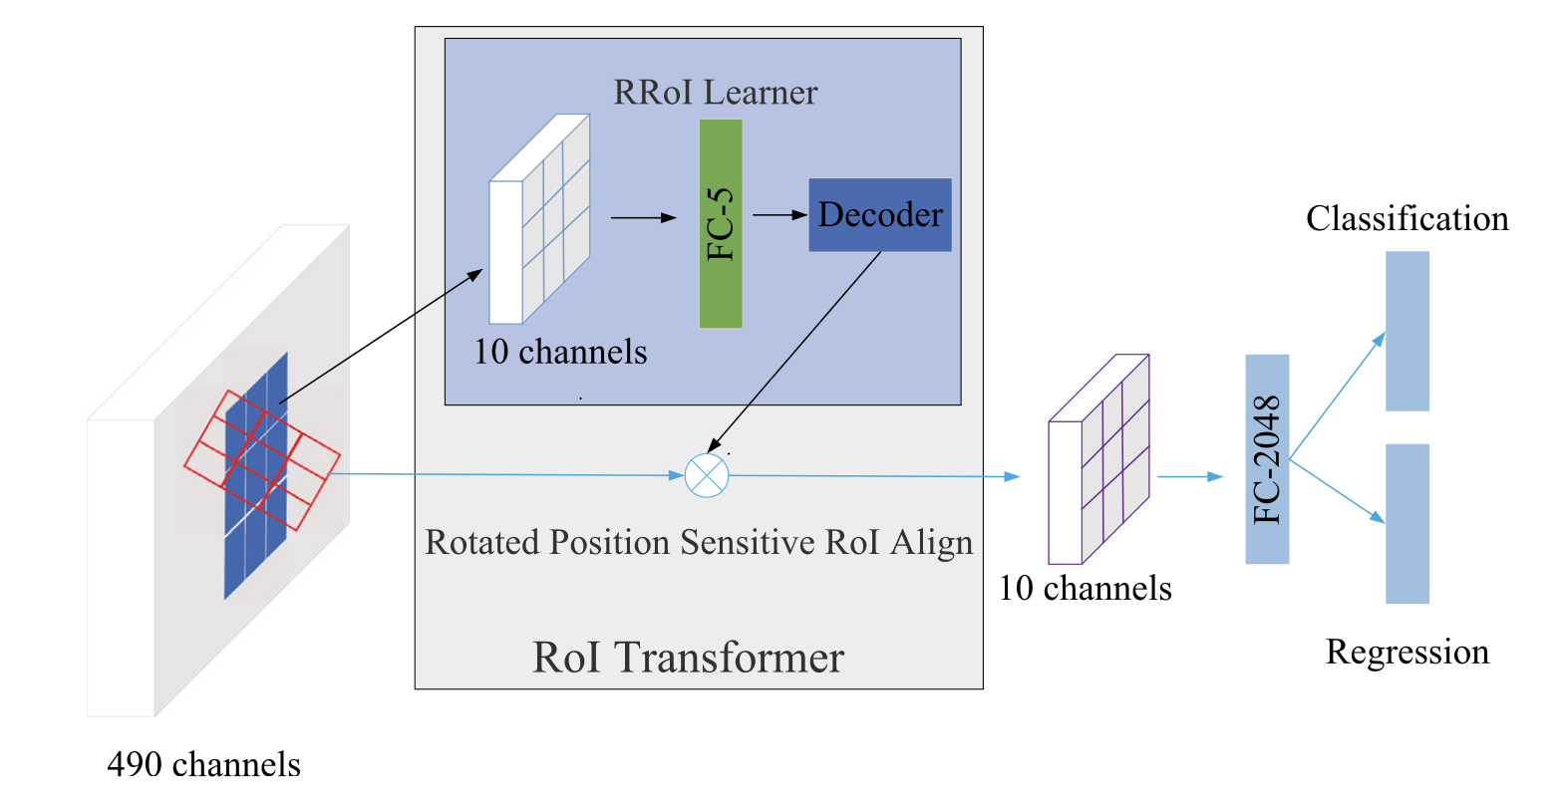

Figure 3.7. The structure of RoI Transformer

The RRoI Leaner is mainly responsible for learning RRoIs from the horizontal feature map HRoIs. RRoI Warping extracts rotation-invariant depth features through the parameters of RRoI. Rotated Position Sensitive (RPS) RoI Align reduces the dimensionality of feature maps and merges a single fully-connected layer into 10 channels, significantly increasing the computational speed.

The first method pre-sets many different angles of anchor to filter, but this is too computationally intensive and affects the detection speed. The second method converts the horizontal bounding box into a oriented bounding box, which is an effective speedup compared to the first method.

#### 3.2.1.2. Feature alignment

Although there is an oriented bounding box surrounding the object, there is still a problem of feature misalignment in the detection.

In feature alignment-based methods, instead of solely relying on predefined anchors, the focus is on aligning feature maps with the spatial structure of objects. This allows the detection network to better focus on key regions in the image, improving accuracy for oriented objects.

R3Det (Refined Single-Stage Rotated Detector) and S2A-Net (Shift and Align Network) (Figure 3.8) are examples of feature alignment methods. Both models refine the anchor positions by aligning feature maps to object boundaries, resulting in more accurate predictions for objects with rotated or skewed shapes. These methods adjust feature extraction mechanisms to match the specific geometry of objects, improving both localization and classification performance in oriented object detection tasks.

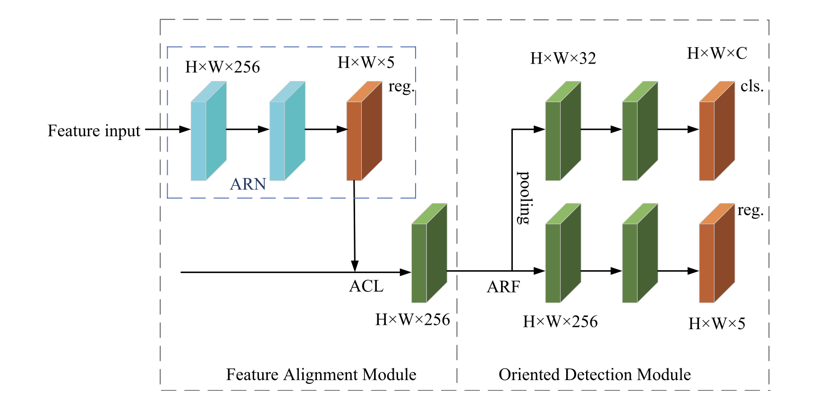

Figure 3.8. The architecture of the S2A-Net. It consists of a backbone network, a feature pyramid network, a feature alignment module (FAM), and an orientation detection module (ODM).

### 3.2.2. Anchor-free Detectors for Oriented Object Detection

The above method is **based on the anchor design**, but the anchor relies too much on the manual design which means that its **hyperparameters are difficult to adjust**. That is why the anchor-free mechanism was born. Classic anchor-free methods include CornerNet, Freeanchor, CenterNet, RepPoints and other methods. Anchor-free methods are mainly divided into two types based on **dense prediction** and based on **key point** estimation (Figure 3.9). Based on dense prediction is to construct a bounding box for detection based on the prediction from the center point to the surrounding area. Key point-based estimation is also based on determining the center point first, and then selecting the diagonal key points to generate the box for prediction. After the YOLO series showed very good performance for the anchor-free mechanism, more and more people began to focus on anchor-free object detection. As a large number of aerial images and remote sensing images are added to the object detection challenge, the application of oriented object detection based on the anchor-free mechanism has also become popular. Excerpt from page 5 [2].

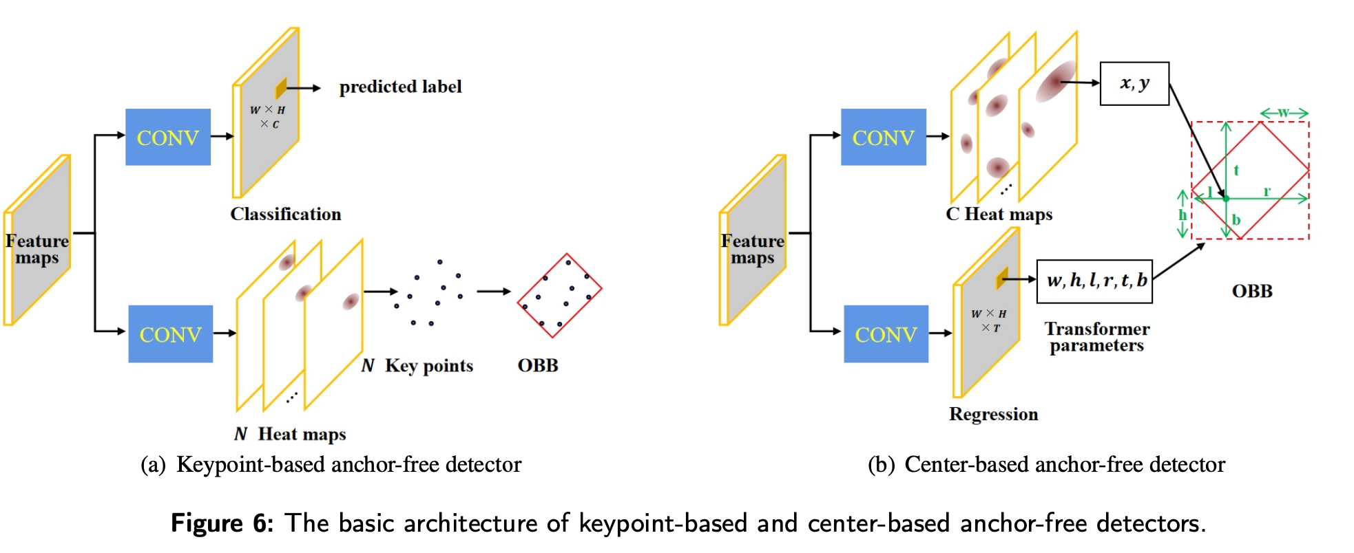

Figure 3.9. The basic architecture of key-point-based and center-based anchor-free detectors.

## 3.3. Oriented RepPoints

Anchor-free detectors have emerged as a promising solution to overcome the inherent limitations of anchor-based methods, such as spatial misalignment and reliance on predefined anchor boxes. Among these methods, Oriented RepPoints stands out as an effective approach for detecting oriented objects by leveraging keypoint-based representation. This method builds upon the concept of RepPoints, which uses a set of points to represent object shapes and extends it to handle oriented objects more effectively.

Oriented RepPoints introduces an advanced scheme called Adaptive Points Assessment and Assignment (APAA). This innovation addresses challenges in determining the quality of keypoints by evaluating them across several dimensions: classification, localization, orientation alignment, and point-wise correlation. By assessing the quality of these points, Oriented RepPoints ensures more accurate representation and detection of objects with varying orientations.

**3.3.1. Overview**

Instead of directly regressing the orientations as done in conventional methods like RoI Transformer, Rotated RetinaNet, and Gliding Vertex, Oriented RepPoints utilizes an adaptive point set as a fine-grained representation. This approach captures the geometric structure of aerial objects that exhibit sharp variations in orientation within cluttered environments. To achieve this, the algorithm introduces differentiable conversion functions, allowing the representative points to adaptively move toward appropriate positions over an oriented object. Oriented RepPoints also proposes a quality measure scheme for selecting high-quality oriented RepPoints during the training stage, without relying on direct point-to-point supervision. To enhance robust adaptive point learning, spatial constraints are employed to penalize vulnerable outliers and associate them with their corresponding instances within complex aerial contexts. Figure 3.10 illustrates the overview of the Oriented RepPoints approach.

The "Oriented RepPoints" section describes an extension of the original RepPoints approach to handle oriented bounding boxes, which are more suitable for detecting objects that are not aligned with the axes of the image, such as aerial images or scenes with rotated objects.

**Key Concepts**:

**RepPoints**: These are representative points that adaptively model object bounding boxes. Instead of using a fixed anchor or a fixed shape for the bounding box, RepPoints generate a set of points that can flexibly represent the object's shape. Excerpt from page 3 [14].

**Oriented Bounding Boxes**: These are bounding boxes that can rotate, allowing for a more accurate representation of objects in cases where they are not axis-aligned.

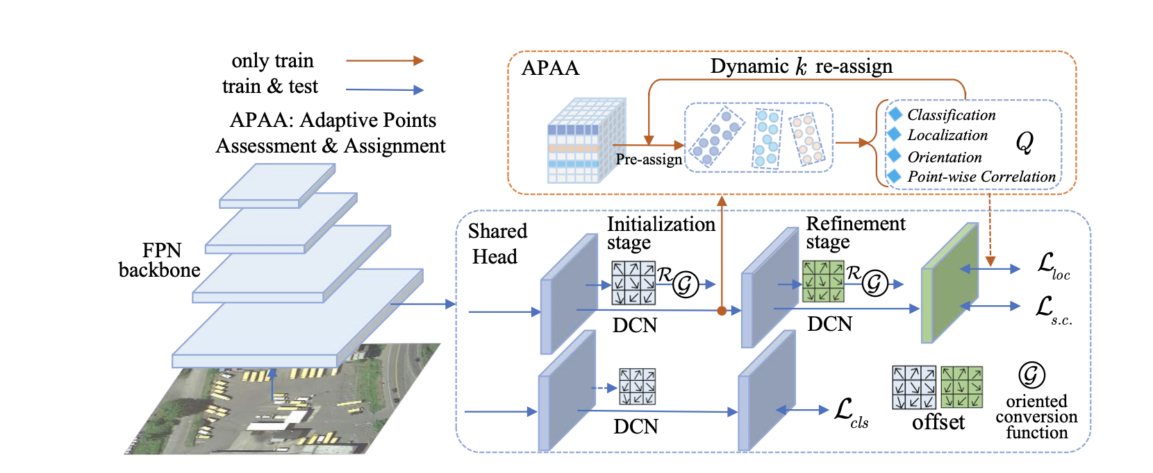

Figure 3.10. The framework of Oriented RepPoints. The proposed method is an anchor-free approach with the adaptive points as the representation, where a backbone with FPN network is employed for feature encoding.

### 3.3.2. Adaptive Points Learning with Orientation

**Oriented Conversion Functions for Adaptive Points**

To enhance the effectiveness of the oriented detector using a point set representation, it is necessary to convert the adaptive points into an oriented bounding box. The conversion from a set of learned points $R$ to an oriented bounding box 𝑂𝐵 is facilitated by an oriented conversion function, denoted as $G$. The relationship between the point set and the oriented bounding box can be mathematically represented as:

$OB=G(R)$ (3.1)

Here, 𝑂𝐵 is the oriented bounding box that is derived from the learned set of points $R$. The goal of the conversion function is to accurately represent the object’s shape and orientation based on the positions of these points.

**Three Oriented Conversion Functions:**

**1) MinAreaRect:**

The MinAreaRect function aims to find the rotated rectangle that covers the smallest possible area while still enclosing the object. This method is particularly useful when seeking to minimize the bounding box area for a given set of points. The function tries to find the most compact rectangle that aligns with the object’s orientation.

*Mathematical Objective:*

The MinAreaRect function aims to compute the minimum-area bounding rectangle that can enclose a set of points 𝑅 in a 2D plane. The rectangle can be rotated, allowing it to tightly fit the shape of the object.

*Mathematical Explanation:*

Convex Hull: First, a convex hull $H$ is computed for the set of points $R$. The convex hull is the smallest convex polygon that can enclose all the points.

Rotating Calipers: Once the convex hull $H$ is obtained, the algorithm uses a technique called "rotating calipers." This method involves rotating a pair of calipers around the convex hull to evaluate the area of the bounding rectangle at different orientations.

Optimization: The algorithm then finds the orientation that results in the smallest area for the bounding rectangle. This orientation is used to define the minimum-area oriented bounding box.

Mathematically, the algorithm seeks to minimize the area 𝐴 of the rectangle: 𝐴=𝑤×ℎ, where 𝑤 and ℎ are the width and height of the rectangle at a particular orientation.

**2) NearestGTCorner:**

The NearestGTCorner function leverages ground-truth annotations to enhance the accuracy of the bounding box. For each corner of the bounding box, the function identifies the closest point from the learned set $R$ and uses it as a predicted corner. These selected corner points are then combined to form a quadrilateral that serves as the oriented bounding box. This function closely aligns the bounding box with the annotated object, ensuring precise localization.

*Mathematical Objective:*

The NearestGTCorner function aims to improve the alignment of the predicted bounding box by selecting the closest points from the set $R$ to the ground truth (GT) corners.

*Mathematical Explanation:*

Distance Calculation: For each corner 𝐶i of the ground-truth bounding box 𝐺𝑇, the function computes the Euclidean distance 𝑑(𝐶i,𝑟j) to each point 𝑟j∈.

(3.2)

Nearest Neighbor: The function selects the point $r_{j}^{*}$ from $R$ that has the minimum distance to each corner $C_{i}$:

$r_{j}^{*} = {argmin}_{j} d(C_{i}, r_{j})$ (3.3)

Quadrilateral Formation: The selected points $r_{j}^{*}$ ​ are then connected to form a quadrilateral. This quadrilateral serves as the oriented bounding box.

**3) ConvexHull:**

The ConvexHull function constructs the oriented bounding box by generating a convex polygon that encloses all the points in the set $R$. This polygon is determined using the Jarvis March algorithm, which is commonly employed in contour-based methods. The ConvexHull method is advantageous for defining the exact shape of objects, especially those with irregular or complex contours.

*Mathematical Objective:*

The ConvexHull function aims to create the smallest convex polygon that can enclose all the points in $R$, defining a bounding box that tightly fits the object.

*Mathematical Explanation:*

Jarvis March Algorithm: The ConvexHull is often computed using the Jarvis March (Gift Wrapping) algorithm, which is an 𝑂(ℎ𝑛) algorithm, where ℎ is the number of points on the convex hull and 𝑛 is the total number of points.

- Initialization: Start with the leftmost point p0 in , and set it as the first point of the convex hull.

- Wrapping: Iteratively select the next point that is most counterclockwise to the current point, ensuring that no other points are to the left of the line formed by the current point and the candidate point.

- Completion: The process continues until the algorithm returns to the starting point p0, completing the convex polygon.

The convex hull $H$ of the points in $R$ is mathematically defined as:

$$H = \left\{p_{i} ∈ R: p_{i} is on the boundary of the convex hull\right\}$$

Note that the NearestGTCorner and ConvexHull are differentiable functions while MinAeraRect is not. Thus, we employ MinAeraRect in the post-processing to get the standard rotated rectangle prediction, and the other two differentiable functions are used to optimize adaptive points learning during the training. Under the supervision of the oriented ground-truth annotations, the points move towards the semantic key and geometric features adaptively for each aerial object, which are driven by the classification and localization loss simultaneously.

The proposed framework consists of two stages. The initialization stage generates the adaptive point sets by refining from the object center point (feature map bins). The refinement stage further gains the accurate adjustment by minimizing the loss function as below:

${L = L}_{cls} + λ_{1}L_{s1} + λ_{2}L_{s2}$ (3.4)

where $λ_{1}$ and $λ_{2}$ are balanced weighting. ${ L}_{cls}$ denotes the object classification loss: $L_{cls} = \frac{1}{{ N}_{cls}}\sum_{i}{F_{cls}(R_{i}^{cls}(θ), b_{j}^{cls})}$ (3.5)

where $R_{i}^{cls}(θ)$ represents the predicted class confidence based on the learned points, and $b_{j}^{cls}$ is the assigned ground-truth class. $F_{cls}$ is the **focal loss** []. ${ N}_{cls}$ denotes the total number of point sets. $L_{s1}$ and $L_{s2}$ represent the spatial localization loss at the initialization and refinement stage, respectively. For each stage, $L_{s}$ can be denoted as below:

$L_{s} = L_{loc} + L_{s.c.}$ (3.6)

where $L_{loc}$ is localization loss based on converted oriented boxes, and $L_{s.c.}$, denotes the spatial constraint loss.

Let ${ N}_{loc}$ denote the total number of **positive point set** samples. $b_{j}^{loc}$ indicates the location of ground-truth box. Thus, is defined as follows:

$L_{loc} = \frac{1}{{ N}_{loc}}\sum_{i}{\left[b_{j}^{cls} ≥ 1\right]}F_{loc}({OB}_{i}^{loc}(θ), b_{j}^{loc})$ (3.7)

where $F_{loc}$ is the GIoU loss [] for the oriented polygon.

Due to the diversity of different categories and the cluttered background in aerial images, a portion of learned points are susceptible to the background or adjacent objects with strong key features, which may move outside the ground-truth bounding box. To facilitate the vulnerable points to capture the geometric features on its instance owner, Oriented Reppoints introduces an effective **spatial constraint** to **penalize the adaptive points outside the bounding box**. Let $ρ_{ij}$ denote the penalty function. The spatial loss $L_{s.c.}$ for each oriented object is defined as below:

$L_{s.c.} = \frac{1}{{ N}_{a}}\frac{1}{{ N}_{o}}\sum_{i = 1}{\sum_{j=1}{ρ_{ij}}}$ (3.8)

where ${ N}_{a}$ indicates the number of assigned positive point set samples for earch object. ${ N}_{o}$ is the number of points outside the GT box in each point set.

Let **p**c denote the geometric center of the ground-truth bounding box. Given a sampled point **p**o outside the bounding box, the penalty term is defined as below:

$ρ=\left\{\begin{aligned} \left\|p_{o} - p_{c} \right\|, p_{o} is outside GT \\ 0, otherwise.\end{aligned}\right.$ (3.9)

where GT denotes the ground-truth box.

### 3.3.3. Adaptive Points Assessment and Assignment

Due to the lack of direct supervision, learning high-quality points is essential to capture the geometric features adaptively for densely-packed and arbitrarily-oriented objects in aerial images. To this end, we propose an effective assessment and assignment scheme to measure the quality of learned points, which towards assigning the representative samples of adaptive points as the positive samples at the training stage.

**Quality Measure of Adaptive Points.** Firstly, we define a quality measure $Q$ to assess the learned adaptive points from four aspects, including classification and localization ability $Q_{cls}$, $Q_{loc}$, orientation alignment $Q_{ori}$, and point-wise correlation $Q_{poc}$ for each oriented point set. Thus, $Q$ is derived as below:

$Q = Q_{cls} + {μ_{1}Q}_{loc} + {μ_{2}Q}_{ori} + {μ_{3}Q}_{poc}$ (3.10)

The classification ability $Q_{cls}$ of a point set $R_{i}$ directly reflects its classification confidence $R_{i}^{cls}(θ)$ where the corresponding classification loss $L_{cls}$ measures the compatibility of the points feature with ground-truth class label $b_{j}^{cls}$ We define $Q_{cls}$ as follows:

$Q_{cls}(R_{i}, b_{j}) = L_{cls}(R_{i}^{cls}(θ), b_{j}^{cls})$ (3.11)

To evaluate the compatibility of the points position with the ground-truth $b_{j}^{loc}$, we employ the localization loss as the quality assessment measure, which is based on the IoU transformation. It indicates the spatial alignment when the center of a point set is near to the object’s geometric center. Therefore, $Q_{loc}$ is defined as below:

$Q_{loc}(R_{i}, b_{j}) = L_{loc}({OB}_{i}^{loc}(θ), b_{j}^{loc})$ (3.12)

Since $Q_{loc}$ can be regarded as a measure of spatial location distance, it is insensitive to the orientation variations, especially for the **square-like objects** in the aerial images. To account for the orientation alignment, Oriented Reppoints employs Chamfer distance to assess the difference in orientation between the predicted point set and ground-truth box contour points. Firstly, adopt the *MinAeaRect* conversion function to obtain four spatial corner points ${\{v}_{1}, v_{2}, v_{3}, v_{4}\}$ from the learned point set. Then, an ordered point set $R^{v}$ (40 points by default) is sampled with the equal interval from two adjacent corner points. Similarly, the points $R^{g}$ are generated for the ground-truth corner points ${\{g}_{1}, g_{2}, g_{3}, g_{4}\}$. Therefore, $Q_{ori}$ is defined as follows:

$Q_{ori}(R_{i}, b_{j}) = CD(R_{i}^{v}(θ), R_{b_{j}}^{g})$ (3.13)

where $CD$ denotes Chamfer distance between the above two group of sampling points:

$CD\left(R^{v},R^{g}\right)=\frac{1}{2n}\sum_{i=1}^{n}{\min_{j}{\left\|\left(x_{i}^{v},y_{j}^{v}\right)-\left(x_{i}^{g},y_{j}^{g}\right)\right\|}_{2}}$

$+ \frac{1}{2n}\sum_{j=1}^{n}{\min_{i}{\left\|(x_{i}^{v}, y_{j}^{v}) - (x_{i}^{g}, y_{j}^{g})\right\|}_{2}}$ (3.14)

$(x_{i}^{v}, y_{j}^{v}) ∈ R^{v}$ denotes the sampled points of predicted spatial corner points, and $(x_{i}^{g}, y_{j}^{g}) ∈ R^{g}$ denotes the sampled points generated from ground-truth corner points.

To measure the point-wise association upon a point set for an oriented object, we extract the point-wise features and employ the cosine similarity between the feature vectors as the correlation measure $Q_{poc}$ for the learned adaptive points. Let $e_{i, k}$ denote the k-th point-wise feature vector of i-th set of adaptive points. $e_{i, k}^{*}$ and $e_{i}^{*}$ represent the normalized embedding feature vector and their mean from the i-th point set:

$e_{i, k}^{*} = \frac{e_{i, k}}{{\left\|e_{i, k}\right\|}_{2}}$ (3.15)

$e_{i}^{*} = \frac{1}{N_{p}}\sum_{k=1}{e_{i, k}^{*}}$ (3.16)

where $N_{p}$ denotes the num of points in a point set. The default setting is 9. Based on the above notations, $Q_{poc}$ of i-th point sets can be formulated as the point-wise feature diversity as below:

$Q_{poc} = 1 - \frac{1}{N_{p}}\sum_{k}{cos〈e_{i, k}^{*},e_{i}^{*} 〉}$

$= 1 - \frac{1}{N_{p}}\sum_{k}{\frac{e_{i, k}^{*} . e_{i}^{*}}{\left\|e_{i, k}^{*}\right\|×\left\|e_{i}^{*}\right\|}}$ (3.17)

**Dynamic** k **Label Assignment.** Based on the quality measure Q, we assign the oriented reppoints samples through an efficient and dynamic top k item selection scheme at different iteration. For each object, we sort all the point set samples from the initialization stage according to their quality scores. To retrieve high-quality adaptive point set samples, we set a sampling ratio σ to assign the top k samples at each iteration as the positive samples for training, which is calculated by:

$k = σ*N_{t}$ (3.18)

where $N_{t}$ denotes the total number of point set samples at the initialization stage for each oriented object.

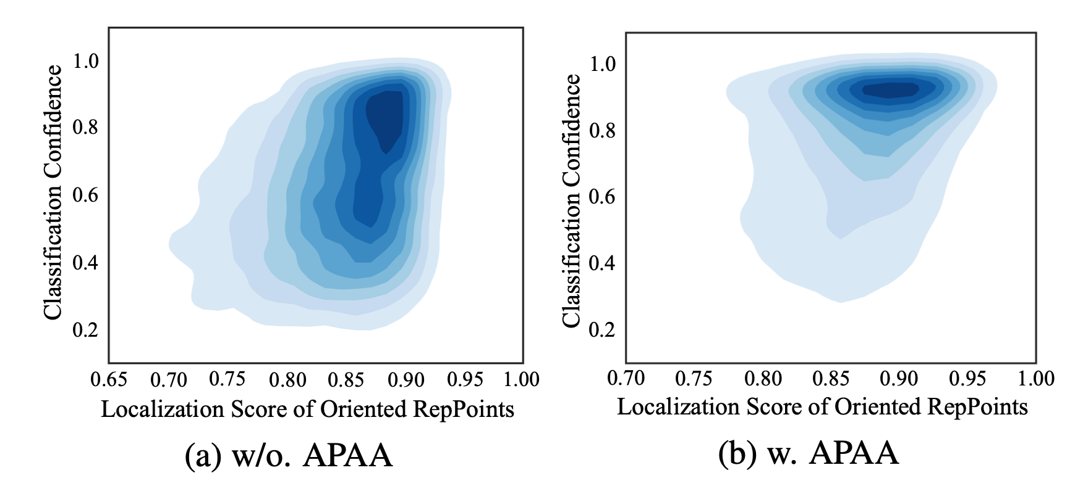

Figure 3.11. The correlation between the predicted classification confidence and localization score of the oriented reppoints with and without APAA scheme.

During the training, the points assigner (excerpt from page 4 [14]) is used to get the sample assignment of center points at the initialization stage. At the refinement stage, the proposed adaptive points assessment and assignment (APAA) scheme is used to select the high-quality points samples according to the quality measure Q. Only the selected positive point sets are assigned with the ground-truth bounding box of target. As shown in Figure 3.11, APAA scheme enables the detector to predict the high-quality oriented reppoints for improving both classification confidence and localization scores. It is worthy of mentioning that the presented scheme is only used for training, which does not incur the computational load at the inference stage.

**3.4. YOLOv5 + Circular Smooth Labels**

**3.4.1. YOLOv5**

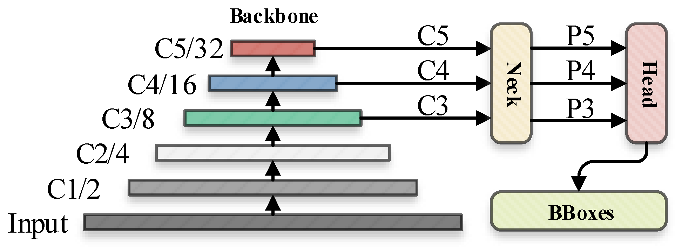

Figure 3.12. The default inference flowchart of YOLOv5

The image was processed through a input layer (input) and sent to the backbone for feature extraction. Figure 3.12 shows the default inference flowchart of YOLOv5.

The backbone obtains feature maps of different sizes, and then fuses these features through the feature fusion network (neck) to finally generate three feature maps P3, P4, and P5 (in the YOLOv5, the dimensions are expressed with the size of 80×80, 40×40 and 20×20) to detect small, medium, and large objects in the picture, respectively. Excerpt from page 4 [6].

After the three feature maps were sent to the prediction head (head), the confidence calculation and bounding-box regression were executed for each pixel in the feature map using the preset prior anchor, so as to obtain a multi-dimensional array (BBoxes) including object class, class confidence, box coordinates, width, and height information.

By setting the corresponding thresholds (confthreshold, objthreshold) to filter the useless information in the array, and performing a non-maximum suppression (NMS) process, the final detection information can be output.

#### 3.4.1.1. YOLOv5 Backbone

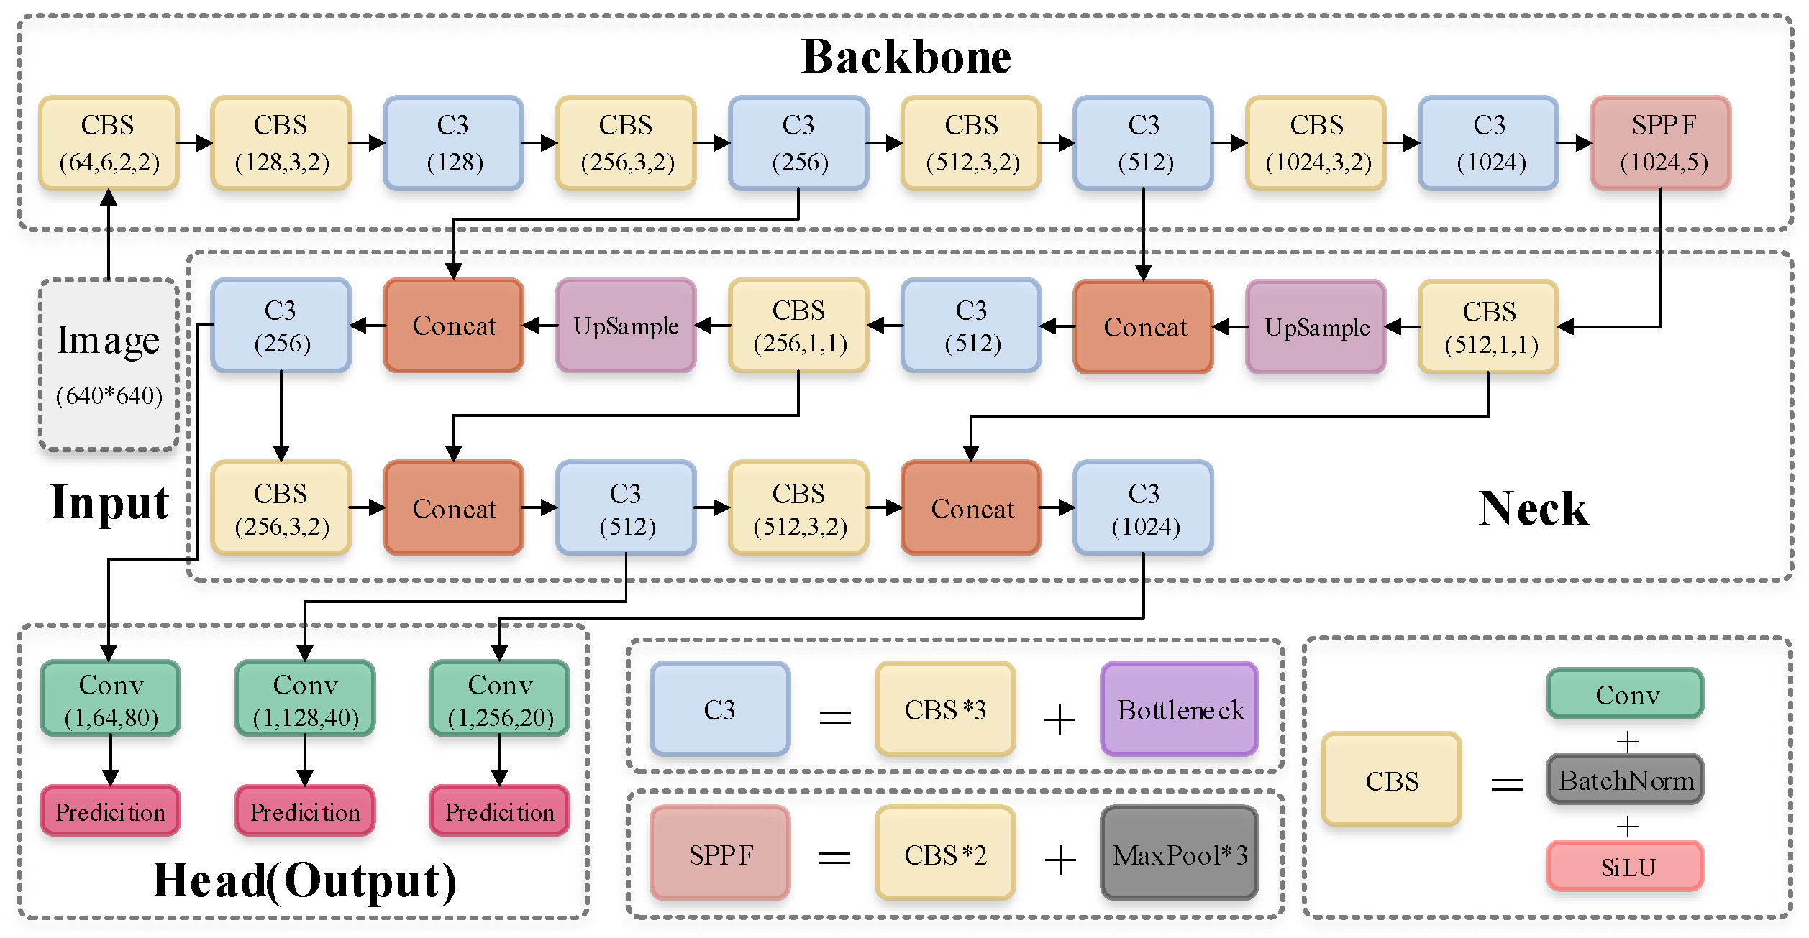

Figure 3.13. Default network structure of YOLOv5

The backbone is CSPDarknet53. The main structure is the stacking of multiple CBS (Conv + BatchNorm + SiLU) modules and C3 modules, and finally one SPPF module (Figure 3.14) is connected.

CBS module is used to assist C3 module in feature extraction, while SPPF module enhances the feature expression ability of the backbone.

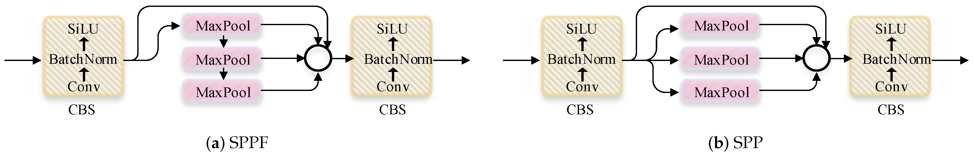

Figure 3.14. Structure comparison of SPPF and SPP

SPPF avoided the repeated operation of SPP as in SPPNet, by max pooling the previous max pooled features.

This can significantly improved the running speed of the module.

#### 3.4.1.2. YOLOv5 Neck

YOLOv5 uses the methods of FPN and PAN.

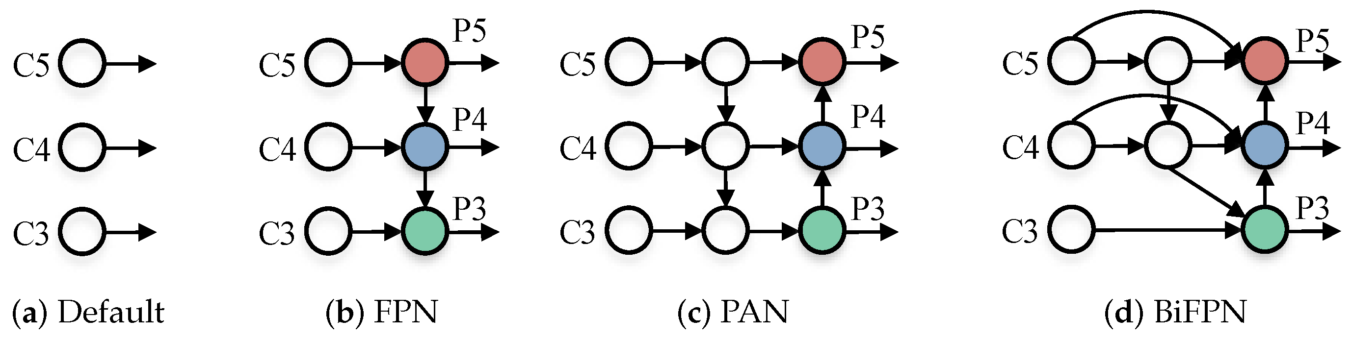

Figure 3.15. Some common feature fusion paths

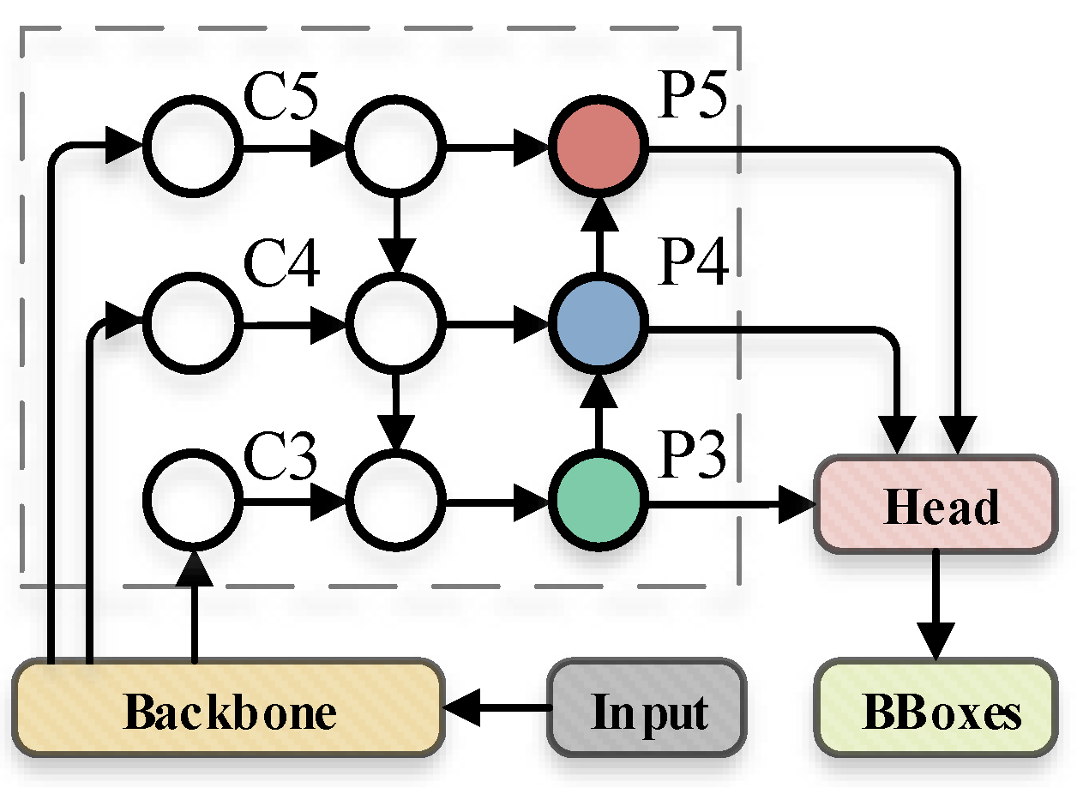

Figure 3.16. The dotted line in the figure is default feature fusion path of YOLOv5

The basic idea of FPN (Figure 3.16) is to up-sampling the output feature map (C3, C4, and C5) generated by multiple convolution down sampling operations from the feature extraction network to generate multiple new feature maps (P3, P4, and P5) for detecting different scales targets.

#### 3.4.1.3. YOLOv5 Head

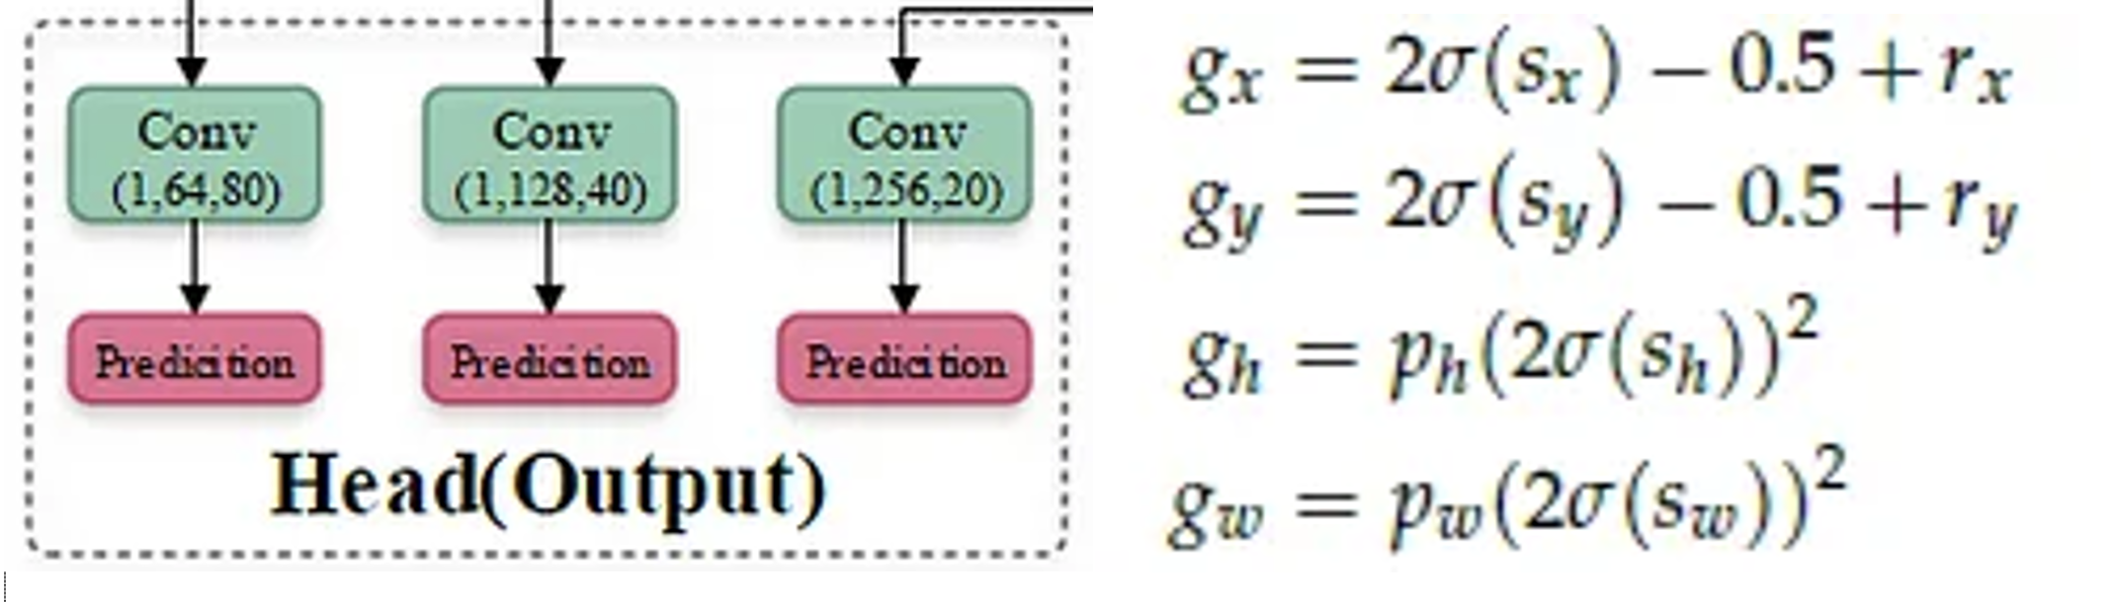

Figure 3.17. YOLOv5 Head & Bounding Box Regression

- The coordinate value of the upper left corner of the feature map is set to (0, 0).

- rx and ry are the **unadjusted coordinates** of the **predicted center point**.

- gx, gy, gw, gh represent the information of the **adjusted prediction box**.

- pw and ph are for the information of the **prior anchor**.

- sx and sy represent the **offsets calculated by the model**.

The process of **adjusting the center coordinate** and **size of the preset prior anchor** to the center coordinate and size of the final prediction box.

#### 3.4.1.4. YOLOv5 Model Variants

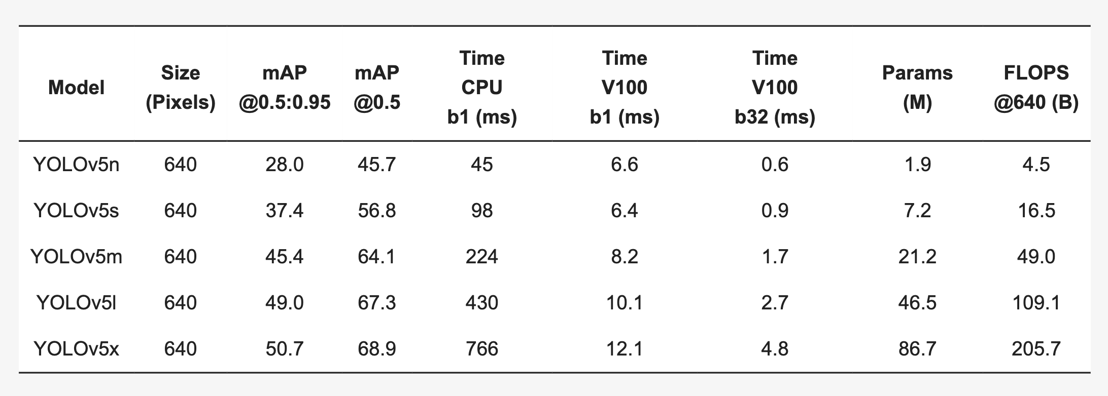

Figure 3.18. Five versions of YOLOv5

There are 5 versions of YOLOv5 (Figure 3.18), namely YOLOv5x, YOLOv5l, YOLOv5m, YOLOv5s, and YOLOv5n.

There are also 5 corresponding larger versions, YOLOv5x6, YOLOv5l6, YOLOv5m6, YOLOv5s6, and YOLOv5n6. Figure 3.19 shows detailed architecture of YOLOv5l.

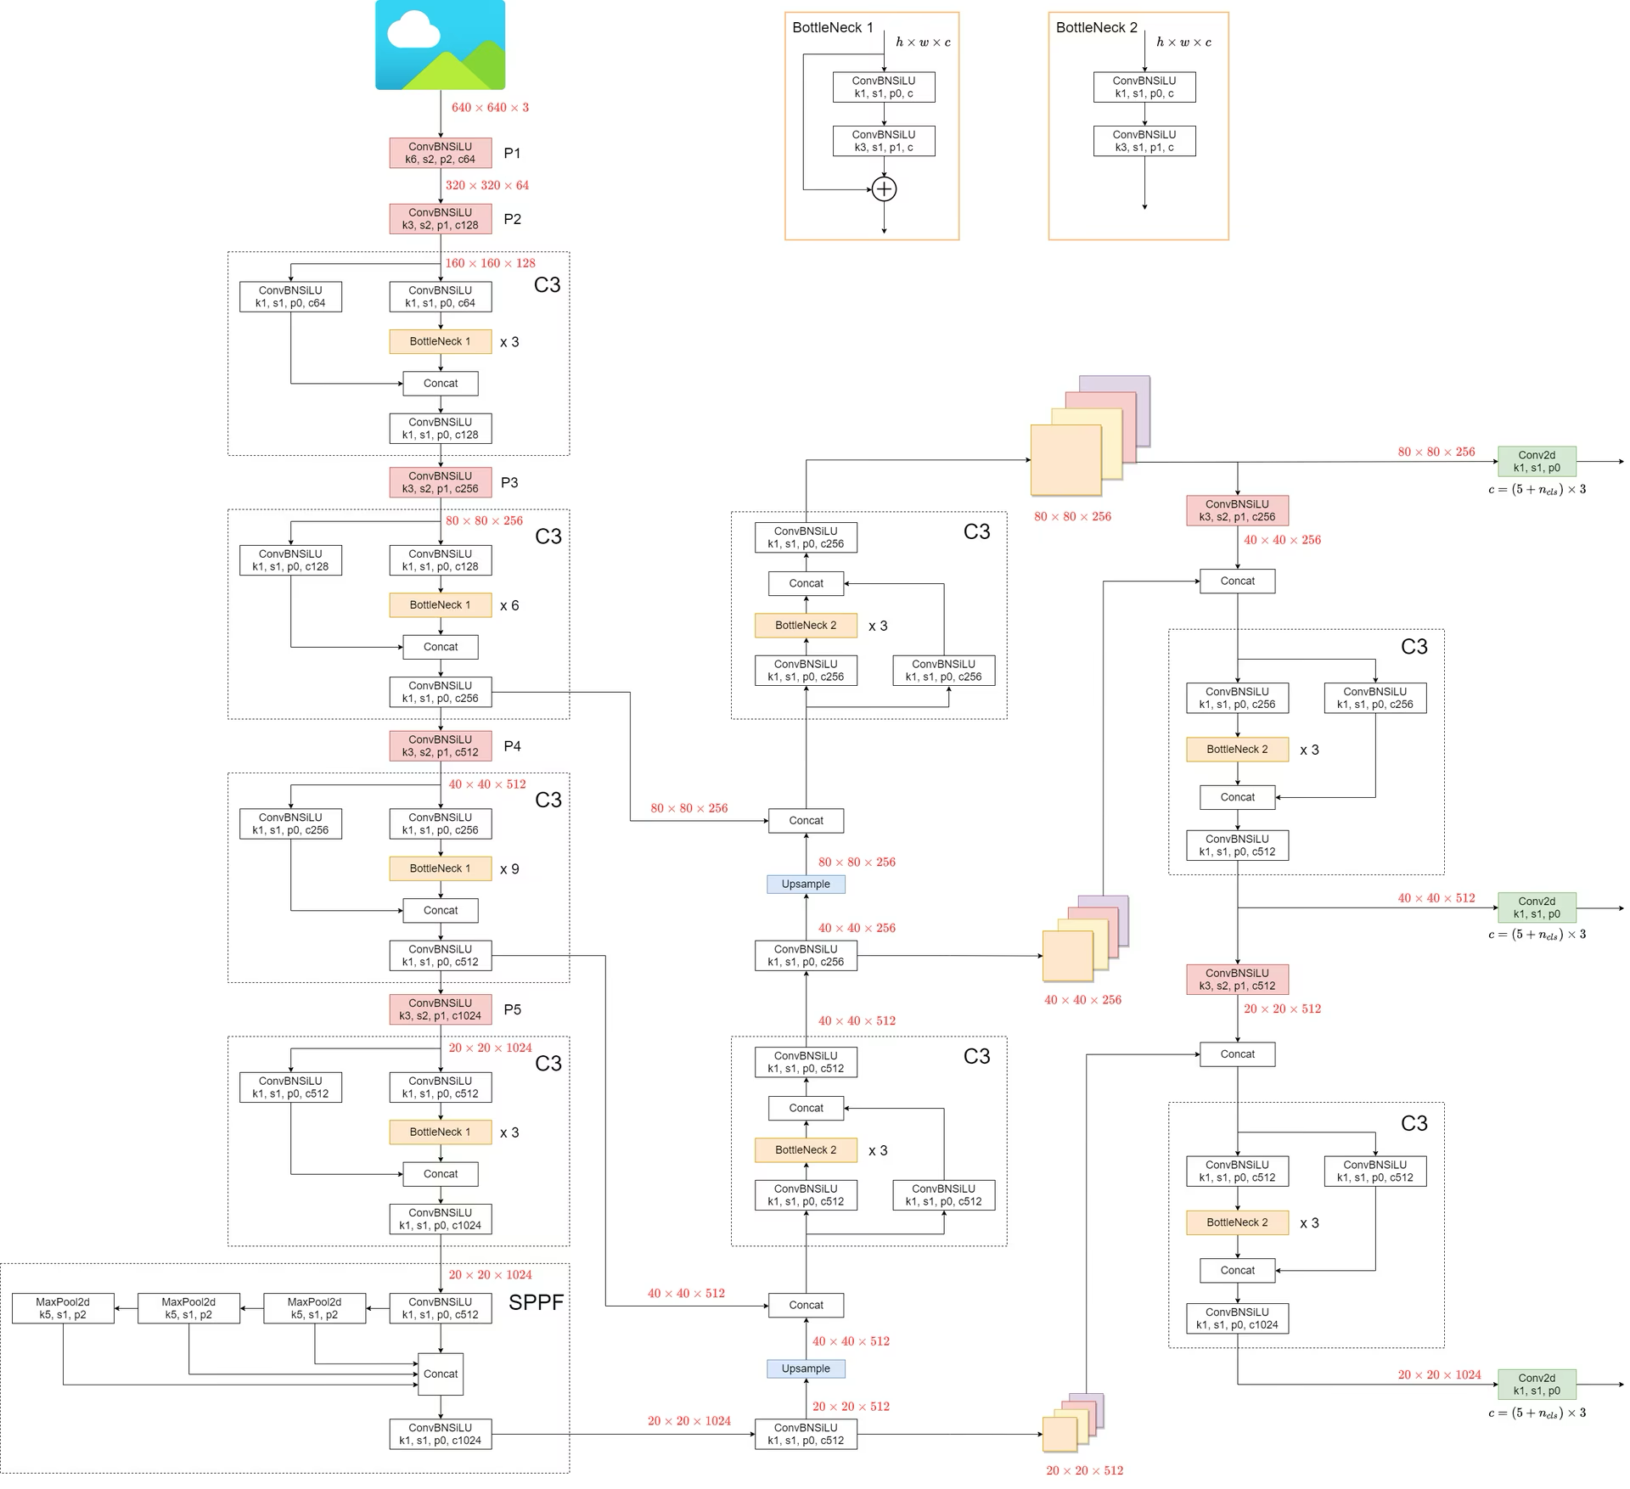

Figure 3.19. YOLOv5l: Detailed Architecture

### 3.4.2. Circular Smooth Labels

#### 3.4.2.1. Regression-based Rotation Detection Method.

Parametric regression is currently a popular method for rotation object detection, mainly including five-parameter regression-based methods and eight-parameter regression-based methods. The commonly used five-parameter regression-based methods realize arbitrary-oriented bounding box detection by adding an additional angle parameter θ. Figure 3.20 (a) shows one of the rectangular definition (x, y, w, h, θ) with 90◦ angular range, θ denotes the acute angle to the x-axis, and for the other side we refer it as w. It should be distinguished from another definition (x, y, h, w, θ) illustrated in Figure 3.20 (b), with 180◦ angular range, whose θ is determined by the long side (h) of the rectangle and x-axis. The eight-parameter regressionbased detectors directly regress the four corners (x1, y1, x2, y2, x3, y3, x4, y4) of the object, so the prediction is a quadrilateral. The key step to the quadrilateral regression is to sort the four corner points in advance, which can avoid a very large loss even if the prediction is correct, as shown in Figure 3.20 (c).

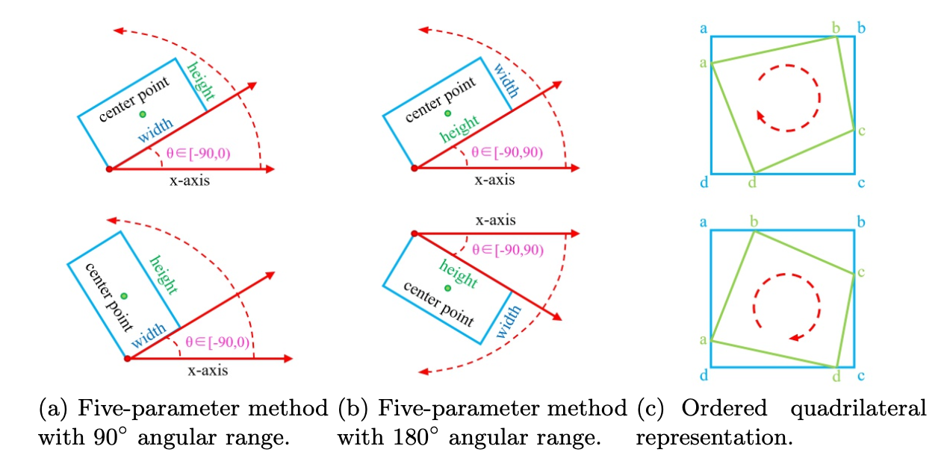

Figure 3.20. Several definitions of bounding boxes

#### 3.4.2.2. Boundary Problem of Regression Method

Although the parametric regression-based rotation detection method has achieved competitive performance in different vision tasks, and has been a building block for a number of excellent detection methods, these methods essentially suffer the discontinuous boundaries problem. Boundary discontinuity problems are often caused by angular periodicity in the five-parameter method and corner ordering in the eight-parameter method, but there exist more fundamental root cause regardless the representation choices of the bounding box.

The boundary discontinuity problem often makes the model’s loss value at the boundary suddenly increase. Thus methods have to resort to particular and often complex tricks to mitigate this issue. Therefore, these detection methods are often inaccurate in boundary conditions. We describe the boundary problem in three typical categories of regression-based methods according to their different representation forms (the first two refer to the five-parameter methods):

- 90◦-regression-based method, as sketched in Figure 3.21 (a). It shows that an ideal form of regression (the blue box rotates counterclockwise to the red box), but the loss of this situation is very large due to the periodicity of angular (PoA) and exchangeability of edges (EoE), see the example in Figure 3.21 (a) for detail. Therefore, the model has to be regressed in other complex forms (such as the blue box rotating clockwise to the gray box while scaling w and h), increasing the difficulty of regression.

- 180◦-regression-based method, as illustrated in Figure 3.21 (b). Similarly, this method also has a problem of sharp increase of loss caused by the PoA at the boundary. The model will eventually choose to rotate the proposal a large angle clockwise to get the final predicted bounding box.

- Point-based method, as shown in Figure 3.21 (c). Through further analysis, the boundary discontinuity problem still exists in the eight-parameter regression method due to the advance ordering of corner points. Consider the situation of an eight-parameter regression in the boundary case, the ideal regression process should be {(a → b),(b → c),(c → d),(d → a)}, but the actual regression process from the blue reference box to the green ground truth box is {(a → a), (b → b), (c → c), (d → d)}. In fact, this situation also belongs to PoA. By contrast, the actual and ideal regression of the blue to red bounding boxes is consistent.

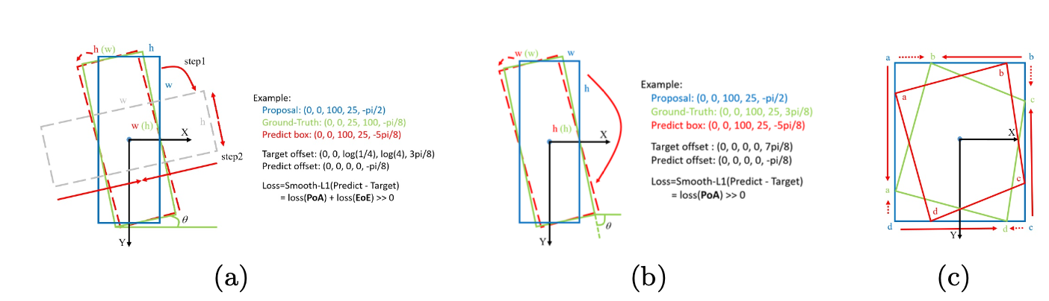

Figure 3.21. The boundary problem of 3 categories of regression based methods. The red solid arrow indicates the actual regression process, and the red dotted arrow indicates the ideal regression process

#### 3.4.2.3. Circular Smooth Label for Angular Classification

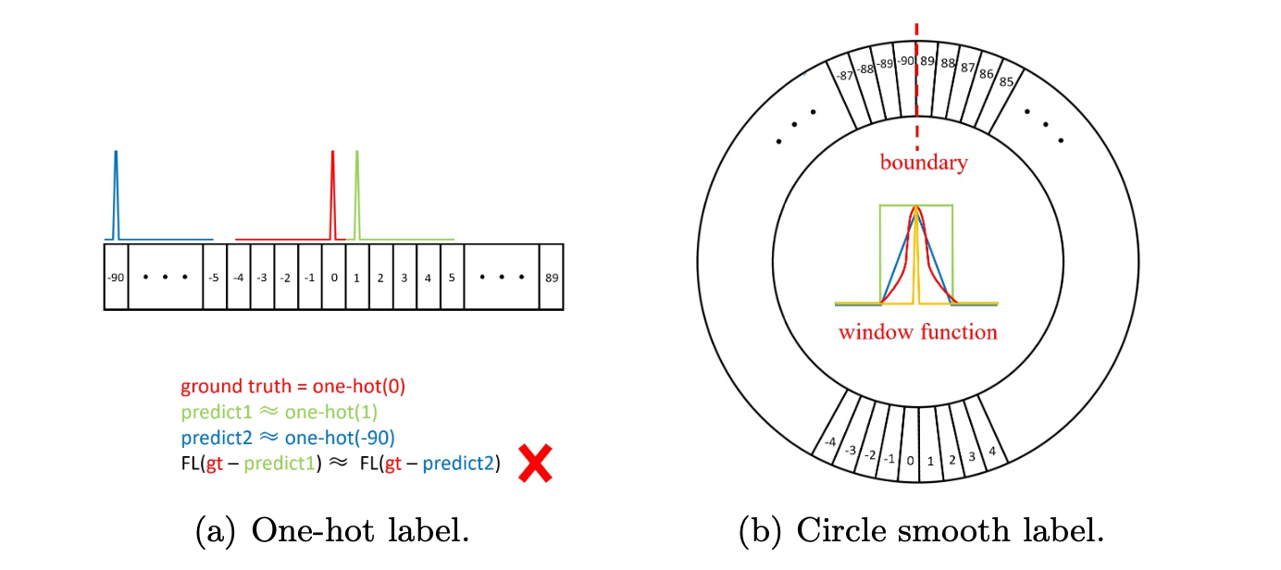

Figure 3.22. Two kinds of labels for angular classification. FL means focal loss

The main cause of boundary problems based on regression methods is that the ideal predictions are beyond the defined range. Therefore, we consider the prediction of the object angle as a classification problem to better limit the prediction results. A simple and straightforward solution is to use the object angle as its category label, and the number of categories is related to the angle range. Figure 3.22 (a) shows the label setting for a standard classification problem (one-hot label encoding). The conversion from regression to classification can cause certain accuracy loss. Taking the five-parameter method with 180◦ angle range as an example, ω (default ω = 1◦) degree per interval refers to a category. We can calculate the maximum accuracy loss Max(loss) and the expected accuracy loss E(loss):

$Max(loss) = \frac{ω}{2}$ (3.19)

$E(loss) = \int_{a}^{b}{x*\frac{1}{b-a}}dx=\int_{0}^{ω/2}{x*\frac{1}{ω/2-0}}dx = \frac{ω}{4}$ (3.20)

Based on the above equations, one can see the loss is slight for a rotation detector. For example, when two rectangles with a 1 : 9 aspect ratio differ by 0.25◦ and 0.5◦ (default expected and maximum accuracy loss), the Intersection over Union (IoU) between them only decreases by 0.02 and 0.05. However, one-hot label has two drawbacks for rotation detection:

- The EoE problem still exists when the bounding box uses the 90◦-regression-based method. In addition, 90◦-regression-based method has two different border cases (vertical and horizontal), while 180◦-regression-based method has only vertical border cases.

- Note vanilla classification loss is agnostic to the angle distance between the predicted label and ground truth label, thus is inappropriate for the nature of the angle prediction problem. As shown in Figure 3.22 (a), when the ground-truth is 0◦ and the prediction results of the classifier are 1◦ and −90◦ respectively, their prediction losses are the same, but the prediction results close to ground-truth should be allowed from a detection perspective.

Therefore, we design a circular smooth label (CSL) technique to obtain more robust angular prediction through classification without suffering boundary conditions, including EoE and PoA. It can be clearly seen from Figure 3.22 (b) that CSL involves a circular label encoding with periodicity, and the assigned label value is smooth with a certain tolerance. The expression of CSL is as follows:

$CSL(x) = \left\{\begin{aligned}g(x), θ - r <x<θ+r \\ 0, otherwise\end{aligned}\right.$ (3.21)

where g(x) is a window function. r is the radius of the window function. θ represents the angle of the current bounding box. An ideal window function g(x) is required to hold the following properties:

- Periodicity: g(x) = g(x + kT ), k ∈ N . T = 180/ω represents the number of bins into which the angle is divided, and the default value is 180.

- Symmetry: 0 ≤ g(θ+ε) = g(θ−ε) ≤ 1,|ε| < r. θ is the center of symmetry.

- Maximum: g(θ) = 1.

- Monotonic: 0 ≤ g(θ±ε) ≤ g(θ±ς) ≤ 1,|ς| < |ε| < r. The function presents a monotonous non-increasing trend from the center point to both sides

We give four efficient window functions that meet the above three properties: pulse functions, rectangular functions, triangle functions, and Gaussian functions, as shown in Figure 3.22 (b). Note that the label value is continuous at the boundary and there is no arbitrary accuracy loss due to the periodicity of CSL. In addition, one-hot label is equivalent to CSL when the window function is a pulse function or the radius of the window function is very small. Excerpt from page 8 [13].

#### 3.4.2.4. Loss function

Our multi-tasking pipeline contains regression-based prediction branch and CSL-based prediction branch, to facilitate the performance comparison of the two methods on an equal footing. The regression of the bounding box is:

$t_{x}=\left(x-x_{a}\right)/w_{a},t_{y}=\left(y-y_{a}\right)/h_{a}$

$t_{w} = log(w/w_{a}), t_{h} = log(h/h_{a})$, (3.22)

$t_{θ} = (θ - θ_{a}) . π/180$ (only for regression branch)

$t_{x}^{'} = (x^{'} - x_{a})/w_{a}, t_{y}^{'} = (y^{'} - y_{a})/h_{a}$

$t_{w}^{'} = log(w^{'} - w_{a}), t_{h}^{'}= log(h^{'}/h_{a})$, (3.23)

$t_{θ}^{'} = (θ^{'} - θ_{a}) . π /180$ (only for regression branch)

where x, y, w, h, θ denote the box’s center coordinates, width, height and angle, respectively. Variables x, xa, x’ are for the ground-truth box, anchor box, and predicted box, respectively (likewise for y, w, h, θ).

The multi-task loss is used which is defined as follows:

$$L = \frac{λ_{1}}{N}\sum_{n =1}^{N}{{obj}_{n} . \sum_{j ∈ \left\{x,y,w,h,θ_{reg}\right\}}{L_{reg}\left(v_{nj}^{'},v_{nj}\right)}}+\frac{λ_{2}}{N}\sum_{n =1}^{N}{L_{CSL}(θ_{n}^{'}, θ_{n})+ \frac{λ_{3}}{N}\sum_{n =1}^{N}{L_{cls} (p_{n}, t_{n})}} (3.24)$$

where N indicates the number of anchors, objn is a binary value (objn = 1 for foreground and objn = 0 for background, no regression for background). $v_{*j}^{'}$ denotes the predicted offset vectors, $v_{*j}$ is the targets vector of groundtruth. $θ_{n}$, $θ_{n}^{'}$ denote the label and predict of angle respectively. tn represents the label of object, pn is the probability distribution of various classes calculated by Sigmoid function. The hyper-parameter λ1, λ2, λ3 control the trade-off and are set to {1,0.5,1} by default. The classification loss Lcls and LCSL is focal loss or sigmoid cross-entropy loss depend on detector. The regression loss Lreg is smooth L1 loss.

### 3.4.3. Combination of YOLOv5 and Circular smooth labels

In the context of oriented object detection, the integration of YOLOv5 with Circular Smooth Labels (CSL) represents a novel approach to enhance both accuracy and performance when dealing with objects appearing at arbitrary angles. YOLOv5, a widely-adopted object detection algorithm, is known for its efficiency in detecting objects using horizontal bounding boxes (HBBs). However, traditional HBBs are not well-suited for detecting objects that are rotated or oriented differently in an image, such as those captured from aerial or drone imagery. This is where the need for Oriented Object Detection (OBB) arises, and combining YOLOv5 with CSL offers a solution

## 3.5. Experiments

### 3.5.1. Dataset

DOTA is a large-scale dataset to evaluate the detection performance of oriented objects in aerial images, which contains 2806 images, 188,282 instances and 15 categories with a variety of orientations, scales, and shapes. The training set has 1411 images while the validation set contains 458 images. Testing set is made of 937 images. The image sizes range from 800 × 800 to 4000 × 4000. In our experiments, both the training set and validation set are employed to train the proposed detector, and the testing set without annotations is used for evaluation. We **crop the original images** into the patches of **1024 × 1024 with a stride of 824**. At the training stage, we randomly resize and flip the images to avoid overfitting.

### 3.5.2. Implementation Details

We implement **Oriented RepPoints** based on both ResNet-50 and ResNet-101 backbone with FPN. The FPN consists of P3 to P7 pyramid levels. The stochastic gradient descent (SGD) optimizer is used in training. The initial learning rate is set to 0.008 with the warming up for 500 iterations, and the learning rate is decreased by a factor of 0.1 at each decay step. The momentum is set to 0.9, and weight decay is 10-4. We train the models with 40 epochs for DOTA. The scale jitter is employed during the training phase. The hyperparameters of focal loss are set to α = 0.25 and γ = 2.0. In Eq. (3.4), we set the balanced weights for each stage λ1 = 0.3 and λ2 =1.0, empirically. We set μ1 =1.0, μ2 = 0.3 and μ3 = 0.1 for quality evaluation Q in Eq. (3.10). A couple of experiments are performed to choose the appropriate values of the sampling ratio σ in **Table 3.1**.

Table 3.1. Evaluation on various σ in the dynamic top k assignment of APAA scheme with ResNet-50-FPN

|  |  |  |  |  |
| --- | --- | --- | --- | --- |
| **σ** | 0.2 | 0.3 | 0.4 | 0.5 |
| **mAP** | 75.36 | 75.23 | **75.92** | 75.55 |

We implement **YOLOv5 with Circular Smooth Labels (CSL)** using the following setup. The model is optimized using stochastic gradient descent (SGD) with an initial learning rate of 0.01, as defined in the configuration file. The momentum is set to 0.937 and weight decay to 5e-4. A cosine learning rate scheduler without restart is employed, and the warm-up period lasts for the first 3 epochs, using a warm-up momentum of 0.8 and a warm-up bias learning rate of 0.1. The model incorporates several augmentations, such as random hue (hsv_h: 0.015), saturation (hsv_s: 0.7), and value (hsv_v: 0.4) adjustments, as well as rotations (degrees: 180.0), scaling (scale: 0.25), translations (translate: 0.1), and flip augmentations (flipud: 0.5, fliplr: 0.5). Mosaic and mixup augmentations are used with probabilities of 0.75 and 0.1, respectively. The model handles object detection loss with a box loss weight of 0.05, classification loss weight of 0.5, and objectness loss weight of 1.0. Additionally, the CSL configuration is specifically adapted for oriented bounding boxes, with a classification theta range of 180 degrees and a circular smooth label radius of 2.0, enabling robust detection of objects in various orientations.

We conduct the experiments on a server with 2 Nvidia Tesla P40 24GB using a total batch size of 8 (2 images per GPU) for training while a single Nvidia Tesla P40 24GB is employed for inference.

**3.5.3. Ablation Study**

To examine the effectiveness of each component in our proposed framework, a series of ablation experiments are performed on DOTA dataset with ResNet-50-FPN.

**Evaluation on oriented conversion functions.** The conventional point set-based object detector RepPoints obtains the upright bounding boxes by square conversion function like min-max, which cannot deal with the aerial objects having arbitrary orientations. To build a reasonable baseline, we compare the different conversion functions that map the adaptive points into the oriented box during the training and post-processing. **Table 3.2** shows the experimental results. Based on the original RepPoints with min-max function both in training and post-processing, it is able to achieve 49.65% mAP. With the proposed oriented MinAeraRect function for post-processing to get the rotated rectangular boxes, it achieves the 53.18% mAP. With the differentiable oriented NearestGTCorner and ConvexHull functions, our Oriented RepPoints obtains the 66.94% mAP and 68.87% mAP, which shows that the oriented conversion functions are essential to aerial object detection.

Table 3.2. Comparison with different conversion functions

|  |  |  |  |
| --- | --- | --- | --- |
| **Methods** | **training** | **post-processing** | **mAP** |
| **Reppoints** | min-max | min-max | 49.65 |
| min-max | MinAeraRect | 53.18 |
| **Oriented RepPoints** | NearestGTCorner | MinAeraRect | 66.94 |
| ConvexHull | MinAeraRect | **68.87** |

Table 3.3. Performance evaluation on spatial constraints. BD, BR, RA and HC denote the categories of Baseball Diamond, Bridge, Roundabout and Helicopter, respectively

|  |  |  |  |  |  |
| --- | --- | --- | --- | --- | --- |
| **Spatial Constraint** | **BD** | **BR** | **RA** | **HC** | **mAP** |
|  | 76.82 | 41.70 | 67.05 | 41.52 | 68.87 |
| **P** | **79.97** | **45.32** | **71.36** | **51.85** | **70.10** |
| improvement | +3.15 | +3.62 | +4.31 | **+10.03** | +1.3 |

conversion functions

**Evaluation on spatial constraint.** To investigate the effectiveness of spatial constraint, we compare it against the baseline method without using it**. Table 3.3** shows the experimental results. It can be observed that our proposed spatial constraint is very effective, especially for the aerial objects with weak feature representation such as HC (Helicopter), and the objects similar to the background, e.g. BD (Baseball Diamond), BR (Bridge) and RA (Roundabout). This is because the spatial constraint enforces the adaptive points on their owner instance object.

**APAA scheme for adaptive points learning.** To study the proposed APAA scheme for adaptive points learning, we first report the performance of the quality measure term-by-term. **Table 3.4** gives the results of different settings on quality assessment measure Q. The detection result is progressively improved, and the proposed approach achieves the best performance with 75.92% mAP and +5.82% gains using all four terms. It indicates that the quality assessment measure is effective to reflect the quality of adaptive points for aerial object detection. In APAA scheme, the number of assigned adaptive points samples is determined by the sampling ratio σ. As shown in **Table 3.1**, the model achieves the best performance when σ = 0.4.

Table 3.4. Performance evaluation on different settings of quality measure Q in APAA scheme

|  |  |  |  |  |  |
| --- | --- | --- | --- | --- | --- |
| Quality Measure $Q$ for Adaptive Points | | | | | |
| $$Q_{cls}$$ |  | **P** | **P** | **P** | **P** |
| $$Q_{loc}$$ |  |  | **P** | **P** | **P** |
| $$Q_{ori}$$ |  |  |  | **P** | **P** |
| $$Q_{poc}$$ |  |  |  |  | **P** |
| mAP | 70.10 | 72.31 | 74.43 | 75.29 | **75.92** |

**3.5.4. Results comparison**

**Results on DOTA.** Oriented RepPoints shows strong performance, especially with the Swin-T-FPN backbone, achieving the highest mAP of 77.61% among anchor-free methods. This indicates its superior detection accuracy. However, the Swin-T-FPN variant has a slower inference speed of 6.8 FPS compared to other models. YOLOv5m_OBB performs slightly lower in accuracy, with a mAP of 77.3%, but compensates with a significantly faster inference speed of 15.5 FPS. This makes it well-suited for real-time applications where speed is prioritized. In summary, Oriented RepPoints is more suitable for tasks demanding higher accuracy, while YOLOv5m_OBB offers a better trade-off between accuracy and speed, making it ideal for real-time scenarios. Figure 3.23 and Figure 3.24 show some visual results on DOTA test set. **Table 3.5** gives the results of Comparison with state-of-the-art methods on DOTA dataset. All reported results are performed on the single-scale DOTA dataset. The results with red color denote the best results and with blue color present the second-best results in each column. Figure 3.25 shows Comparison detection results of Oriented RepPoints with 3 different backbones (R-50-FPN, R-101-FPN, Swin-T-FPN) and YOLOv5_OBB. Figure 3.26 and Figure 3.27 shows training process of Oriented RepPoints. Figure 3.28 shows train loss, val loss and metrics in training phase of YOLOv5_OBB.

Table 3.5. Comparison with state-of-the-art methods on DOTA dataset.

| **Methods** | **Backbone** | **PL** | **BD** | **BR** | **GTF** | **SV** | **LV** | **SH** | **TC** | **BC** | **ST** | **SBF** | **RA** | **HA** | **SP** | **HC** | **mAP** | **fps** |
| --- | --- | --- | --- | --- | --- | --- | --- | --- | --- | --- | --- | --- | --- | --- | --- | --- | --- | --- |
| *Anchor-based Methods* | | | | | | | | | | | | | | | | | | |
| RetinaNet-O | R-50-FPN | 88.65 | 77.62 | 41.80 | 58.16 | 74.57 | 71.63 | 79.11 | 90.27 | 82.17 | 74.31 | 54.75 | 60.58 | 62.56 | 69.67 | 60.62 | 68.42 | 10.5 |
| S2A-Net | R-50-FPN | 89.10 | 82.83 | 48.37 | 71.09 | 78.11 | 78.39 | 87.22 | 90.82 | 84.90 | 85.62 | 60.35 | 62.59 | 65.26 | 69.11 | 57.93 | 74.11 | 9.8 |
| **YOLOv5m_OBB** | CSPDarknet53 | **90.20** | **85.10** | 55.30 | 71.61 | 79.39 | 81.03 | 87.65 | 85.70 | **88.87** | 84.03 | 63.40 | 66.20 | 68.40 | 72.10 | **68.82** | **77.3** | **15.5** |
| Faster RCNN-O | R-50-FPN | 88.42 | 73.04 | 44.86 | 59.05 | 73.23 | 71.45 | 77.11 | 90.82 | 78.92 | 83.88 | 48.59 | 62.91 | 62.18 | 64.87 | 56.16 | 69.03 | 9.5 |
| SCRDet | R-101-FPN | **89.98** | 80.63 | 52.08 | 68.35 | 68.35 | 60.30 | 72.41 | 90.84 | **87.94** | **86.86** | **65.02** | 66.65 | 66.24 | 68.22 | **65.21** | 72.60 | 7.4 |
| RoI-Trans | R-101-FPN | 88.64 | 82.60 | 52.51 | 70.85 | 77.93 | 76.66 | 86.86 | 90.70 | 83.83 | 82.49 | 53.94 | 67.58 | 74.67 | 68.75 | 61.03 | 74.60 | 7.2 |
| Gliding Vertex | R-101-FPN | 89.60 | **85.00** | 52.18 | **77.30** | 73.97 | 73.10 | 86.78 | 90.70 | 78.98 | **86.81** | 59.47 | **70.91** | 72.86 | 70.82 | 57.28 | 74.98 | 7.5 |
| ReDet | ReR-50-ReFPN | 88.74 | 82.59 | 53.92 | 74.95 | 78.08 | **84.01** | **87.99** | 90.84 | 87.73 | 85.70 | 61.71 | 60.34 | **75.96** | 67.93 | 63.54 | 76.20 | 8.9 |
| Oriented R-CNN | R-101-FPN | 88.88 | 83.50 | 55.29 | **76.95** | 74.28 | 82.12 | 87.54 | **90.90** | 85.60 | 85.35 | **65.53** | 66.84 | 74.38 | 70.17 | 57.30 | 76.30 | 7.6 |
| *Anchor-free Methods* | | | | | | | | | | | | | | | | | | |
| CenterNet-O | DLA-34 | 81.01 | 64.02 | 22.61 | 56.59 | 38.62 | 64.01 | 64.91 | 90.81 | 78.01 | 72.51 | 44.99 | 41.12 | 55.51 | 55.01 | 57.41 | 59.11 | **11.7** |
| DRN | H-104 | 89.70 | 82.33 | 47.21 | 64.07 | 76.24 | 74.42 | 85.83 | 90.56 | 86.17 | 84.87 | 57.66 | 61.92 | 69.29 | 69.62 | 58.47 | 73.22 | 7.2 |
| Oriented Reppoints | R-50-FPN | 87.01 | 83.08 | 54.08 | 71.07 | **80.17** | 78.35 | 87.21 | **90.92** | 85.88 | 86.20 | 59.85 | **70.48** | 73.44 | 72.21 | 58.93 | 75.92 | 9.7 |
| Oriented Reppoints | R-101-FPN | 89.51 | 84.05 | **59.84** | 71.74 | 79.93 | 80.01 | 87.31 | 90.82 | 87.52 | 85.21 | 59.13 | 66.35 | 75.21 | **73.73** | 57.21 | 76.50 | 8.6 |
| **Oriented Reppoints** | Swin-T-FPN | 89.09 | 82.30 | **56.69** | 74.93 | **80.68** | **83.71** | **87.65** | 90.79 | 87.09 | 85.83 | 63.58 | 68.58 | **75.93** | **73.52** | 63.74 | **77.61** | 6.8 |

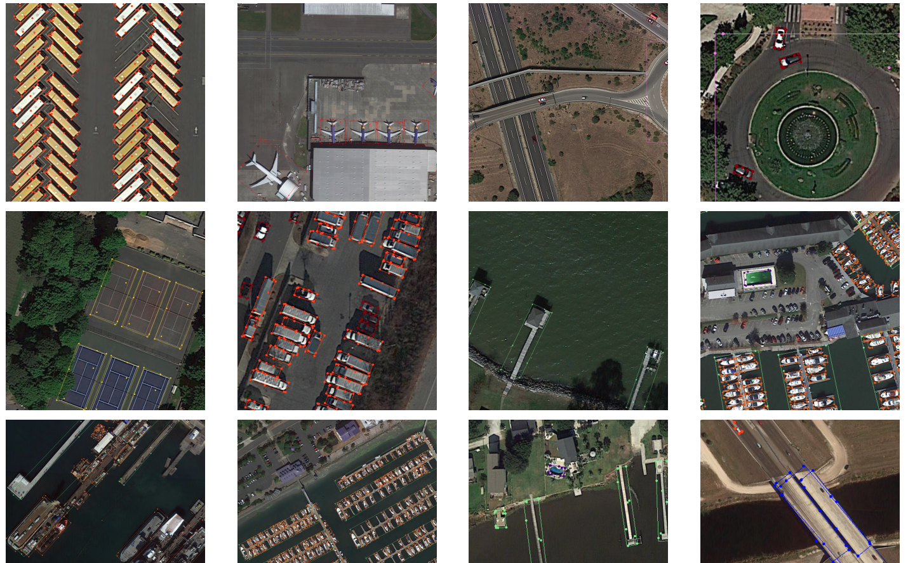

Figure 3.23. Examples detection results of Oriented RepPoints with Swin-T-FPN backbone on DOTA test set

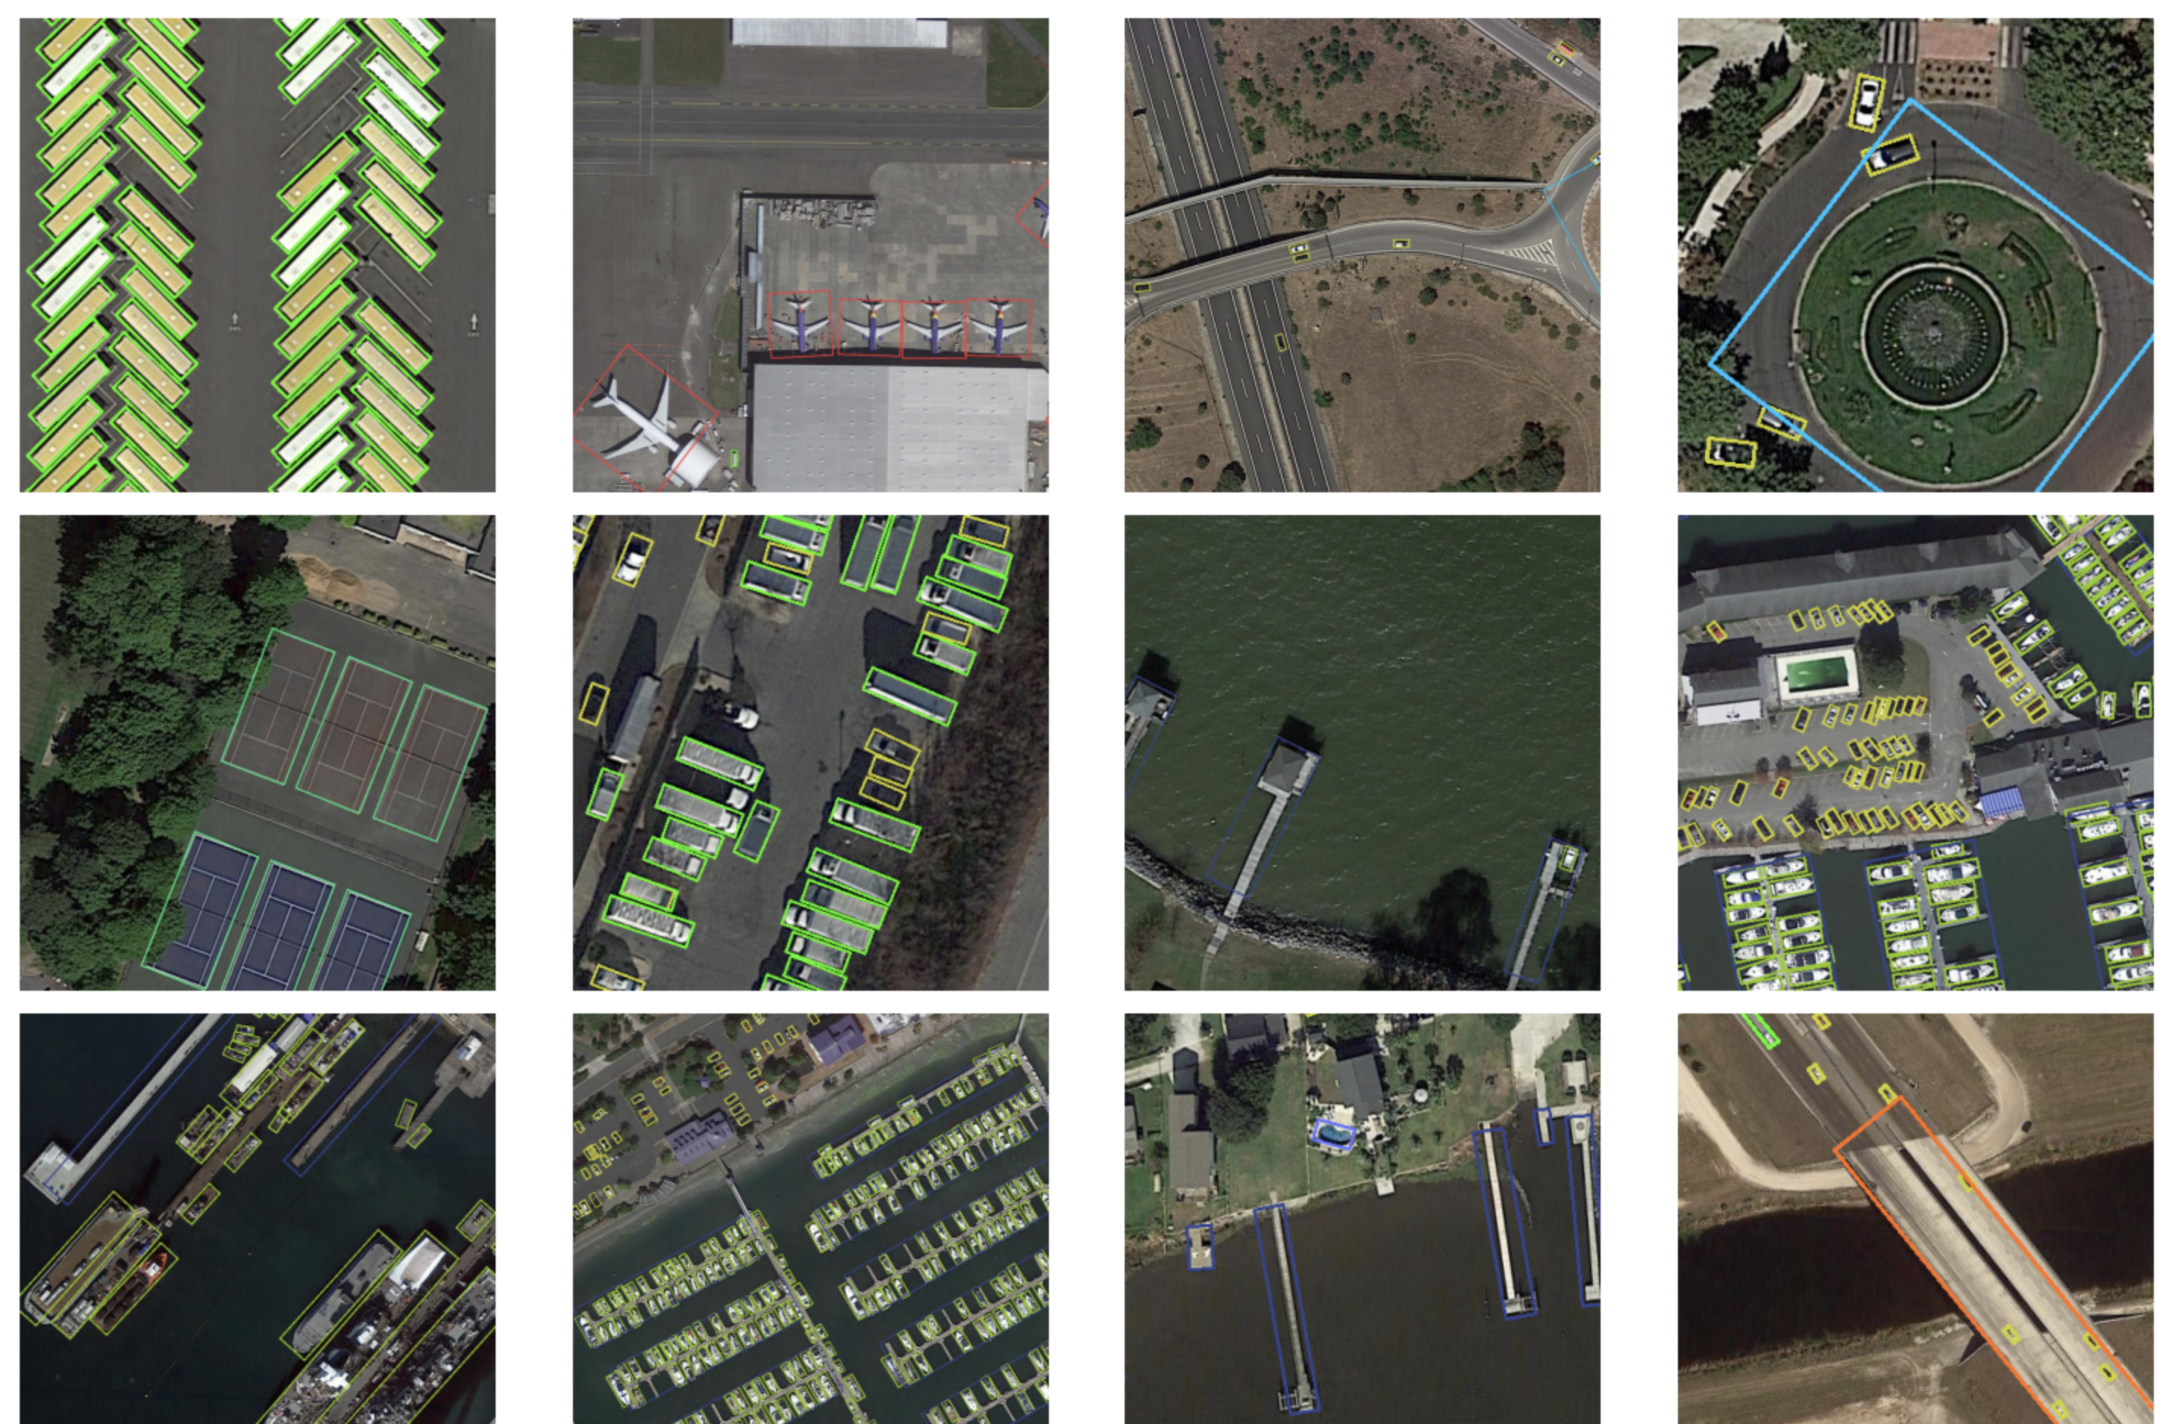

Figure 3.24. Examples detection results of YOLOv5_OBB on DOTA test set

Table 3.6. Comparison for Oriented RepPoints with different backbone and with or with-out data augmentation (HSV & Rotation)

|  |  |  |  |
| --- | --- | --- | --- |
| **Model** | **Backbone** | **Data aug (HSV + Rotation)** | **mAP** |
| Oriented Reppoints | R-50-FPN |  | 75.92 |
| Oriented Reppoints | R-101-FPN |  | 76.50 |
| Oriented Reppoints | Swin-Tiny | **P** | **78.09** |

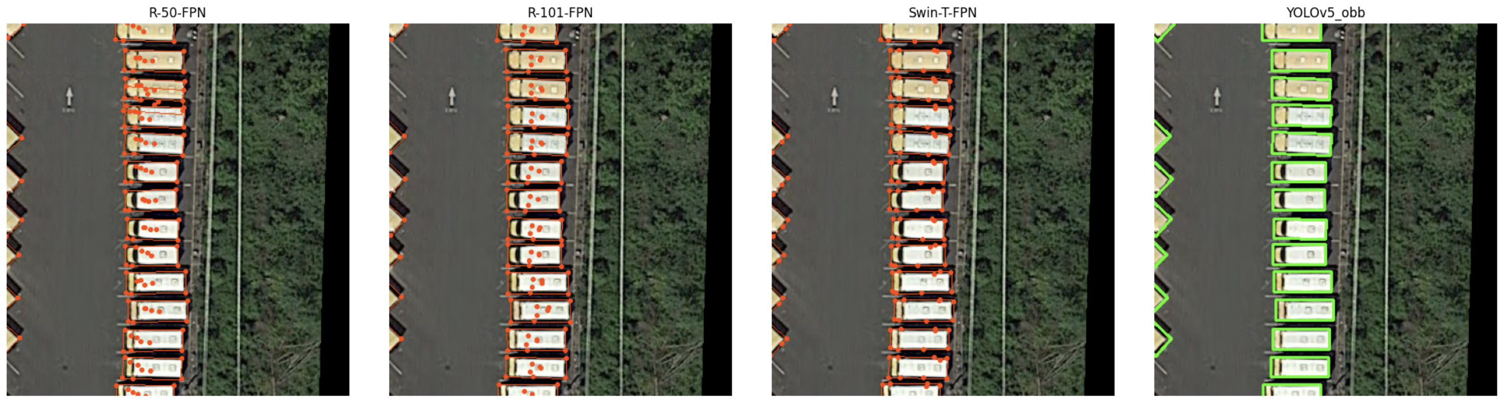

Figure 3.25. Comparison detection results of Oriented RepPoints with 3 different backbones (R-50-FPN, R-101-FPN, Swin-T-FPN) vs. YOLOv5_OBB

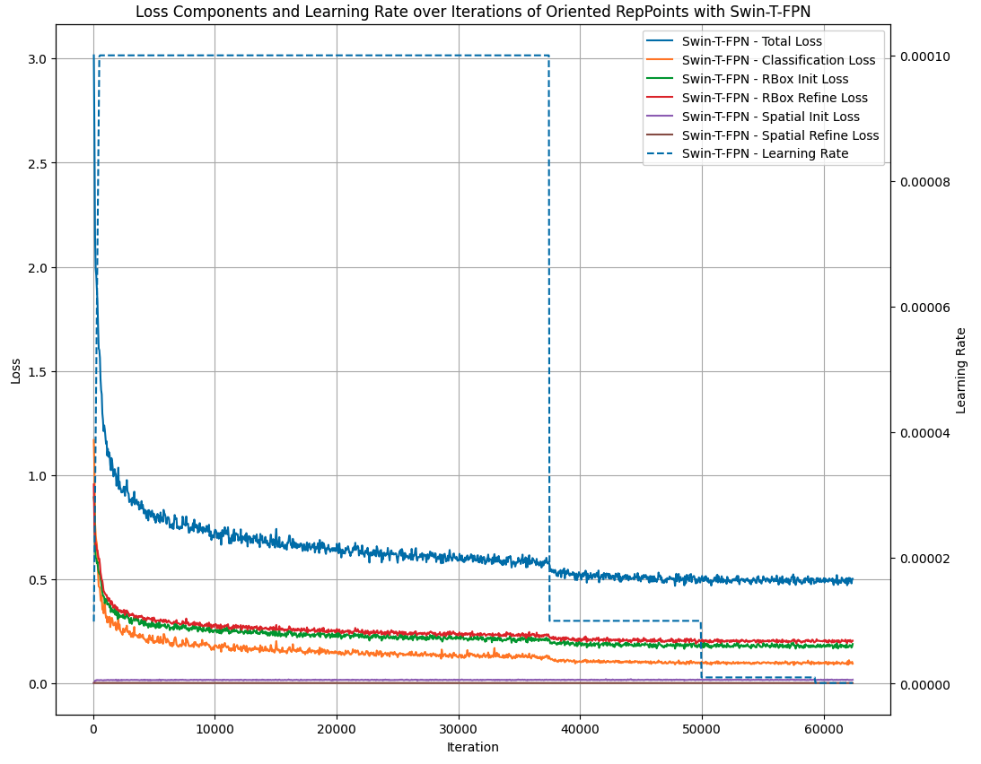

Figure 3.26. Loss Components and Learning Rate over Epochs of Oriented RepPoints with Swin-T-FPN backbone

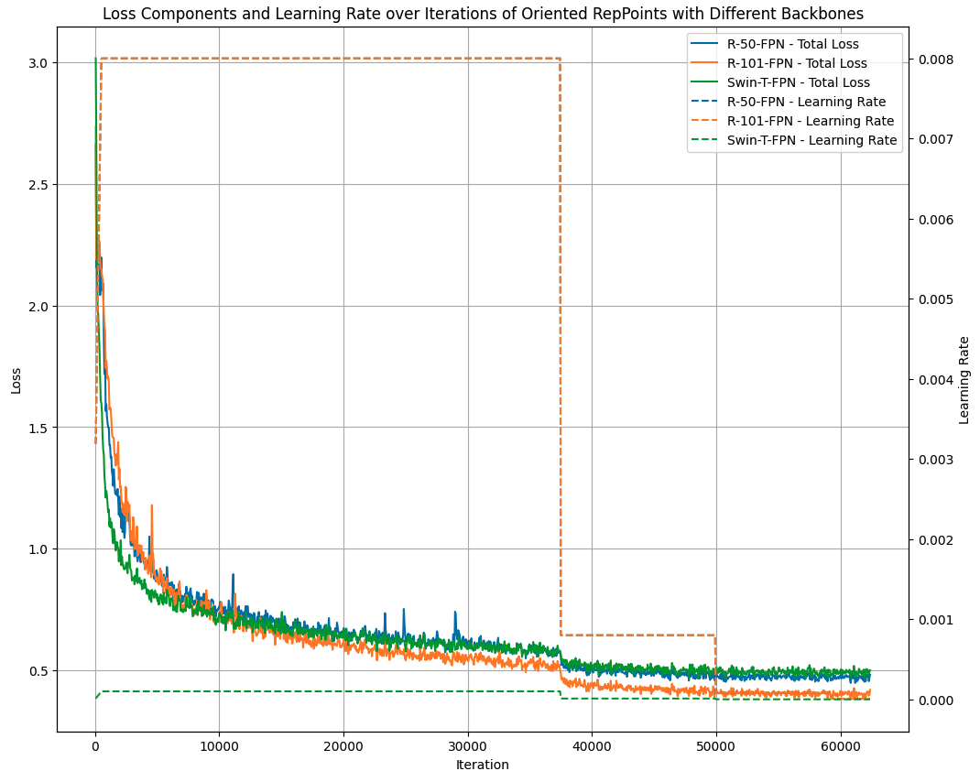

Figure 3.27. Comparison of Total loss and Learning rate across different backbones

### 3.5.5. Discussion

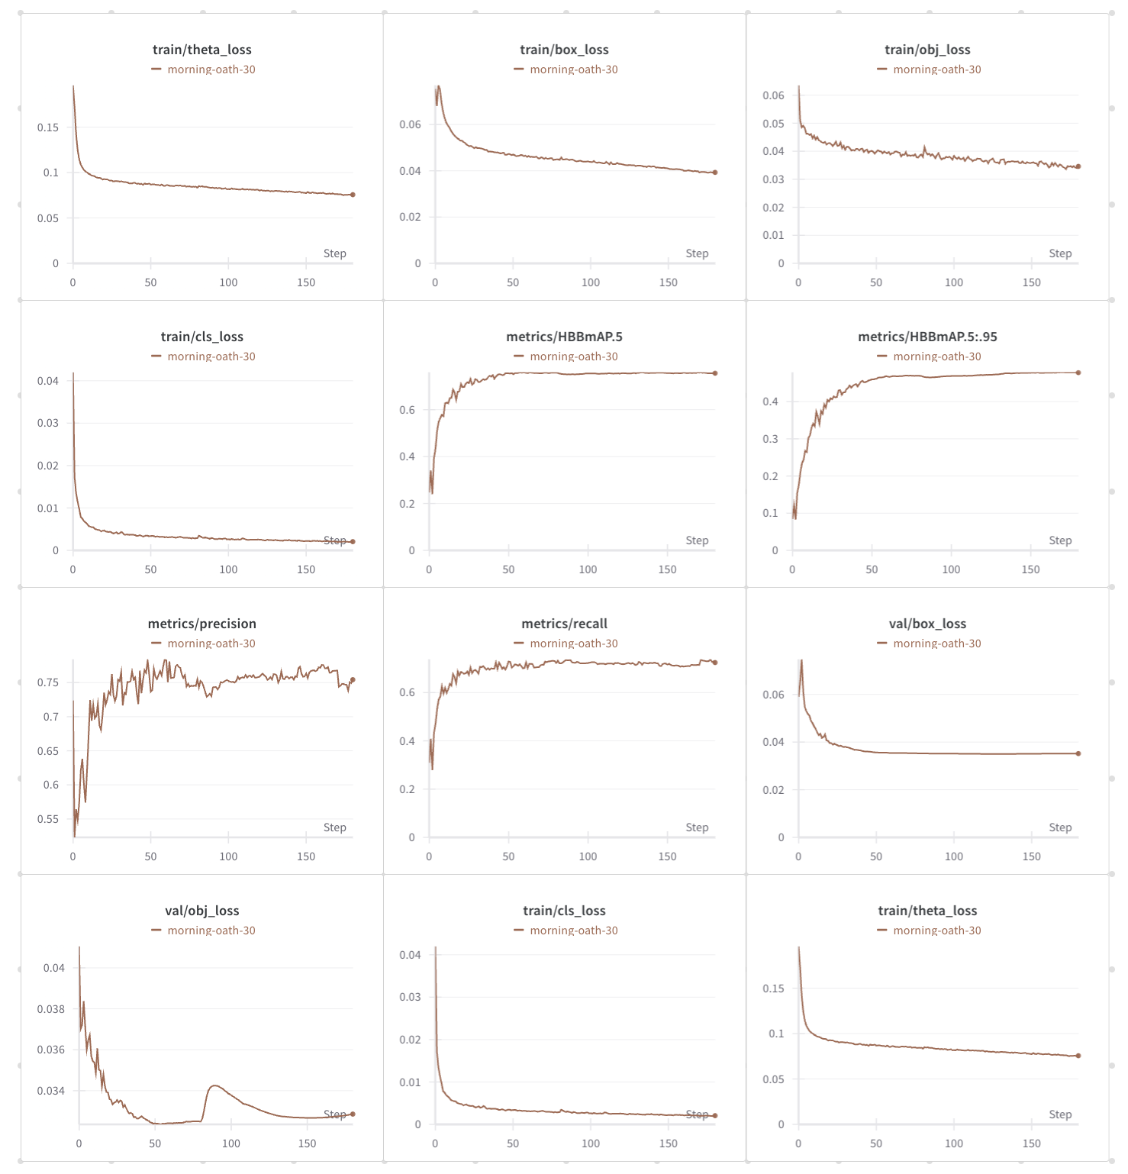

Figure 3.28. Train loss, val loss and metrics in training phase of YOLOv5_OBB

In this discussion, we delve into the performance and characteristics of the algorithms tested on the DOTA dataset with oriented bounding boxes, with particular focus on Oriented RepPoints and YOLOv5_OBB.

Oriented RepPoints stands out as an anchor-free detector that excels in accuracy, achieving a mAP of 77.61%. This level of precision is impressive, particularly in tasks requiring nuanced and accurate object detection, such as in complex scenes typical of the DOTA dataset. Oriented RepPoints adopts a unique approach by leveraging an adaptive point set rather than relying on predefined anchors. This design contributes to its superior accuracy and flexibility across varying object scales and orientations. However, its inference speed places it somewhere between one-stage and two-stage detectors, making it neither the fastest nor the slowest in terms of processing time. This trade-off between speed and accuracy is crucial for applications where precise object localization is paramount, but the time constraints are not overly stringent.

On the other hand, YOLOv5_OBB combines the efficiency of YOLOv5 with the circular smooth label technique, delivering a balanced performance. While its accuracy (mAP 77.3%) is marginally lower than that of Oriented RepPoints, YOLOv5_OBB compensates with faster inference speed. As a one-stage detector, it processes images more quickly, making it highly suitable for real-time applications where speed is a critical factor. Despite its slightly lower accuracy, YOLOv5_OBB's performance is robust, and its rapid inference capabilities can be particularly advantageous in scenarios where time efficiency is prioritized over marginal gains in detection accuracy.

***Conclusion***: The choice between Oriented RepPoints and YOLOv5_OBB depends on the specific needs of the task at hand. If the primary goal is to achieve the highest possible accuracy, particularly in applications where precise object detection is critical, Oriented RepPoints would be the preferred option. However, if the application demands faster processing speeds with a slight compromise on accuracy, YOLOv5_OBB offers a more suitable balance. Therefore, the selection of the algorithm should be guided by whether accuracy or speed is the primary concern for the given application.

## 3.6. Additional Experiments on DroneVehicle Dataset

Objective: Extend the evaluation to the DroneVehicle dataset, which contains both RGB and IR images, in order to understand the performance of YOLOv5_obb and compare it with other algorithms in this new context.

### 3.6.1. Dataset

In recent years, some aerial view datasets have been proposed for aerial vehicle detection. For example, VisDrone consists of 263 video clips and 10209 images with rich annotations (such as object bounding boxes, object categories, occlusion, truncation ratios, etc). DOTA includes 15 different categories and contains 188282 annotated object instances. The latest DOTA-v1.5 also adds many annotations to the small object instances about or below 10 pixels that were missed previously. Excerpt from page 2 [3].

Existed datasets have greatly promoted the application of vehicle detection in aerial view scenes, but there are many dark night scenarios in the real world, and it is difficult to handle such cases only relying on the RGB modality. However, all of the above-mentioned datasets only contain RGB modality except the VEDAI. The infrared images generally perform well in dark night scenarios, but unfortunately, the VEDAI dataset is small and lacks sufficient dark night scenarios, so the complementarity of the two modalities cannot be reflected.

In contrast to the above-mentioned aerial view datasets, we propose DroneVehicle dataset contains pairs of RGB images and infrared images collected in various urban environments, which can support the research of cross-modal vehicle detection.

#### 3.6.1.1. Datasets description

The DroneVehicle remote sensing dataset comprises 28,439 RGB-infrared image pairs, depicting vehicles and captured by UAVs equipped with cameras. These images represent various regional scenes, including urban roads, residential areas, and highways. The lighting conditions during capture are categorized into dark night, night, and day, while the shooting height is divided into 80 m, 100 m, and 120 m. Additionally, the shooting angle is categorized into 15°, 35°, and 45°.Some example images are shown in Figure 3.29.

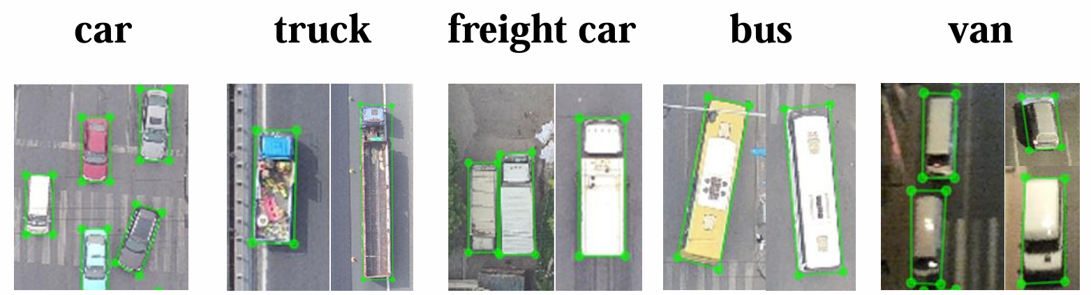

Figure 3.29. Examples of five categories in the DroneVehicle

In typical object detection tasks, objects are usually recognized by upright rectangular bounding boxes, annotated in the format (x, y, w, h), where (x, y) represents the coordinates of the center, and w and h correspond to the width and height of the bounding box. However, in the task of oriented object detection, objects are annotated using a four-point polygon (xi, yi), where i = 1, 2, 3, 4 for each object, with (xi, yi) denoting the vertices of the oriented bounding boxes in the image. In the DroneVehicle dataset, to annotate objects at the image boundaries, the authors added a white border with a width of 100 pixels to the top, bottom, left, and right of each image, resulting in a final image size of 840 x 712. We decided to retain this border during training because some annotations have coordinates within the white border area.

Table 3.7. Summary of annotation counts for classes in the Drone Vehicle dataset

|  |  |  |  |  |  |  |  |  |  |  |
| --- | --- | --- | --- | --- | --- | --- | --- | --- | --- | --- |
| Subset | Car | | Freight-car | | Truck | | Bus | | Van | |
| R | I | R | I | R | I | R | I | R | I |
| Train | 246,700 | 270,350 | 8,712 | 11,193 | 13,685 | 15,833 | 10,421 | 11,334 | 7,275 | 7,701 |
| Test | 124,114 | 137,148 | 3,978 | 5,062 | 7,102 | 8,657 | 4,161 | 4,467 | 3,960 | 4,282 |
| Validation | 18,965 | 20,588 | 710 | 918 | 1,336 | 1,470 | 751 | 789 | 700 | 725 |
| Dataset | 389,779 | 428,086 | 13,400 | 17,173 | 22,123 | 25,960 | 15,333 | 16,590 | 11,935 | 12,708 |

**Statistics and Attributes:** During the dataset calibration phase, affine transformation and region cropping are applied to the RGB-infrared image pairs to ensure alignment of most cross-modality image pairs. The annotations in the DroneVehicle dataset consist of oriented bounding boxes for five categories. A statistical summary of the annotations for each class is presented in Table 3.1.

The brightness levels, altitudes, and shooting angles of the images in the dataset are also summarized by the authors as shown in the Figure 3.30.

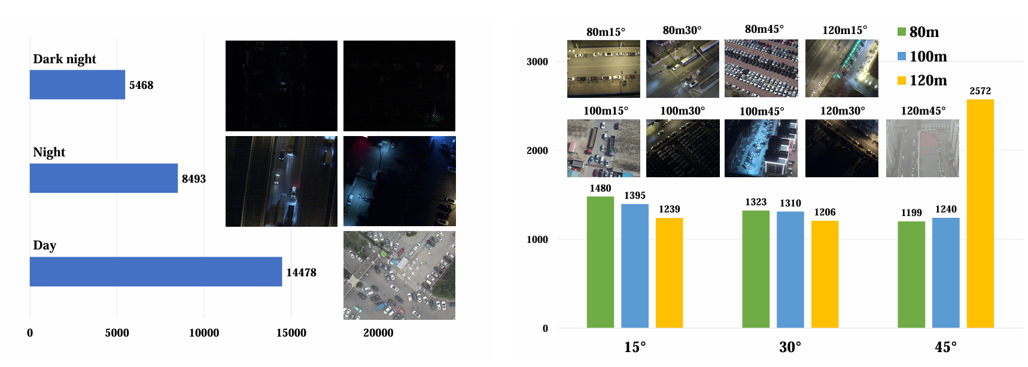

Figure 3.30. The distribution of data under different lighting conditions (left) and at different heights and angles (right) in the DroneVehicle dataset and its sample images.

#### 3.6.1.2. Dataset processing pipeline

The data preprocessing steps before feeding the data into the training process are as follows:

train_pipeline = [

*dict*(*type*='LoadImageFromFile'),

*dict*(*type*='LoadAnnotations', *with_bbox*=True),

*dict*(*type*='RResize', *img_scale*=(512,640)),

*dict*(

*type*='RRandomFlip',

*flip_ratio*=[0.25, 0.25, 0.25],

*direction*=['horizontal', 'vertical', 'diagonal'],

*version*=angle_version),

*dict*(*type*='Normalize', **img_norm_cfg),

*dict*(*type*='Pad', *size_divisor*=32),

*dict*(*type*='DefaultFormatBundle'),

*dict*(*type*='Collect', *keys*=['img', 'gt_bboxes', 'gt_labels'])

]

This data processing pipeline is designed for pre-processing images and annotations in preparation for training a deep learning model, specifically for tasks like object detection. Each step in the pipeline serves a specific function to transform the raw input data into a format that can be efficiently used by the model. Below is an objective description of each step:

**LoadImageFromFile**: This step is responsible for loading images from files. The images are read from the disk and converted into tensors, which are the format required for input into a deep learning model.

**LoadAnnotations**: In this step, the annotations associated with the images are loaded. These annotations include bounding boxes (which define the locations of objects within the images) and the corresponding labels for each object. This information is crucial for object detection tasks, as the model learns to identify and localize objects based on these annotations.

**RResize**: The images are resized to a fixed scale of (512, 640) in this step. Resizing standardizes the image dimensions, ensuring that all images fed into the model have the same size, which simplifies processing and helps improve computational efficiency.

**RRandomFlip**: This is a data augmentation step that performs random flipping of images to introduce variability in the dataset. The images can be flipped horizontally, vertically, or diagonally with a probability of 0.25 for each direction. This helps prevent the model from becoming too dependent on specific orientations of objects in the training data.

**Normalize**: In this step, the pixel values of the images are normalized using the mean and standard deviation values defined in img_norm_cfg. Normalization is important for ensuring that the input images have a consistent range of pixel values, which stabilizes the training process and can lead to better convergence.

**Pad**: Padding is applied to the images to ensure that their dimensions are divisible by 32 (as specified by size_divisor=32). This is typically done to match the input requirements of certain convolutional neural network architectures and to optimize the performance on GPU hardware.

**DefaultFormatBundle**: This step bundles the images, bounding boxes, and labels into a standardized format that is compatible with the subsequent processing steps or the model itself. This ensures that the data is organized correctly and ready for training or inference.

**Collect**: In the final step, the required data components are collected into a dictionary. The keys include the image (img), ground truth bounding boxes (gt_bboxes), and ground truth labels (gt_labels). These components are the essential inputs for training the model on object detection tasks.

For datasets consisting of paired Infrared and RGB images, we modified the data loading functions to simultaneously load the paired images.

For methods based on the Yolo model, we additionally utilized the mosaic loading method to augment the images. Mosaic augmentation involves selecting four random images from the dataset, resizing them to fit into quadrants of a new canvas, and then stitching these images together to form a single composite image. After the images are combined, the bounding boxes of the objects in each image are adjusted to reflect their new positions within the composite image. This technique enhances data diversity and helps improve the model's ability to generalize by exposing it to various object appearances and contexts within a single frame.

Thus, the previous sections have introduced and provided information on object detection methods using infrared and RGB images for the task of object detection in UAV-captured images, with the goal of oriented object detection. In this section, we will present the experiments, comparisons, and evaluations conducted with these methods on the proposed Drone Vehicle dataset. Due to the specific nature of the task, which involves oriented object detection and the use of multiple types of images, this dataset is the only one that meets the required criteria.

### 3.6.2. Implementation

**Datasets and metrics.** We evaluate our method on DroneVehicle dataset, which is a large-scale multi-modal dataset for vehicle detection in UAVs images. Though the DroneVehicle performs pre-registration on each RGB-IR image pair, the weakly misalignment problem still exists.

This dataset is divided into 17,990 image pairs for training, 1,469 image pairs for validating, and the remaining 8,980 image pairs for testing. Following the standard evaluation metrics, we report the mean average precision (mAP) with intersection over union (IoU) threshold of 0.4 on the validation set.

**Training details.** The experiments are carried out on a single NVIDIA Tesla P40 GPU with 24 GB of memory. We implement our algorithm with Pytorch toolbox and SGD optimizer with a momentum of 0.937 and a weight decay of 0.0005. The initial learning rate is set to 0.01 and eventually reduced to 0.002 by cosine annealing. The input size of our model is set to 640×640 in the preprocessing stage and the batch size is 16. The training epoch is set to 300 epochs.

### 3.6.3. Results comparison

**Compared methods.** We compare YOLOv5_obb method with the state-of-the-art unimodal object detection methods. Unimodal methods: We choose a series of oriented object detection methods for comparison, including the one-stage methods: RetinaNet, S2ANet, and YOLOv5m; and the two-stage methods: Faster R-CNN, Oriented R-CNN, and RoI Transformer. RGB and IR images are separately used as training data to evaluate the detection performance of each algorithm.

Table 3.8. Detection results (mAP, in %) on DroneVehicle dataset.

| **Methods** | **Model type** | **Car** | **Truck** | **Freight-car** | **Bus** | **Van** | **mAP (%)** |
| --- | --- | --- | --- | --- | --- | --- | --- |
| **RGB modal** | | | | | | | |
| RetinaNet-O | Single stage detector | 78.4 | 33.5 | 21.3 | 70.0 | 28.7 | 47.1 |
| S2A-Net | 76.9 | 49.6 | 36.1 | 77.9 | 37.0 | 55.5 |
| **YOLOv5m_OBB** | **79.5** | 49.6 | **40.9** | **80.8** | 38.6 | **57.9** |
| Faster RCNN-O | Two stage detector | 79.0 | 48.8 | 37.1 | 76.8 | 37.0 | 55.8 |
| RoI-Trans | 78.0 | 51.3 | 38.7 | 78.7 | **39.9** | 57.3 |
| Oriented R-CNN | 77.7 | **50.2** | 39.4 | 78.4 | 37.8 | 56.7 |
| **IR modal** | | | | | | | |
| RetinaNet-O | Single stage detector | 88.7 | 35.3 | 39.4 | 76.4 | 32.0 | 54.4 |
| S2A-Net | 89.9 | 64.1 | 51.3 | 88.7 | 40.6 | 66.9 |
| **YOLOv5m_OBB** | 89.1 | 59.4 | **53.4** | 86.4 | **51.8** | 68.0 |
| Faster RCNN-O | Two stage detector | 89.4 | 53.5 | 48.3 | 87.0 | 42.6 | 64.2 |
| RoI-Trans | **90.1** | **65.0** | 52.6 | **88.9** | 44.9 | **68.3** |
| Oriented R-CNN | **90.1** | 64.4 | 53.3 | 88.6 | 42.2 | 67.7 |

The results on the DroneVehicle dataset (**Table 3.8**) highlight the performance of YOLOv5_obb compared to several other state-of-the-art methods on both RGB and IR modalities. Note that all detectors locate and classify vehicles with OBB heads. Best results are highlighted in **bold**. And the second one is marked with underline.

**RGB Modal Evaluation**: YOLOv5m_obb demonstrates a balanced performance across the vehicle categories, especially excelling in the detection of freight cars and trucks with a mAP of 57.9%, outperforming even two-stage detectors such as Faster RCNN-O (55.8%). While it falls slightly short in comparison to Oriented R-CNN on categories like bus and van, its superior speed-to-accuracy trade-off makes it a compelling choice for real-time applications, especially when dealing with UAV data, where processing speed is crucial.

**IR Modal Evaluation**: In the infrared (IR) modality, YOLOv5m_obb further strengthens its position, achieving the highest mAP of 68.0%. It surpasses both single-stage and two-stage detectors in detecting smaller and more challenging vehicle types such as freight cars (53.4%) and vans (51.8%), showcasing its robustness in diverse environments and lighting conditions. Notably, the precision in detecting cars (89.1%) also highlights the method's adaptability to infrared data, where contrast and features are less distinct than in RGB images.

**Comparison with Other Methods**: While YOLOv5m_obb performs well overall, it is important to note that RoI-Trans and Oriented R-CNN outperform it in specific categories, particularly in the IR modality. RoI-Trans, for example, achieves higher scores in detecting buses and freight cars, with an mAP of 68.3% in infrared modal. However, these methods typically trade off speed for accuracy, which, depending on the application, may not be desirable for UAV-based object detection scenarios where real-time inference is often required.

### 3.6.4. Discussion

The results from this section demonstrate the versatility and strength of YOLOv5_obb when applied to both RGB and IR datasets, making it a strong candidate for practical applications. This lays the foundation for **Chapter 4** of the report, where the potential of **fusion techniques** between RGB and IR images is explored. Fusion approaches could further enhance detection accuracy by leveraging the strengths of both modalities, building on the findings from this experiment.

# Chapter 4 MULTI-MODAL METHODS FOR UAV-BASED ORIENTED OBJECT DETECTION

## 4.1. Introduction

Object detection is a pivotal task in computer vision that involves the precizezse identification and localization of objects within an image and the assignment of distinct object classes to those objects. However, traditional and deep learning methods encounter limitations in detecting objects accurately under poor lighting conditions, where visible (RGB) images often contain sparse information.

To address this challenge, infrared sensors have emerged as a promising alternative for object detection in unlit conditions. Unlike natural light images, infrared (IR) sensors can detect the physical intensity of infrared radiation and are less susceptible to lighting transformations. Excerpt from page 2 [16].

To improve the accuracy of object detection in all-weather conditions, multispectral object detection methods leveraging the rich complementary information from RGB and IR images have emerged as a promising solution.

These RGB-Infrared cross-modality images, while introducing effective information, also introduce redundant information. For example, infrared images are not sensitive to light, which can provide more effective object locations and categories for RGB images under low-light conditions. However, due to the lack of color information and the adverse effect of thermal crossover, some false objects with a similar appearance to real objects may appear in infrared images, which are redundant information for RGB images under good lighting conditions. How to handle this dilemma and take the respective advantages of the RGB and infrared modalities to jointly improve the performance of object detection has attracted widespread attention from the community.

Our DroneVehicle shows that the RGB-Infrared cross modality vehicle detection still faces great challenges in aerial scenes. Figure 4.1 (a) shows some RGB images that are completely out of light in aerial scenes, which leads to uncertain vehicle locations. Excerpt from page 7 [2].

In this situation, the corresponding infrared images can provide more clear imaging details. Nevertheless, due to the color information lacking, the infrared images also perform poor detection accuracy in some daytime scenarios with good illumination.

For instance, some confusing rectangle objects in the infrared image look similar to vehicles, as shown in the first row of Figure 4.1 (b). Besides, due to the thermal crossover of infrared imaging devices, “ghost shadows” will appear in some locations without any vehicles. These problems cause strong uncertainty when we use infrared images in object detection, and affect the detection accuracy. Moreover, due to the subtle difference between the poses of the visible light camera and the infrared camera during image collection, there may be some pixel misalignment between the RGB and infrared images, which also brings cross-modality uncertainty in object position.

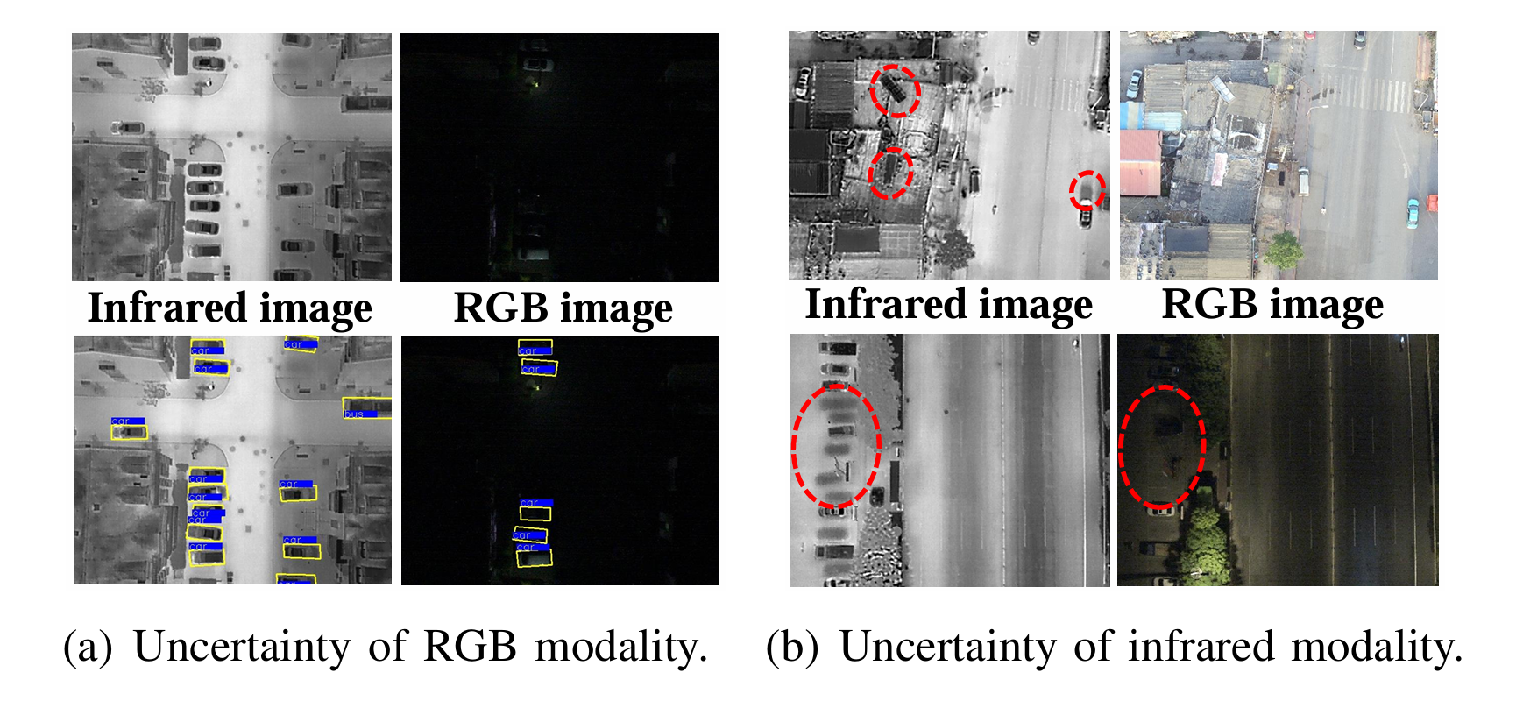

Figure 4.1. Uncertainty in the RGB modality and infrared modality

However, the inevitable heterogeneity of multi-spectral images obtained from different sensors can lead to conflicts in the complementary information of multi-modal data, which can hinder the accuracy of object classification and localization. Semantic conflicts arise when two or more modalities perceive the same object information but assign inconsistent semantic categories to the object. In such cases, fine-grained information crucial for classification may be overshadowed during the fusion process, leading to confusion of object categories and background.

As illustrated in Figure 4. 2, cross-modal semantic conflict leads to object classification confusion and mislocalization, which impacts the final detection and classification results. In 4.2 (a), conflicting detection can emerge from inconsistent information regarding detected objects. In 4.2 (b) Conflicting classification of RGB and IR images can confuse classification. In 4.2 (c), Conflicting background information between RGB and IR images can lead to redundancy and false detection. Unfortunately, the aforementioned feature fusion-based methods ignore the semantic conflict problem in the cross-modal fusion process, reducing the discriminability of cross modal fusion features and leading to a confusing representation of cross-modal semantic information.

Figure 4.2. illustrations of the information with semantic conflicts in multispectral object detection for different inputs. RGB and IR inputs fuse using feature concatenation. The different color bounding box is the area of interest.

Given the advantages of combining multiple image types for object detection in UAV-captured images and the challenges encountered when using strategies to fuse two types of images, along with the specific characteristics of the oriented object detection task in UAV imagery, we were motivated to research and propose a Conflict-Aware Cross-Modal method to address the problem of oriented object detection in UAV-captured images.

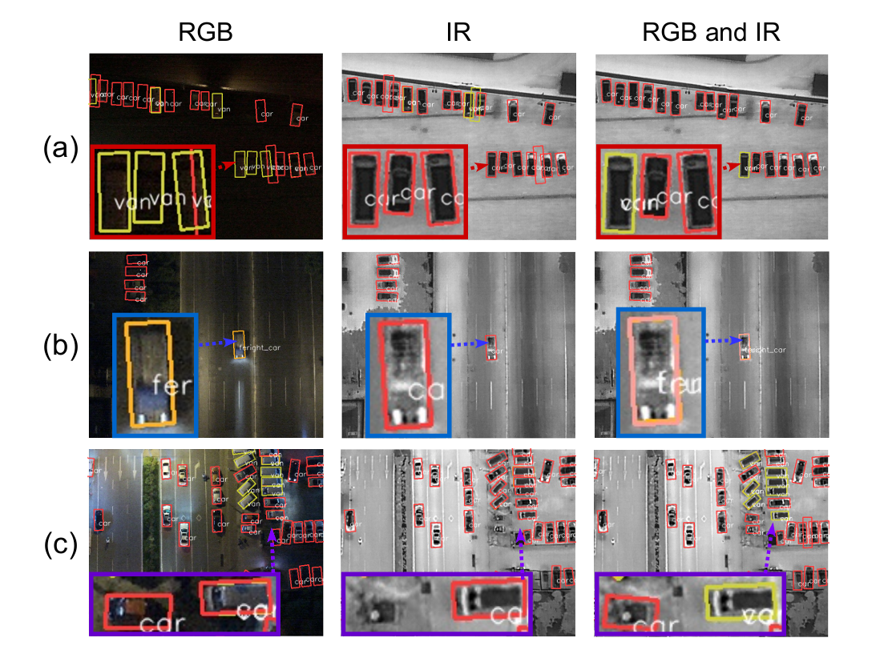

Figure 4.2. Illustrations of the information with semantic conflicts in multispectral object detection for different inputs.

## 4.2. Image fusion

Image fusion is the process of combining multiple images of the same scene or subject captured from different sources or sensors into a single composite image. The objective of image fusion is to extract and integrate relevant information from each source image to create a fused image that contains more comprehensive and informative data than any individual input image. The keys to an excellent fusion method are effective image information extraction and appropriate fusion principles, which allow useful information to be extracted from source images and integrated in the fused image without introducing any artifact in the process. Image fusion techniques are commonly used in various fields such as remote sensing, medical imaging, surveillance, and computer vision to enhance image quality, improve feature visibility, and facilitate decision-making processes. By integrating comple mentary information from multiple sources, image fusion enables better in terpretation and analysis of complex scenes or datasets.

Fusing the features of two modalities is the core problem in multispectral object detection, which can be described as:

$F_{Fused}=F(F_{R}, F_{T}) =F(ϕ_{R}(I_{R}), ϕ_{T}(I_{T}))$ (4.1)

Where IR and IT represents the input RGB image and the input Thermal image, respectively. FR denotes the RGB feature maps and FT denotes the Thermal feature maps. The feature extraction functions of networks, $ϕ_{R}(.)$ and $ϕ_{T}(.)$, are applied to generate the feature maps for the different modal input images.

$F_{Fused}$ indicates the fused feature maps, and $F(.)$ is the function of fusion. In the Eq.1, multi-modality fusion can be divided into two aspects: input variable (i.e., input features), and fusion functions. Following the idea of Eq. (1), the previously published investigations in the literature can also be sorted into two categories, one is focued on the input features (“macro” level), and the other is focued on constructing the fusion functions (“micro” level).

### 4.2.1. Macro-level fusion methodology

On this level, researchers aim to solve the problem of where to fuse, that is, which stage of the input features to choose to fuse. Most of them explore the best fusion stage by designing the macro network architectures. One of the fundamental approaches is pixel-level fusion, where the pixel intensities from corresponding locations in multiple input images are combined to produce a new image with enhanced spatial or spectral characteristics. Feature-level fusion, on the other hand, focuses on extracting relevant features from each input image and integrating them to preserve important information while discarding redundant or irrel evant details. Additionally, decision-level fusion involves merging decisions or classifications made by individual algorithms or experts, enabling more robust and accurate analysis. Excerpt from page 4 [17].

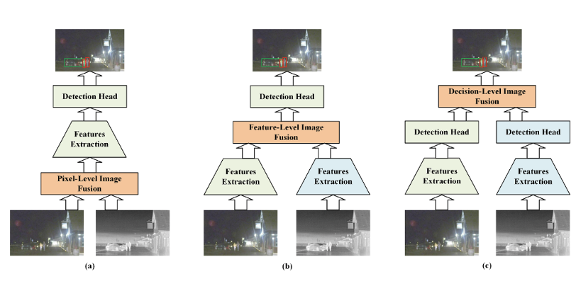

Figure 4.3. Three ways of fusing visible and infrared images in multimodal object detection task

**Pixel-level fusion**, as a fundamental approach to macro-level fusion, involves the direct combination of pixel intensities from corresponding locations in multiple input images to create a new composite image. This method aims to enhance the spatial or spectral characteristics of the resulting image by integrating information from the input images at a fine-grained level.

Pixel level fusion is commonly used in scenarios where preserving the spatial details of the original images is crucial, such as in remote sensing applications for land cover classification or in medical imaging for combining images from dif ferent modalities. However, pixel-level fusion may not always be optimal for tasks that require selective preservation of certain features or information.

**Feature-level fusion**, on the other hand, focuses on extracting relevant features from each input image and integrating them to preserve important information while discarding redundant or irrelevant details. This approach typically involves applying feature extraction techniques, such as edge detection, texture analysis, or scale-invariant feature transform (SIFT), to each input image separately. The extracted features are then combined or concatenated to form a new feature representation, which is used to generate the fused image. Feature-level fusion is particularly useful when the goal is to emphasize specific characteristics or patterns in the input images while suppressing noise or irrelevant information. It is commonly employed in applications such as target recognition in surveillance imagery or in medical imaging for tumor detection and classification.

**Decision-level fusion** involves merging decisions or classifications made by individual algorithms or experts to produce a final decision or classification result. This approach is often used in scenarios where multiple sources of information or different algorithms are available, and it aims to improve the overall accuracy and reliability of the final decision by aggregating diverse viewpoints or sources of evidence. Decision-level fusion can be performed using various fusion rules or algorithms, such as the majority voting rule, weighted averaging, or Bayesian fusion. It is widely applied in fields such as remote sensing for land cover mapping, where decisions from different classifiers or sensors need to be combined to generate accurate and consistent classification maps.

To explore the potential of deep models for multispectral pedestrian detection further, a research designed another two ConvNet fusion architectures (feature-level fusion and decision-level fusion) and demonstrated that the halfway fusion model achieved the best detection synergy. Since then, several subse quent works illustrated that the feature fusion over whelmingly outperforms the other three fusion architectures.

### 4.2.2. Micro-level fusion methodology

Besides the macro network architectures, the construction of fusion function is another key point for complementary learning of modality interaction. Naturally, the most straightforward way is to utilize concatenation, element wise addition, element-wise average/maximum, and element wise cross product to merge feature maps of RGB and infrared modalities directly.

Two variations of novel Gated Fusion Units (GFU) are proposed in GFD-SSD to investigate the combination of feature maps generated by the two SSD middle layers. Zhang et. al. proposed a novel cycle fuse-and refine module to improve the multispectral feature fusion while achieving the complementary/ consistency balance of the features.

Transformer is originally a classic Natural Language Processing (NLP) model proposed by the Google team in 2017. However, due to its strong representation ability and concise model, it has been extended to computer vision and multimodal f ields in recent years. Different from the prior methods, a Transformer-based scheme is proposed to fuse intra-modal and inter-modal information for multispectral object detection in current paper.

## 4.3. Multi-modal Object Detection via Cross-Modal Conflict-Aware Learning

We propose a CALNet for multispectral object detection, comprising CCR and SCF modules. Our CCR module diminishes inter-modal heterogeneity by mining contextual information of analogous pixels to rectify conflicting information in multispectral features. After that, our SCF module selects rich semantic features by ranking the importance of intra-modal features and aggregates inter-modal features.

4.3.1. Overall Architecture

Figure 4.9 displays the comprehensive architecture (CALNet) of the cross-modal conflict-aware learning Network framework, a proposed multispectral object detector for aerial object detection. The framework comprises a two-stream backbone network, three fusion modules and an oriented detection head. For simplicity, we omit the details of the oriented detection head in the feature pyramid net work description.

To address the challenge of semantically conflicting information in multispectral data, we introduce a CCR module that rectifies heterogeneity in high-level RGB and infrared features by employing similar pixel contextual information. Furthermore, we develop an SCF module that selects significant features for cross-modal fusion, enhancing the discriminative properties of the fused features. Finally, we input the cross-modal fused features from the last three layers of features into the oriented detection head to predict the final object detection results, achieving both optimal performance and efficient computation.

With the overall architecture introduced, the following section will detail the modules within this architecture.

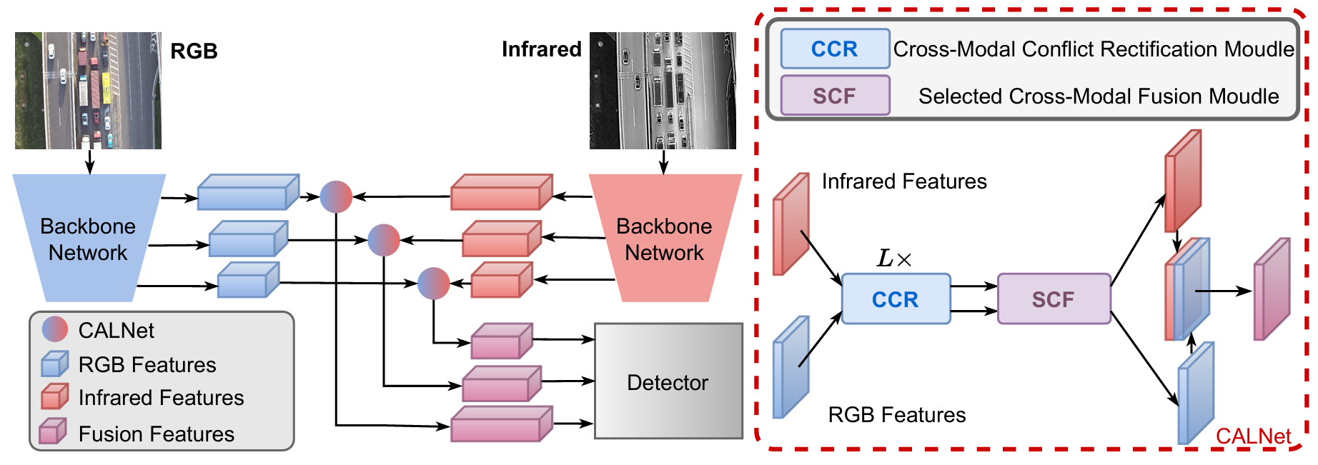

Figure 4.4. The overall architecture of the proposed multispectral object detection framework

**Backbone Network.** The backbone network is specifically illustrated in Figure 4.10. Consistent with numerous multispectral object detection models, our proposed multispectral object detector incorporates a two-stream network, composed of two symmetrical unimodal feature extractors. These extractors have identical network structures but distinct parameters, enabling the extraction of RGB and infrared features at various levels. A two-stream backbone is employed to extract RGB features {𝒓𝑡 | 𝑡 = 1, 2, ··· , 5} and IR features {𝒊𝑡 | 𝑡 = 1, 2, ··· , 5} at spatial sizes of 1/2, 1/4, ··· , 1/32 of the input data. Following this, the last three layers of features are selected for input into our Fusion Module - CALNet. The output of the Fusion Module consists of IR and RGB fusion features, which are then added to the original IR and RGB features to retain the unique characteristics of each image type. These two types of features are subsequently combined and serve as the next generation feature.

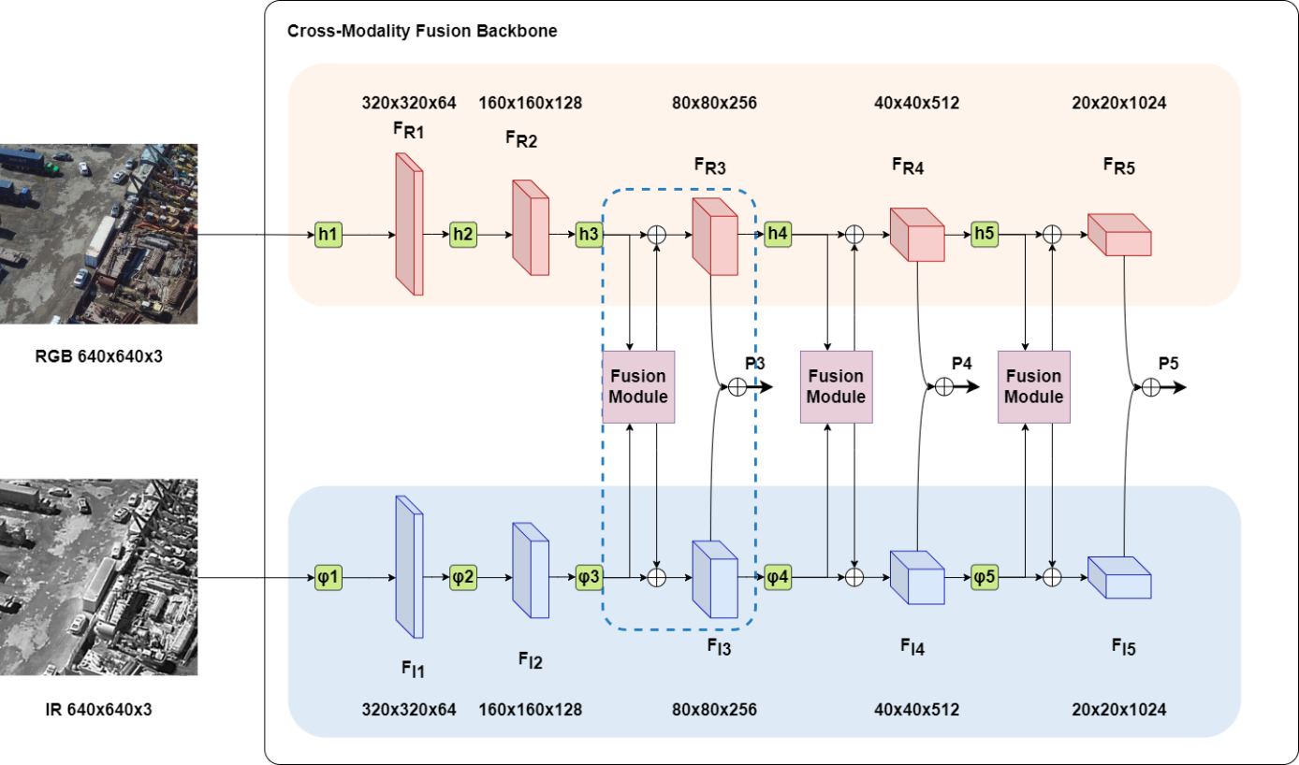

Figure 4.5. Framework of Cross-Modality Fusion Backbone - ResNet 50

The following equation describes the Fusion process:

$\left[{\tilde{r_{t}} \atop \tilde{i_{t}}}\right] = SCF(CCR(\left[{r_{t} \atop i_{t}}\right]))$ (4.2)

Finally, we add features $\tilde{r_{t}}$ and $\tilde{i_{t}}$ as follows: G = Add ( $\tilde{r_{t}}$, $\tilde{i_{t}}$). The output feature G is fed to the detector to predict the object confidence scores and bounding box coordinates.

### 4.3.2. Cross-Modal Conflict Rectification Module

Existing research primarily focuses on utilizing complementary information in multispectral data, yet it inadequately addresses the semantic conflict arising from multi-modal. This shortcoming hampers the impact of fine-grained semantic information on object class inference. To tackle this issue, we introduce the CCR module. The semantic conflict is resolved by employing the transformer’s dynamic modeling capabilities to guide contextual information exchange between modalities, consequently mitigating cross-modal semantic conflicts and reducing modal heterogeneity. Figure 4.11(a) depicts the structure of the CCR module. Before implementing the CCR module, we acquire features 𝒓 and 𝒊 from the two-stream net work and join them to compute pixel similarity: 𝒇 = Concat (𝒓, 𝒊).

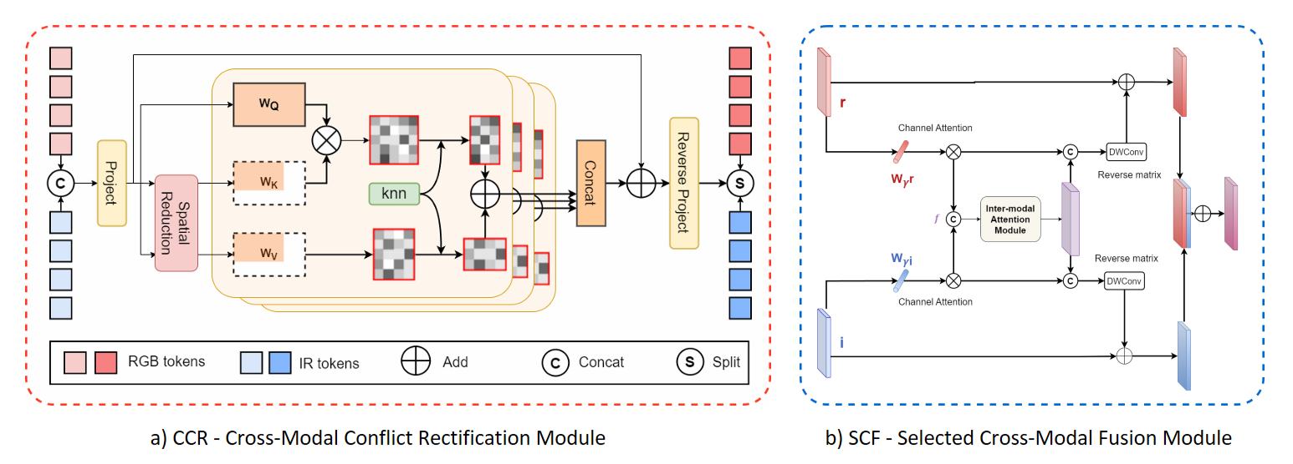

Figure 4.6. Structures of our CCR and SCF modules

We first identify the nearest neighboring patch relationship within this space to extract the contextual information association between patterns. Since features from distinct spaces cannot directly compute similarity, we project these features from the disparate spaces into a shared joint space. Specifically, the multi spectral feature 𝒇 is projected through a linear layer, forming a query 𝑊𝑄 ∈ R 𝑛×𝑑𝑞, a key 𝑊𝐾 ∈ R 𝑛×𝑑𝑘, and a value 𝑊𝑉 ∈ R 𝑛×𝑑𝑣, where 𝑛 = 𝑚 ×ℎ ×𝑤 represents the number of patches and 𝑚 denotes the number of multispectral inputs.

Given the high computational burden of the transformers, which is linearly associated with the number of multispectral inputs, we use a spatial reduction attention to diminish the dimensionality of the key and value, thus enhancing the efficiency of the cross-modal conflict resolution. We employ an 𝑠 × 𝑠 depth-wise convolution with stride 𝑠 to decrease the spatial size of 𝑊𝐾 and𝑊𝑉 before the attention. The spatial reduction attention is defined as:

$\left\{\begin{aligned}W_{K'}=DWConv(W_{K})∈ R^{\frac{n}{S^{2}}×d_{k}}, \\ W_{V'}=DWConv(W_{V})∈ R^{\frac{n}{S^{2}}×d_{k}},\end{aligned}\right.$ (4.3)

where DWConv(·) denotes the depth-wise separable convolution. Each row of the query represents the features of each pixel point.

The CCR module comprises 𝐿 layers, with sequences of the (𝑙 + 1)𝑡ℎ layer being 𝑙 = 0, ..., 𝐿− 1. The forward process of the exemplar feature in one layer can be expressed as:

$\left\{\begin{aligned}f^{l}=f^{l}+{Attn}_{knn}(LN(f^{l})) \\ f^{l+1}=f^{l}+Reverse(LN(f^{l}))\end{aligned}\right.$ (4.4)

where LN represents LayerNorm, and Reverse denotes the feed forward network, serving to reverse project back into the RGB and IR modalities. The key to our design is attention.

For the i-th query patch, we first calculate the euclidean distance of all keys, then obtain its 𝑘-nearest neighbors from the keys and values, and ultimately compute the scaled dot product attention. Next, a similarity attention is employed to aggregate a unique model patches with some of the most similar patches outside of that model. Reduce the heterogeneity between patches by using extra-modal contextual information to auxiliary rectify semantic conflicts. The similarity attention is calculated using the following formula:

$A_{i}=softmax(\frac{〈W_{Q_{i}}, \left(W_{K_{j_{1}}}, ...,W_{K_{j_{k}}}\right)〉}{\sqrt{d}}), W_{K_{j_{1}}}∈N_{i}^{k}$ (4.5)

where 1/√𝑑 is the scaling factor. Since the computation of the Euclidean distance for all keys against each query is slow, we take advantage of the matrix multiplication to speed it up. As with the vanilla attention, all queries and keys are computed by dot product:

$A={f^{l}}_{W_{Q}}. {f^{l}}_{{W_{K}}^{T}}$ (4.6)

and then row-wise top-k elements are selected for softmax computing. The formula attention is:

${\left[X\right]}_{ij}= \left\{\begin{aligned}1, A_{ij}∈ top-k (row j) \\ -∞, otherwise\end{aligned}\right.$ (4.7)

${Att}_{knn}(f^{l})= softmax \left(\frac{A∙X}{\sqrt{d}}\right)∙f^{l}W_{V}$ (4.8)

where 𝑿 is an adjacency matrix based on top-k elements. The resulting matrix is the value shape Att𝑘𝑛𝑛(𝒇𝒍) ∈ R𝑛×𝑘, with 𝑘 denoting the 𝑘 most similar nodes calculated based on the metric distance. Following this, the feature can be passed through subsequent rounds of the CCR module to further reduce heterogeneity between cross modal. Semantic conflicting information is rectified by cross-modal contextual information, thus reducing the heterogeneity of cross modal images and producing semantically consistent information.

### 4.3.3. Selected Cross-Modal Fusion Module

Prior research has employed a simple parameter to assess the importance of RGB and IR modalities. However, low information value regions in unimodal data can affect the scoring of high information value regions (e.g., RGB images with partial lighting). To address this issue, we propose a novel Selected Cross-Modal Fusion (SCF) module to capture rich semantic features, as depicted in Figure 4.11 (b).

This module filters out low-semantic features by adaptively assigning weights to intra-modal and incorporate inter-modal consistent information to enrich the intra-modal semantic representation.

We first obtain the weight coefficients 𝛾 for each channel by normalizing features derived from the intra-modal. Next, we multiply each channel with the corresponding weight coefficients to attain a sparse weight penalty, which suppresses less significant channel expressions. Given modal 𝒓 and 𝒊, the self-adaptive weight of intra-modal features is defined as:

$r = S (W_{γ}^{r}∙BN(r)), i = S (W_{γ}^{r}∙BN(i))$ (4.9)

where the weights are obtained as $W_{γ}={γ_{i}}/{\sum_{j=0}{γ_{j}}}$, 𝐵𝑁 is batch normalization, S is the sigmoid function.

By assigning weights to the selection, we filter out numerous insignificant features under inadequate lighting conditions. In this manner, we drawrefined intra-modal features. To incorporate inter modal features, we concatenate these features to obtain 𝒇. Inspired by, we fuse RGB and IR features to further reduce inter-modal heterogeneity using the inter-modal attention module.

The concept of the inter-modal attention module is derived from the Convolutional Block Attention Module (CBAM). However, instead of using a single type of feature as input, the two features are concatenated and then passed through this module. This module will be further discussed in the section below. The detailed inter-modal attention module is as follows:

$H_{c}(f) = S(MLP(AvgPool(f)) + MLP(MaxPool(f))),$ (4.10)

where S is the sigmoid function, and 𝐴𝑣𝑔𝑃𝑜𝑜𝑙 and 𝑀𝑎𝑥𝑃𝑜𝑜𝑙 signify cross-modal global pooling operations along the 𝑑, ℎ, and 𝑤 dimensions. The refined feature 𝒇𝑐 ∈ R𝑚× ℎ× 𝑤× 𝑑, derived from the inter-modal attention, can be expressed as 𝒇𝑐 = H𝑐·𝒇. On the other hand, the spatial attention map H𝑠 ∈ Rℎ×𝑤×𝑑 undergoes further multiplication with 𝒇𝑐, compressing the inter-modal dimension. This process results in injected inter-modal features with the same dimensions as the intra-modal features, as follows:

$H_{c}(f) = S(C[AvgPool(f_{c}); MaxPool(f_{c})])$ (4.11)

where C represents a convolutional filter, and ${\hat{f}=H}_{c}$. Next, we reverse the inter-modal features to the intra-modal features as:

$\tilde{r}=r+R_{rgb}(r, \hat{f}), \tilde{i}=i+R_{ir}(i, \hat{f}),$ (4.12)

where R(·) denotes the reverse matrix which employs depth-wise separable convolution. Finally, we obtain RGB and IR features with consistent representations, which are combined to produce the final features. By selecting features to obtain rich semantic intramodal features while interacting with features, the consistency of inter-modal features is further augmented during the fusion.

### 4.3.4. Explanation

#### 4.3.4.1. Convolution Block Attention Module (CBAM).

CBAM module takes an intermediate feature map generated by a convolutional layer. This feature map contains information about the image across different channels. CBAM has two sequential sub-modules: Channel Attention Module and Spatial Attention Module (Figure 4.12). Excerpt from page 3 [10].

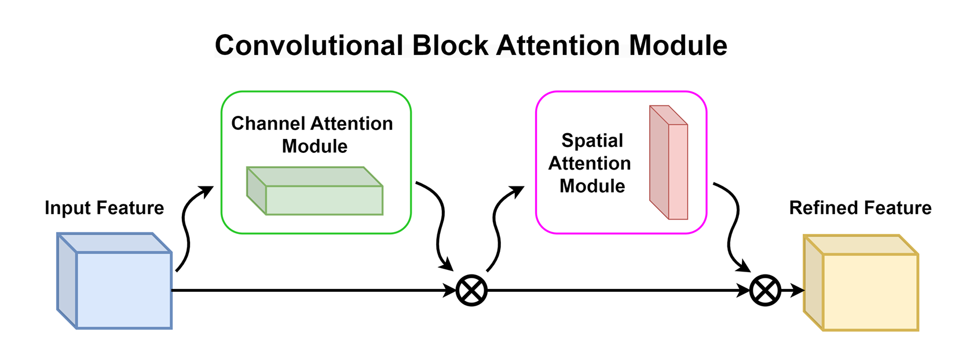

Figure 4.7. Convolutional Block Attention Module

The intermediate feature map adaptively refined through our module (CBAM) at every convolutional block of deep network. CBAM module were sequentially applied channel and spatial attention modules, so that each of the branches can learn ‘what’ and ‘where’ to attend in the channel and spatial axes respectively.

F′ = Mc(F) ⊗F, (4.13)

F′′ = Ms(F′) ⊗ F′ (4.14)

Channel attention module (Figure 4.13): This module focuses on "what" information is important. It uses two techniques average pooling and max pooling. These methods compress the feature map along the spatial dimensions (height and width), retaining only the overall channel-wise information. The average pooling captures the general presence of a feature across the image, while max pooling highlights the most prominent activation in each channel. These compressed features are then passed through a small convolutional layer to generate a channel attention map. This attention map assigns weights to each channel, indicating how important it is relative to others.

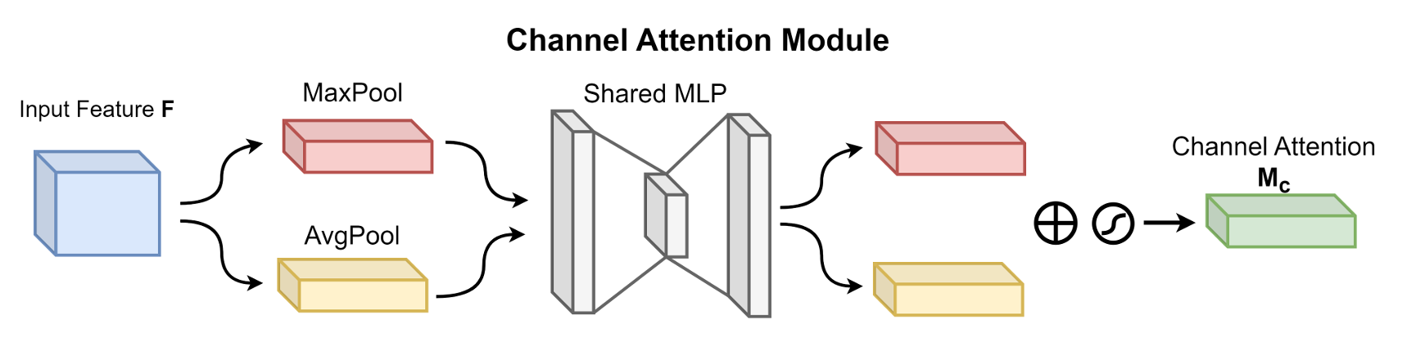

Figure 4.8. Channel Attention Module

$$M_{c}\left(F\right)=σMLP\left(AvgPool\left(F\right)\right)+MLP\left(MaxPool\left(F\right)\right)$$

$=σ(W_{1}(W_{0}(F_{avg}^{c}))+W_{1}(W_{0}(F_{max}^{c})))$ (4.15)where σ denotes the sigmoid function, W0 and W1 are the MLP weights and are shared for inputs and ReLU activation.

Spatial attention module (Figure 4.14): This module focuses on "where" the import ant information is located in the image. It operates on the original feature map. Similar to CAM, it uses average pooling to capture the overall activation across channels at each spatial location. This information is then passed through a small convolutional layer to generate a spatial attention map. This attention map assigns weights to each spatial location in the feature map, highlighting areas with more relevant features.

$$M_{s}\left(F\right)=σ\left(f^{7×7}\left([AvgPool\left(F\right)\right); MaxPool\left(F\right)]\right)$$

$=σ\left(f^{7×7}([F_{avg}^{s}; F_{max}^{s}])\right)$ (4.16)

where σ denotes the sigmoid function, f 7× 7 represents for convolution operation with kernel size 7 × 7.

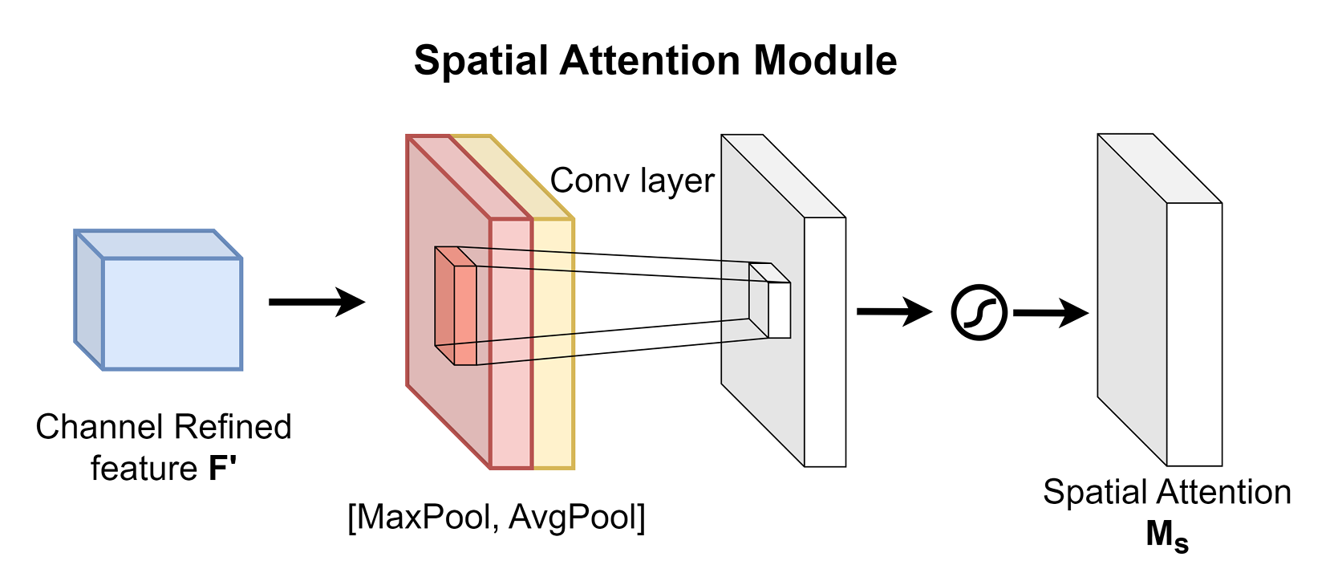

Figure 4.9. Spatial Attention Module

#### 4.3.4.2. Why Transformer?

The main idea behind our module is leveraging the self-attention mechanism to learn the binary relationship of RGB and infrared modalities, more precisely, leveraging the correlation matrix to weigh each position of the input feature maps. It can be formulated as Eq. (4.17). In the formula, i j represents the correlation between the i-th position and the j-th position on the feature maps. According to the Eq. (4.17), four matrix blocks can be inferred naturally, when calculating the correlation matrix. Two of them are intra-modality correlation matrix blocks (RGB and thermal), and the other two are inter-modality correlation matrix blocks, as illustrated in Fig 4.15.

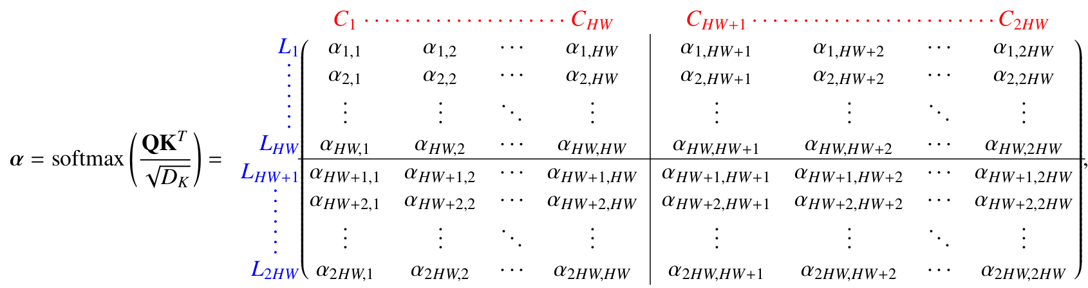(4.17)

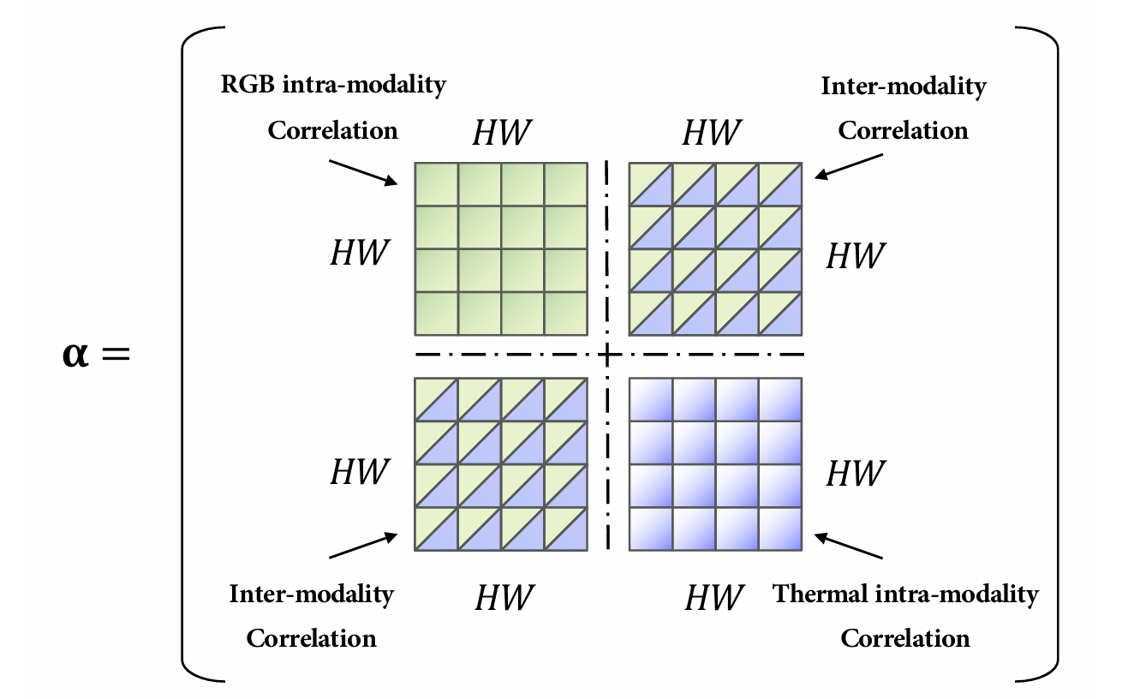

Figure 4.10. Illustration of the correlation matrix

Hence, with the help of Transformer, we don’t need to carefully design the modal fusion module. We just need to simply splice the multi-modal features into a sequence, and then the Transformer can automatically perform simultaneous intra-modality and inter-modality information fusion and robustly capture the latent interactions between RGB and thermal domains.

In this method, the idea is to use a self-attention mechanism to calculate the correlations between different parts within each type of image and to utilize the Convolutional Block Attention Module to compute their correlations in the context of combining the two types of images. Additionally, top-k token selection strategies are employed to minimize computational issues. This method is based on the approach using Transformer for fusionbut includes improvements in two modules, making the fusion more efficient and reducing computational complexity.

## 4.4. Experiments

**Datasets and metrics.** We evaluate our method on DroneVehicle dataset, which is a large-scale multi- modal dataset for vehicle detection in UAVs images.

### 4.4.1. Comparison methods

To evaluate the effectiveness of multi-modal object detection methods on UAV-captured images, we conducted four groups of experiments as follows. All the experiments focused on oriented object detection.

**a) Comparison between single modal methods and multi-modal methods**

We trained and evaluated the oriented object detection methods on individual RGB and Infrared data. These methods, discussed in Chapter 3, include both one-stage and two-stage approaches. The dataset used is the Drone Vehicle dataset.

Additionally, we trained and evaluated multi-modal object detection methods on the Drone Vehicle dataset. These methods were presented in Section 4.2. The purpose of this experiment is to assess the effectiveness of these multi-modal methods compared to single-modal object detection methods.

We also ran benchmarks and evaluated the speed of the methods to determine the trade-off between accuracy and speed for these models.

**b) Ablation Studies**

**Compare between three macro-level fusion methods**: Experiment and compare three image fusion methods in multi-modal object detection algorithms: fusion at the pixel level, fusion at the feature level, and fusion at the decision level.

**Ablation Studies on the role of CCR and SCF modules:** Test scenarios with and without the CCR module and compare the accuracy results to determine its role in improving the model's accuracy. This also partially demonstrates the effectiveness of the Transformer and attention mechanisms when used to combine two features compared to using other conventional functions in the group of micro-level fusion methods.

### 4.4.2. Experiments setting

We trained the models on an Nvidia Tesla P40 server, continuing the training until the models showed signs of overfitting on the validation set. A Resnet-50 pretrained model was used for feature extraction across all models. The optimal parameters for each model were selected according to their respective publications to achieve the highest effectiveness. The CalNet model, as an enhancement over Yolov5, was trained for 50 epochs. The remaining models were trained using the mmRotate framework for 12 to 14 epochs. To evaluate the models on the Test set of the DroneVehicle dataset, we used DotaDevkit to assess the mAP values on the dataset.

The specific settings for each section are as follows:

**Group 1: The group tested the single-modal models on the Drone Vehicle dataset**

We used the mmRotate framework and attempted to replicate the configurations as described by the authors of the respective research methods. All methods employed the SGD Optimizer with a Momentum of 0.9 and a Weight Decay of 0.0001.

The setup for certain parameters of these methods is as follow:

Table 4.1. Setup for parameters of single-modal methods

|  |  |  |  |
| --- | --- | --- | --- |
| **Method Name** | **Batch size** | **Lr** | **Epochs** |
| O-RCNN | 4 | 0.005 | 14 |
| O-Reppoints | 4 | 0.008 | 12 |
| R3Det | 4 | 0.0025 | 12 |
| RoiTrans | 4 | 0.005 | 12 |
| S2ANet | 4 | 0.0025 | 14 |

**Group 2: The group tested and evaluated the multi-modal methods**

We only list a few parameters that differ from the default configuration provided by the frameworks.:

**- Training Parameters for training UA-CMDet (Table 4.2):**

Table 4.2. Training Parameters for training UA-CMDet

|  |  |  |  |
| --- | --- | --- | --- |
| **Parameter** | **Value** | **Parameter** | **Value** |
| Framework | mmDetection | Learning rate | 0.005 |
| Epochs | 12 | Image_scale | (512, 640) |
| Batch size | 2 |  |  |

**- Training Parameters for training C2Former (Table 4.3):**

Table 4.3. Training Parameters for training C2Former

|  |  |  |  |
| --- | --- | --- | --- |
| **Parameter** | **Value** | **Parameter** | **Value** |
| Framework | mmRotate | Learning rate | 0.001 |
| Epochs | 24 | Image_scale | (712, 840) |
| Batch size | 4 |  |  |

**- Training Parameters for training E2E-MFD (Table 4.4):**

Table 4.4. Training Parameters for training E2E-MFD

| **Parameter** | **Value** | **Parameter** | **Value** |
| --- | --- | --- | --- |
| Framework | mmRotate | Learning rate | 0.0001 |
| Epochs | 24 | Image_scale | (712, 840) |
| Batch size | 1 | Optimizer | AdamW |
| Weight decay | 0.05 |  |  |

**- Training Parameters for training CALNet (Table 4.5):**

Table 4.5. Training Parameters for training CALNet

|  |  |  |  |
| --- | --- | --- | --- |
| **Parameter** | **Value** | **Parameter** | **Value** |
| Framework | mmRotate | Learning rate | 0.037 |
| Epochs | 24 | Image_scale | (712, 840) |
| Batch size | 1 | Momentum | 0.843 |
| Mosaic | 1.0 | Mixup | 0 |
| Scale | 0.25 | Backbone | ResnetCSP |
| Detection Head | Yolov5 |  |  |

**- Comparison of Three Image Fusion Methods**

For pixel-level fusion, we generated fusion images using the E2E-MFD model and trained them with the Oriented RCNN and S2ANet models. The C2Former model represents the group of Feature-level fusion models, while the UA_CMDet model represents the group of Decision-level fusion models. The experimental setups were consistent with those in Experiments 1 and 2.

**- Benchmark Testing for Speed**

The models were run on the test set with a batch size of 1, and the processing times were recorded and analyzed.

## 4.5. Results

### 4.5.1. Comparison between single-modal and multi-modal methods

**Comparison on Drone Vehicle test set:**

We compared multi-modal object detection methods with single-modal detection methods on the test set of the Drone Vehicle dataset. The multi-modal methods we evaluated were those presented in Section 4.3, which include state-of-the-art approaches: six single-modal and four multi-modal methods. The results, as shown in Table 4.6, indicate that multi-modal object detection methods outperform single-modal approaches. Specifically, the single-modal methods achieved mAP scores ranging from 45% to 60% when using RGB images and slightly better results with Infrared images, ranging from 55% to 65% mAP. In contrast, the multi-modal methods yielded significantly better results, with mAP scores ranging from 70% to 77%, approximately 15% higher than those using only RGB images and 10% higher than those using only Infrared images. Among the multi-modal detection methods, the E2E-MFD approach, which utilizes Multi-task Learning, achieved the highest mAP scores. Specifically, our method improves the accuracy for cars, trucks, freight cars, buses, and vans by 1.04%, 4.15%, 8.82%, 1.03%, and 9.69% mAP@0.5, respectively.

Table 4.6. Comparison of single and multi-modal methods on Drone Vehicle test set

|  |  |  |  |  |  |  |  |  |
| --- | --- | --- | --- | --- | --- | --- | --- | --- |
| **Detectors** | **Model Type** | **AP-mAP** | | | | | | **Modal** |
| **Car** | **Truck** | **Fre** | **Bus** | **Van** | **mAP** |
| R3Det | One-stage | 75.8 | 41.4 | 31.5 | 74.7 | 27.1 | 50.1 | RGB |
| S2ANet | One-stage | 76.9 | 49.6 | 36.1 | 77.9 | 37.0 | 55.5 |
| Yolov5(l)-OBB | One-stage | 79.5 | 49.6 | 40.9 | 80.8 | 38.6 | 57.9 |
| RoiTrans | Two-stage | 78.0 | 51.3 | 38.7 | 78.7 | 39.9 | 57.3 |
| Oriented -RCNN | Two-stage | 77.7 | 50.2 | 39.4 | 78.4 | 37.8 | 56.7 |
| Oriented-Reppoints | Two-stage | 76.9 | 50.4 | 36.7 | 79.3 | 36.5 | 56.0 |
| R3Det | One-stage | 89.7 | 56.7 | 44.9 | 86.5 | 36.3 | 62.8 | Infrared |
| S2ANet | One-stage | 89.9 | 64.1 | 51.3 | 88.7 | 40.6 | 66.9 |
| Yolov5(l)-OBB | One-stage | 89.1 | 59.4 | 53.4 | 86.4 | 51.8 | 68.0 |
| RoiTrans | Two-stage | 90.1 | 65.0 | 52.6 | 88.9 | 44.9 | 68.3 |
| Oriented -RCNN | Two-stage | 90.1 | 64.4 | 53.3 | 88.6 | 42.2 | 67.7 |
| Oriented-Reppoints | Two-stage | 90.1 | 63.5 | 51.5 | 87.4 | 41.9 | 68.8 |
| UA-CMDet | Two-stage | 88.5 | 56.1 | 72.6 | 88.7 | 54.3 | 72.1 | RGB+IR |
| C2Former | Two-stage | 90.2 | 68.3 | 64.4 | 89.8 | 58.5 | 74.2 |
| E2D-MFD | Two-stage | 90.3 | 79.3 | 64.6 | 89.8 | 63.1 | 77.4 |
| CALNet | One-stage | 90.24 | 75.23 | 63.48 | 88.93 | 56.79 | 74.94 |

**Comparison on Speed versus Accuracy.**

We compared the speed and accuracy of various detectors on an NVIDIA Tesla P40 GPU. All detectors were tested at a batch size of 1. As shown in Figure4.16, our detector exhibits detection accuracy (74.9% mAP@0.5) compared to other multispectral detectors while maintaining a comparable speed (10 FPS).

Figure 4.11. Speed vs accuracy on the Drone Vehicle using a GPU batch size of 1. Speed comparison using FPS

### 4.5.2. Ablation Studies

#### 4.5.2.1. Three macro-level fusion methods

The results comparing three macro-level fusion methods using a combination of two types of images in the oriented object detection task.

Table 4.7. Ablation experiments of three image fusion methods on Drone Vehicle

| **Detector** | **Fusion Type** | **ModelType** | **AP-mAP** | | | | | | **Fps/s** | **Modal** |
| --- | --- | --- | --- | --- | --- | --- | --- | --- | --- | --- |
| **Car** | **Tr.** | **Fre** | **Bus** | **Van** | **mAP** |
| S2ANet | Pixel Fusion | One-stage | 89.8 | 60.5 | 48.4 | 88.3 | 41.4 | 65.7 | 16 | Fusion Images |
| Oriented-RCNN | Pixel Fusion | Two-stage | 89.9 | 64.1 | 51.3 | 88.7 | 40.6 | 66.9 | 12 | Fusion images |
| E2E-MFD | Pixel Fusion | One-stage | 90.3 | 79.3 | 64.6 | 89.8 | 63.1 | 77.4 | 4 | Fusion  images |
| CalNet | Feature Fusion | One-stage | 90.24 | 75.23 | 63.48 | 88.93 | 56.79 | 74.94 | 10 | R+I |
| C2Former | Feature Fusion | Two-stage | 90.2 | 68.3 | 64.4 | 89.8 | 58.5 | 74.2 | 3.6 | R+I |
| UA-CMDet | Decision Fusion | Two-stage | 88.5 | 56.1 | 72.6 | 88.7 | 54.3 | 72.1 | 3.4 | R+I |

The experimental results in Table 4.7 show that methods using Pixel-level fusion yield lower results compared to fusion at the Feature level when conflict resolution methods between the modalities are employed. This outcome can be attributed to the fact that the images from the two modalities may have a certain degree of misalignment. Such misalignment can negatively impact the accuracy of the image fusion process. Furthermore, in the case of night-time RGB images, when fused with Infrared images, the results are not satisfactory because these images lack any color information other than black. Conversely, daytime images or images with more light yield better fusion results. This significantly affects the model’s ability to combine and recognize objects.

#### 4.5.2.2. Cross-Modal Conflict Rectification Module and Selected Cross-Modal Fusion Module

In this section, we will evaluate the conflict resolution modules between RGB and IR modalities during the fusion process. The experiments will compare the scenarios with and without these modules.

Ablation experiments of CCR and SCF modules:

Table 4.8. Ablation experiments of CCR and SCF module on the DroneVehicle dataset

| **Method** | **CCR** | **SCF** | **AP-mAP** | | | | | |
| --- | --- | --- | --- | --- | --- | --- | --- | --- |
| **Car** | **Truck** | **Fre** | **Bus** | **Van** | **mAP** |
| Baseline | - | - | 89.32 | 60.07 | 49.43 | 86.63 | 45.46 | 66.18 |
| Baseline + SCF | - | ✓ | 90.20 | 69.31 | 85.46 | 57.44 | 47.46 | 70.43 |
| Baseline + CCR | ✓ | - | 90.24 | 72.92 | 59.73 | 88.85 | 50.51 | 72.45 |
| CalNet | ✓ | ✓ | 90.24 | 75.23 | 63.48 | 88.93 | 56.79 | 74.94 |

Table 4.9. Performance of CALNet with the different number of CCR modules

|  |  |  |
| --- | --- | --- |
| **Method** | **Number of CCR** | **mAP@0.5** |
| CALNet | (2, 2, 2) | 72.91 |
| (3, 3, 3) | 73.45 |
| (3, 6, 3) | 74.94 |

The baseline employed in this research is a one-stage, two-stream object detector without the CCR and SCF modules, which integrates two modalities through an additive fusion process. The CCR module is designed to address the cross-modal semantic conflict issue by reducing inter-modal heterogeneity, as shown in Table 4.8. The baseline model, when augmented with only the CCR module, exhibits a 6.27% mAP@0.5 improvement. The SCF module remains stable in terms of enhancement for the cross-modal fusion module. Compared to the baseline, the CCR and SCF modules together contribute to a 8.76% mAP@0.5 increase.

We also compare the effectiveness of using different numbers of CCR modules (Table 4.9), as the number of Transformer layers can affect the model's processing speed. With these experiments, the number of CCR modules in the three sections (3, 3, 6) yields the most promising results. This can be explained by the fact that using more Transformer layers in Layer 4 allows for better detection of medium-sized objects in this feature map layer. For the remaining two feature maps, using 2 to 3 layers provides equivalent results.

Under identical experimental conditions, we conducted experiments to validate the effectiveness of the SCF module. The aim of SCF is to adaptively select features with rich semantics by evaluating feature importance. As depicted in Table 3, the baseline + SCF yields a 4.25% mAP@0.5 enhancement to the model, while SCF continues to provide a 2.54% mAP@0.5 improvement to the model featuring the CCR module. Consequently, the CCR and SCF modules cooperate to further advance cross-modal information fusion. We observe that the CCR module alone outperforms the SCF module, indicating that cross-modal fusion favors the resolution of semantically conflicting information. The combined experimental results demonstrate that integrating the advantages of each component improves the outcomes for DroneVehicle.

### 4.5.3. Visualization Results

#### 4.5.3.1. Classification Performance

Conflicting information between different modalities can create semantic ambiguity and significantly affect the categorization of objects. To investigate the performance of CalNet in addressing cross-modal semantic conflicts, we compared the classification accuracy of CALNet and the baseline model on the DroneVehicle dataset (as shown in Figure 4.17(b)). This dataset consists of five classes of automobiles, presenting a significant challenge for fine-grained classification due to the substantial ambiguity among classes.

The fine-grained classification further compounds the classification confusion problem. We collecting two confusion matrices from the evaluation process on the test set of the Baseline and CALNet models, as shown in Figure 4.18.

The data shows that the baseline model struggles with classifying vans, trucks, buses, and freight cars. In contrast, CALNet enhances classification accuracy for trucks, vans and freight cars by 15%, 10%, and 19%, respectively. The confusion matrix for the baseline model reveals that while it performs well with the car class, it frequently confuses trucks with cars and the background. Additionally, it has difficulty distinguishing between vans and cars due to their similar sizes. The integration of the CALNet module has led to a significant improvement in recognition results.

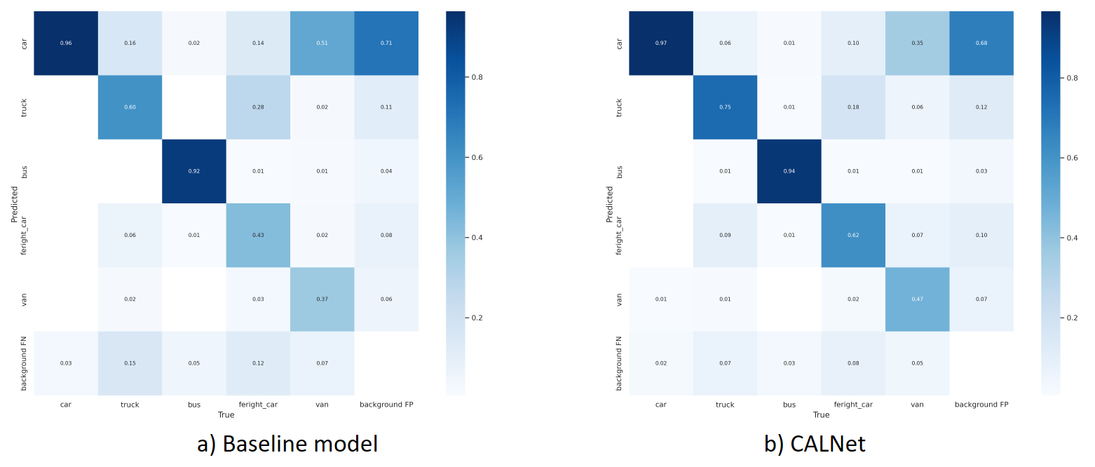

Figure 4.12. Confusion Matrixes of Baseline model and CALNet

#### 4.5.3.2. Feature Visualization

Figure 4.19 presents the visualization results of CALNet. The RGB and IR modalities exhibit limitations in ac curately capturing both object and background features due to their distinct characteristics. Following the CALNet process, object features are emphasized, while background features are globally integrated. This integration results in the extraction of meaningful background information and the reduction of background noise. The proposed CALNet effectively combines cross-modal features, accelerating the fusion of background information and increasing the prominence of object features across low to high levels.

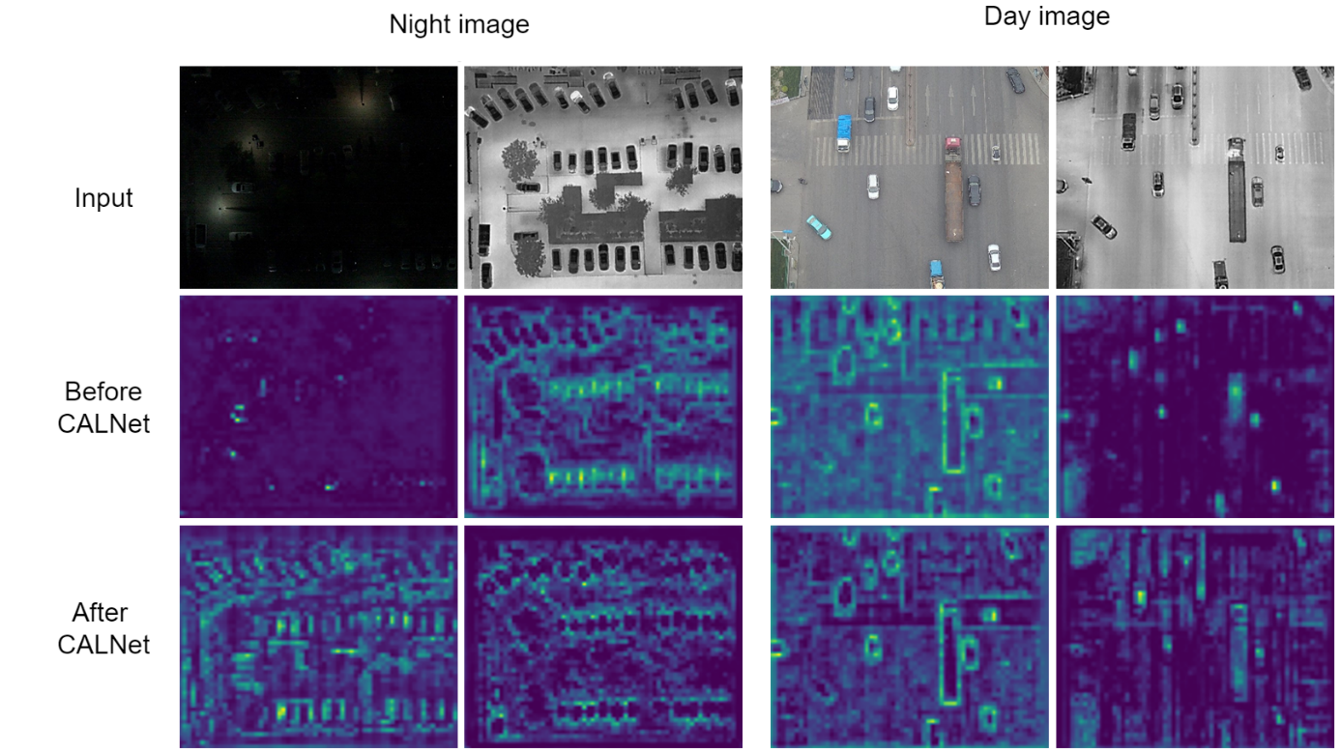

Figure 4.13. Visualization of the features in Stage3 before and after the CALNet. The two modal feature maps are compensated using complementary information

#### 4.6.3.3. Quantitative Visualization

Figure 4.20 displays the visualization of CALNet in different scenarios on the DroneVehicledataset with accurate classification and localization of objects in dense small objects and low light conditions using different color boxes for different categories. The performance is excellent in locating tiny objects, dense objects, and fine-grained classification under various light conditions. We compare to results from other model.

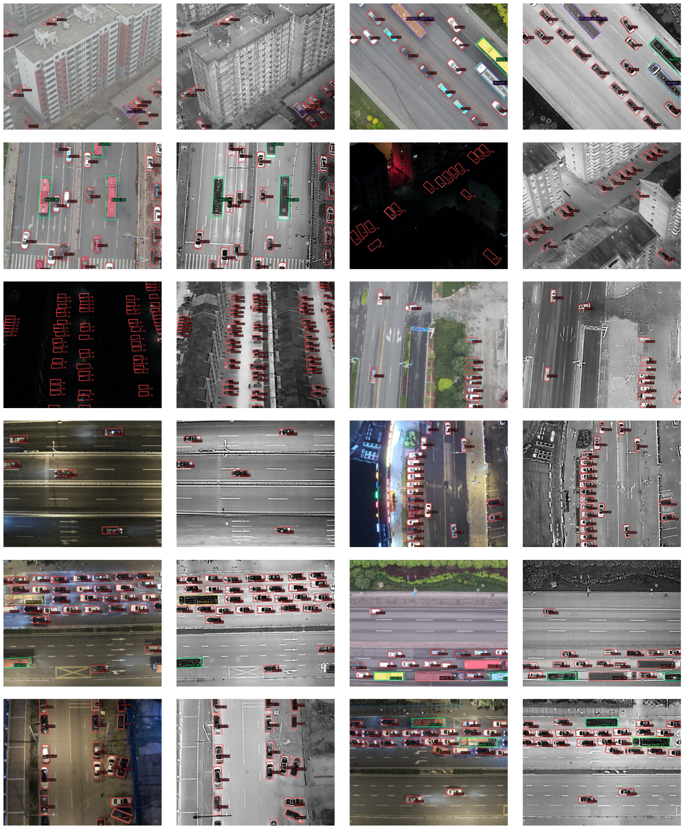

Figure 4.14. Visualization results of CALNet on the DroneVehicle

## 4.6. Discussion

In this work, we propose CALNet, a novel approach for detecting multispectral objects that integrates cross-modal fusion and conflict rectification. Our CALNet method includes a CCR module that minimizes modal discrepancies by addressing semantically inconsistent multispectral features while leveraging cross-modal contextual information. Meanwhile, our SCF module ranks the intra-modal importance of features to select semantically rich ones and mines inter-modal complementary information to fuse multi spectral features. We design a one-stage orientated detector based on CALNet to demonstrate the effectiveness of our approach in mitigating cross-modal semantic conflicts. Extensive experiments on the multispectral object detection benchmarks validate that CALNet achieves state-of-the-art results and robustness.

# CONCLUSION

**Achievements**

- The research has thoroughly explored deep learning methods applied to UAV-based object detection, with a special focus on oriented object detection and multi-modal techniques.

- Successfully implemented and evaluated state-of-the-art oriented object detection algorithms, such as Oriented RepPoints and yolov5 OBB, demonstrating superior performance in addressing the unique challenges of UAV imagery, particularly in terms of orientation accuracy and bounding box precision.

- Explored multi-modal methods, including cross-modal conflict-aware learning, which significantly improved detection accuracy through the fusion of RGB and infrared data.

- Experimental results validated the effectiveness of these methods, providing robust solutions for complex object detection scenarios in UAV applications.

**Future Work**

- Further refinement of oriented object detection algorithms is needed to enhance real-time processing capabilities for practical deployment in UAV systems.

- Expanding the scope of multi-modal methods to integrate data from other sensors, to provide richer contextual information and improve detection accuracy.

- Investigating the integration of advanced deep learning techniques, such as attention mechanisms and generative models, may yield improved results.

- Addressing the scalability of these methods for large-scale deployment in diverse environments will be essential for broader adoption in various UAV applications.

# REFERENCES

[1] Chen Zhiming, Chen Kean, Lin Weiyao, See John, Yu Hui, Ke Yan, and Yang Cong. "Piou loss: Towards accurate oriented object detection in complex environments." In ECCV, 2020.

[2] Cheng Gong, Wang Jiabao, Li Ke, Xie Xingxing, Lang Chunbo, Yao Yanqing, and Han Junwei. "Anchor-free oriented proposal generator for object detection." arXiv preprint, 2021.

[3] Fang Qingyun, Han Dapeng, and Wang Zhaokui. "Cross-Modality Fusion Transformer for Multispectral Object Detection.", IEEE, 2022.

[4] He Xiao, Tang Chang, and Zou Xin. "Multispectral Object Detection via Cross-Modal Conflict-Aware Learning." Association for Computing Machinery, USA, 2023.

[5] Jiao Licheng, Zhang Fan, and Liu Fang. "A Survey of Deep Learning-Based Object Detection." IEEE Access, USA, 2019.

[6] Jocher Glenn, "Yolov5.", Ultralytic, Ultralytic, 2020.

[7] Sun Yiming, and Cao Bing. "Drone-based RGB-infrared cross-modality vehicle detection via uncertainty-aware learning." IEEE Transactions on Circuits and Systems for Video Technology, USA, 2022.

[8] Tang Guangyi, Ni Jianjun, and Zhao Yonghao. "A survey of object detection for UAVs based on deep learning." Remote Sensing, Japan, 2023.

[9] Vaswani Ashish, Shazeer Noam, and Parmar. "Attention is all you need." Curran Associates Inc., USA, 2017.

[10] Woo Sanghyun, Park Jongchan, and Lee Joon-Young. "CBAM: Convolutional Block Attention Module." Computer Vision – ECCV, Germany, 2018.

[11] Xie Xingxing, Cheng Gong, Wang Jiabao, Yao Xiwen, and Han Junwei. "Oriented r-cnn for object detection.", ICCV, 2021.

[12] Xi Wu, Wei Li, Danfeng Hong, Deep Learning for UAV-based Object Detection and Tracking: A Survey, IEEE GRSM, 2021

[13] Yang X., and Yan J. "Arbitrary-oriented object detection with circular smooth label." In Proceedings of the European Conference on Computer Vision. Springer, 2020.

[14] Yang Ze, Liu Shaohui, Hu Han, Wang Liwei, and Lin Stephen. "Reppoints: Point set representation for object detection." ICCV, 2019.

[15] Yuan Maoxun, and Wei Xingxing. "C2Former: Calibrated and Complementary Transformer for RGB-Infrared Object Detection." IEEE Transactions on Geoscience and Remote Sensing, USA, 2024.

[16] Zhang Jiaqing. "Efficient MFD: Towards More Efficient Multimodal Synchronous Fusion Detection." arXiv preprint, China, 2024.

[17] Zhao Zhong-Qiu. "Object Detection with Deep Learning: A Review.", IEEE Transactions on Neural Networks and Learning Systems, USA, 2019.